Analysis of the Cause of Collapse of World Trade Center 7
Progression of the Project Daily Report

Date: 05/26/2015
Submitted by Zhili Quan

Today, the part of the drawing of WTC7 (World Trade Center 7) the 12th floor was done by with the help AUTOCAD by research assistant Zhili Quan. Due to the fact that 8th to 20th and 24th to 45th floors all share the same framing plan, the 12th floor framing plan can be used for all of them once it is finished.
Dr. Hulsey and two of his fellow student assistants Feng Xiao and Zhili Quan had a meeting at 4:00pm. From there some new advices have been given. Dr. Hulsey pointed out to use AUTOCAD “Block” function to put all the drawings together once they are all finished. Consider stairs and Elevators as load resisting elements for the structure. Dr. Hulsey also suggested that potentially using holograms to animate the building and how it was collapsed can be very enlightening.
Here is the drawing of part of the 12th floor by AUTOCAD.
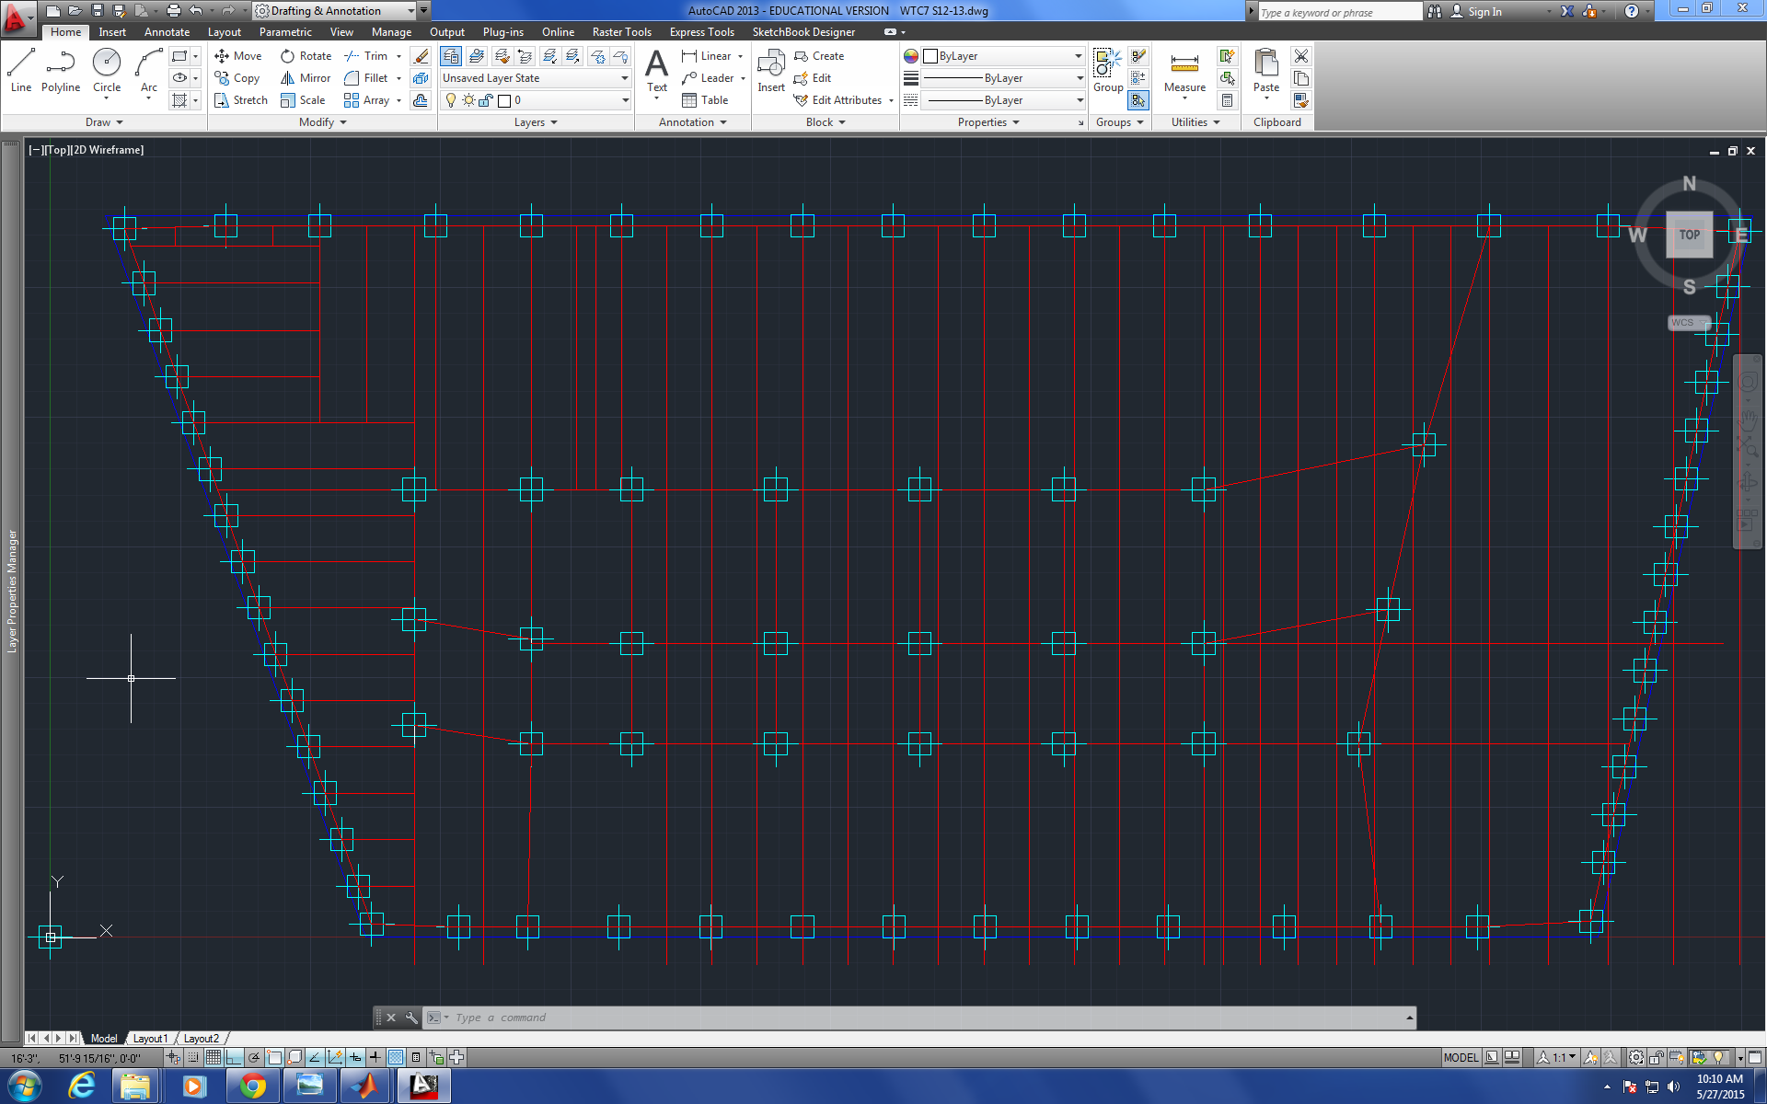
Figure 1
Analysis of the Cause of Collapse of World Trade Center 7
Progression of the Project Daily Report

Date: 05/27/2015
Submitted by Zhili Quan

Today, more of the drawing of WTC7 (World Trade Center 7) the 12th floor was done by research assistant Zhili Quan. All the columns are marked. Most of the beams and girders are placed.
Dr. Hulsey and two of his fellow student assistants Feng Xiao and Zhili Quan had their daily meeting at 4:00pm. Not a lot was being discussed. Basically keep drawing and finish all the floors first. Dr. Hulsey pointed out that by the end of the summer, a runnable model should be handy.
However, two potential errors on one of the drawings may be detected by Zhili Quan. The potential errors are spotted on framing plan of the 12th floor.
It is not wisable to continue unless at least one of them is confirmed or disconfirmed by everybody on board.
The following diagrams show the potential errors.
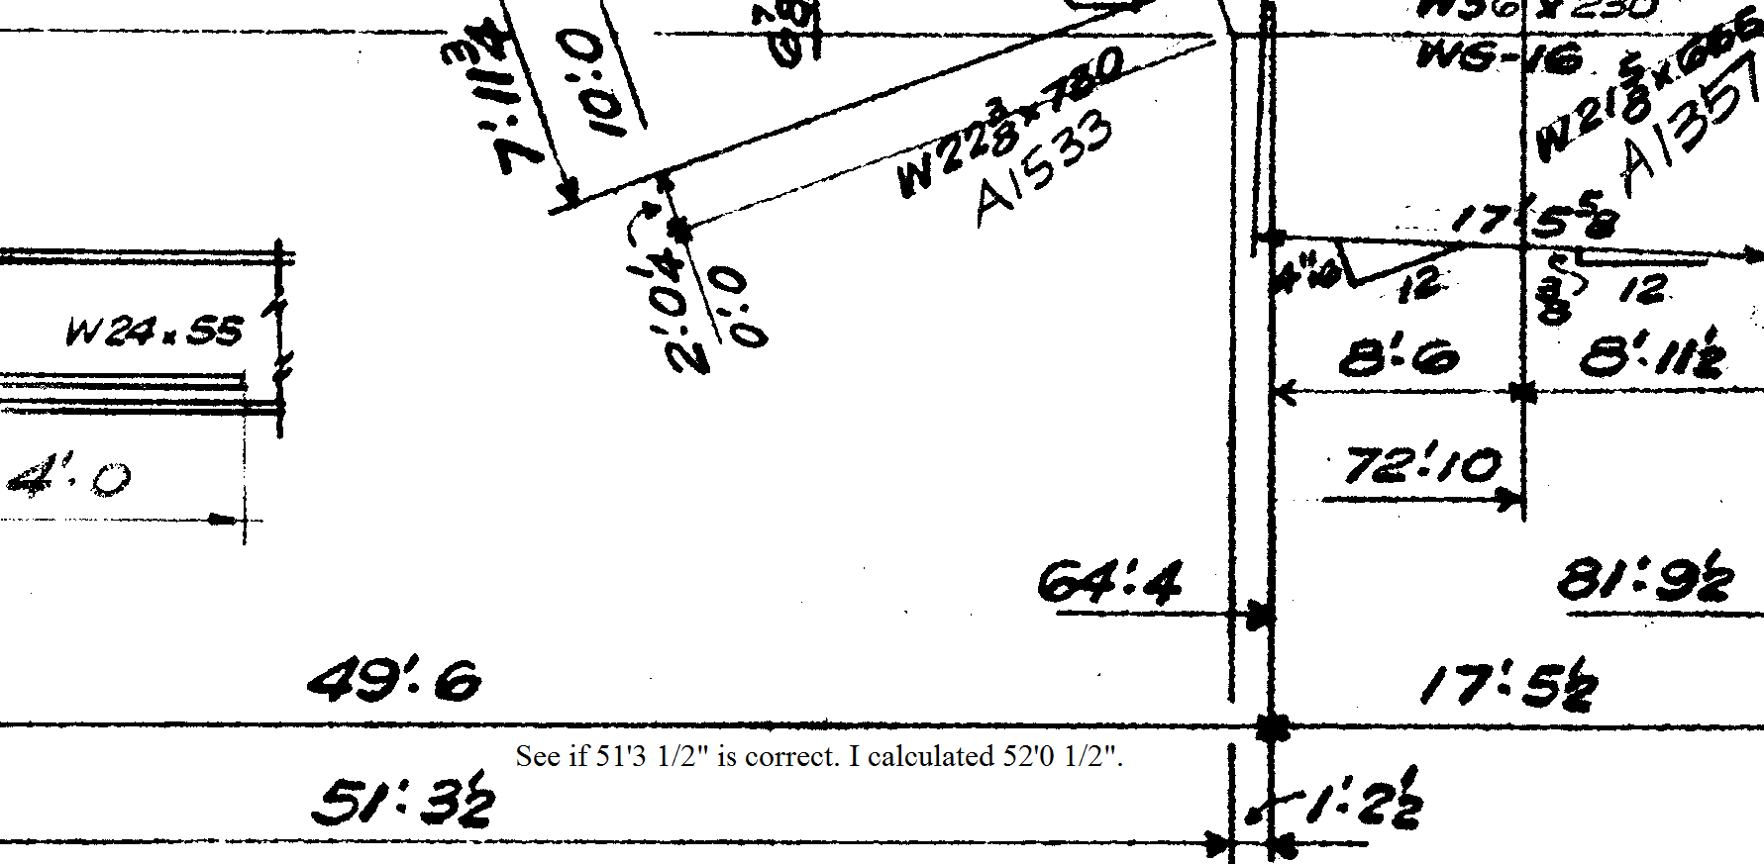
Figure 1
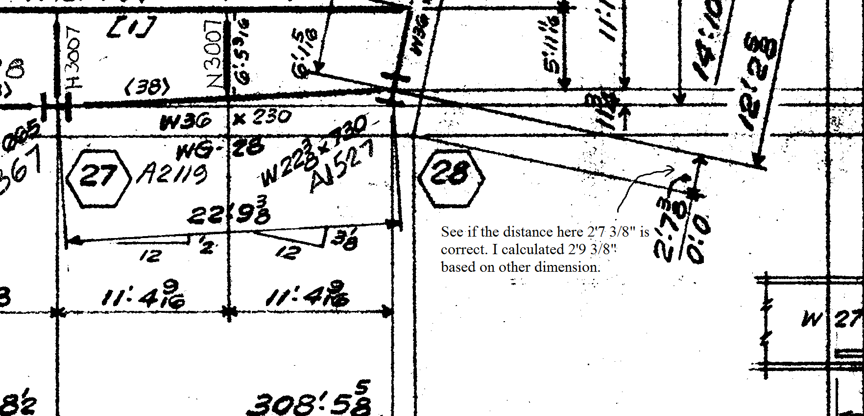
Figure 2

Analysis of the Cause of Collapse of World Trade Center 7
Progression of the Project Daily Report

Date: 05/28/2015 Working Hours: 8
Submitted by Zhili Quan
Today, the drawing of floor framing of the 12th floor is finished. The following figure shows the framing plan.
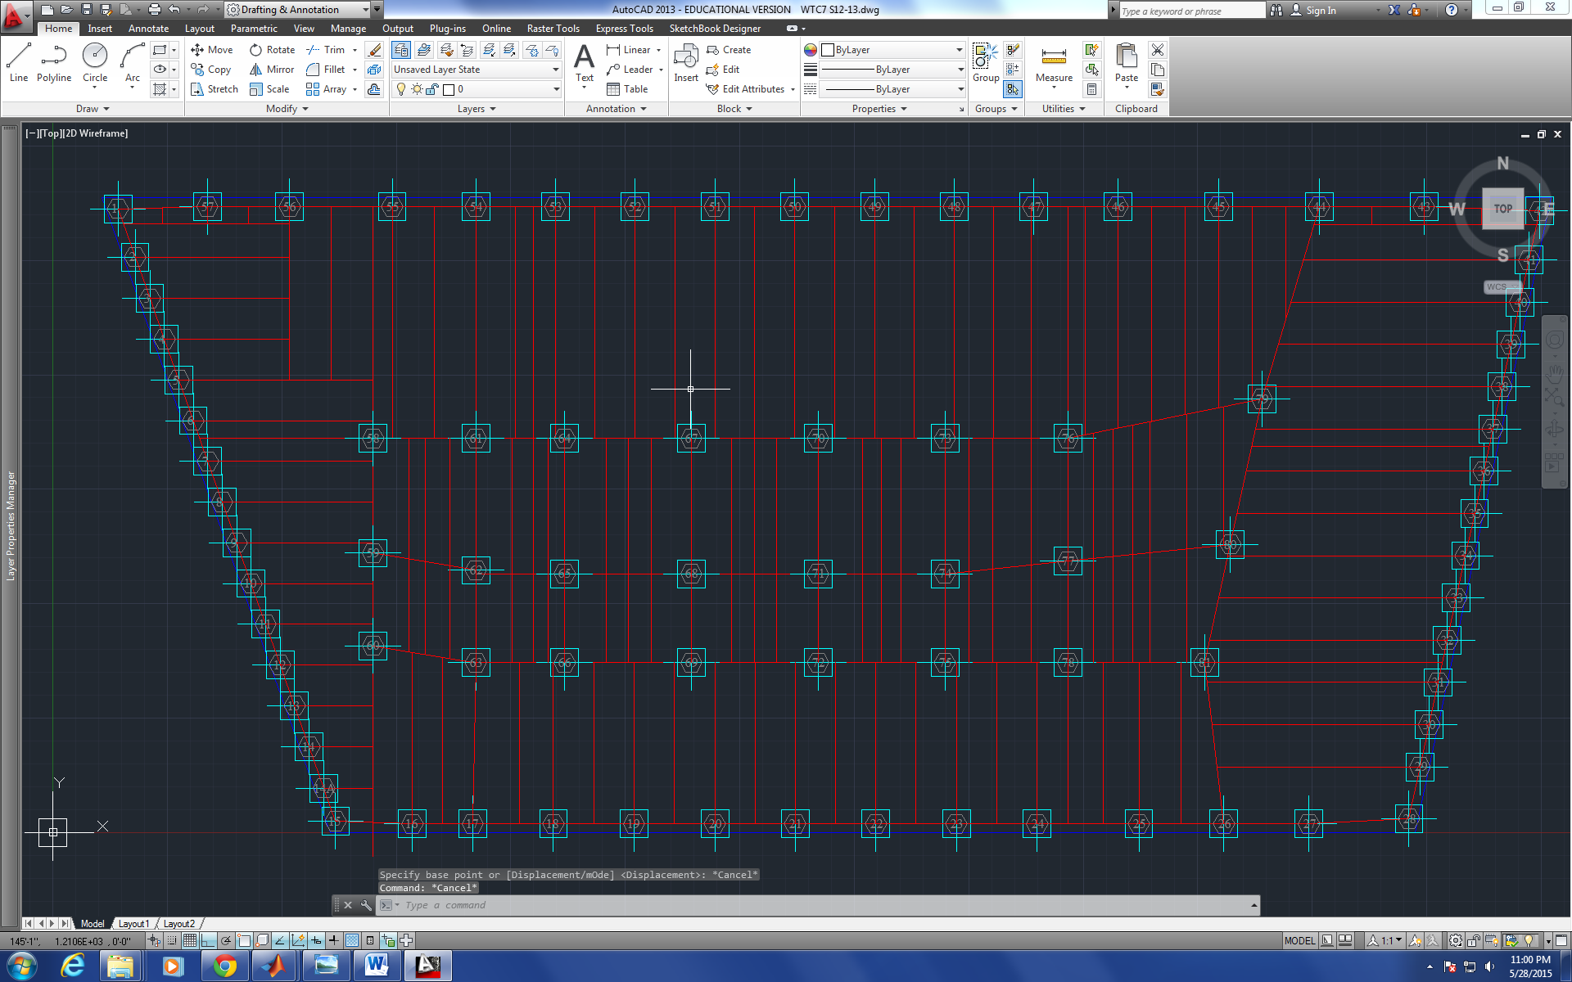
Figure 1
Due to the fact that 8th to 20th and 24th to 45th floors all have the same framing plan. The drawing can be adjusted slightly to make framing plans for all these floors.
The two potential dimension corrections were also confirmed by fellow student assistant Feng Xiao. The corrections have been documented and highlighted.
Study on Solidworks and COMSOL was being done as the potential finite element software to model the responses of the connections of the building.

Analysis of the Cause of Collapse of World Trade Center 7
Progression of the Project Daily Report

Date: 05/29/2015 Working Hours: 8
Submitted by Zhili Quan
Today, the drawing of floor framing of the 1th floor is getting started. The good news is, after finishing the 12th floor framing plan drawing. The rest of the floor framing plan drawings have become much easier due to the similarity among floor framing plan drawings so they can be stacked together on each other.
More study on Solidworks was being done and the software looks promising in potentially testing the stiffness of the connections of the building.
In the daily meeting, Dr. Hulsey informed the fellow research assistants Zhili Quan and Feng Xiao he just learned that the building was built on caisson foundations. Therefore, research on caisson foundations needs to be conducted, and in this case, how the foundation of the building was built needs to be studied as well. So far, little knowledge is known about the foundation of the building.

Analysis of the Cause of Collapse of World Trade Center 7
Progression of the Project Daily Report

Date: 06/01/2015 Working Hours: 8
Submitted by Zhili Quan
Today, the drawing of floor framing of the 1st floor framing plan is finished. The following figure shows the framing plan.
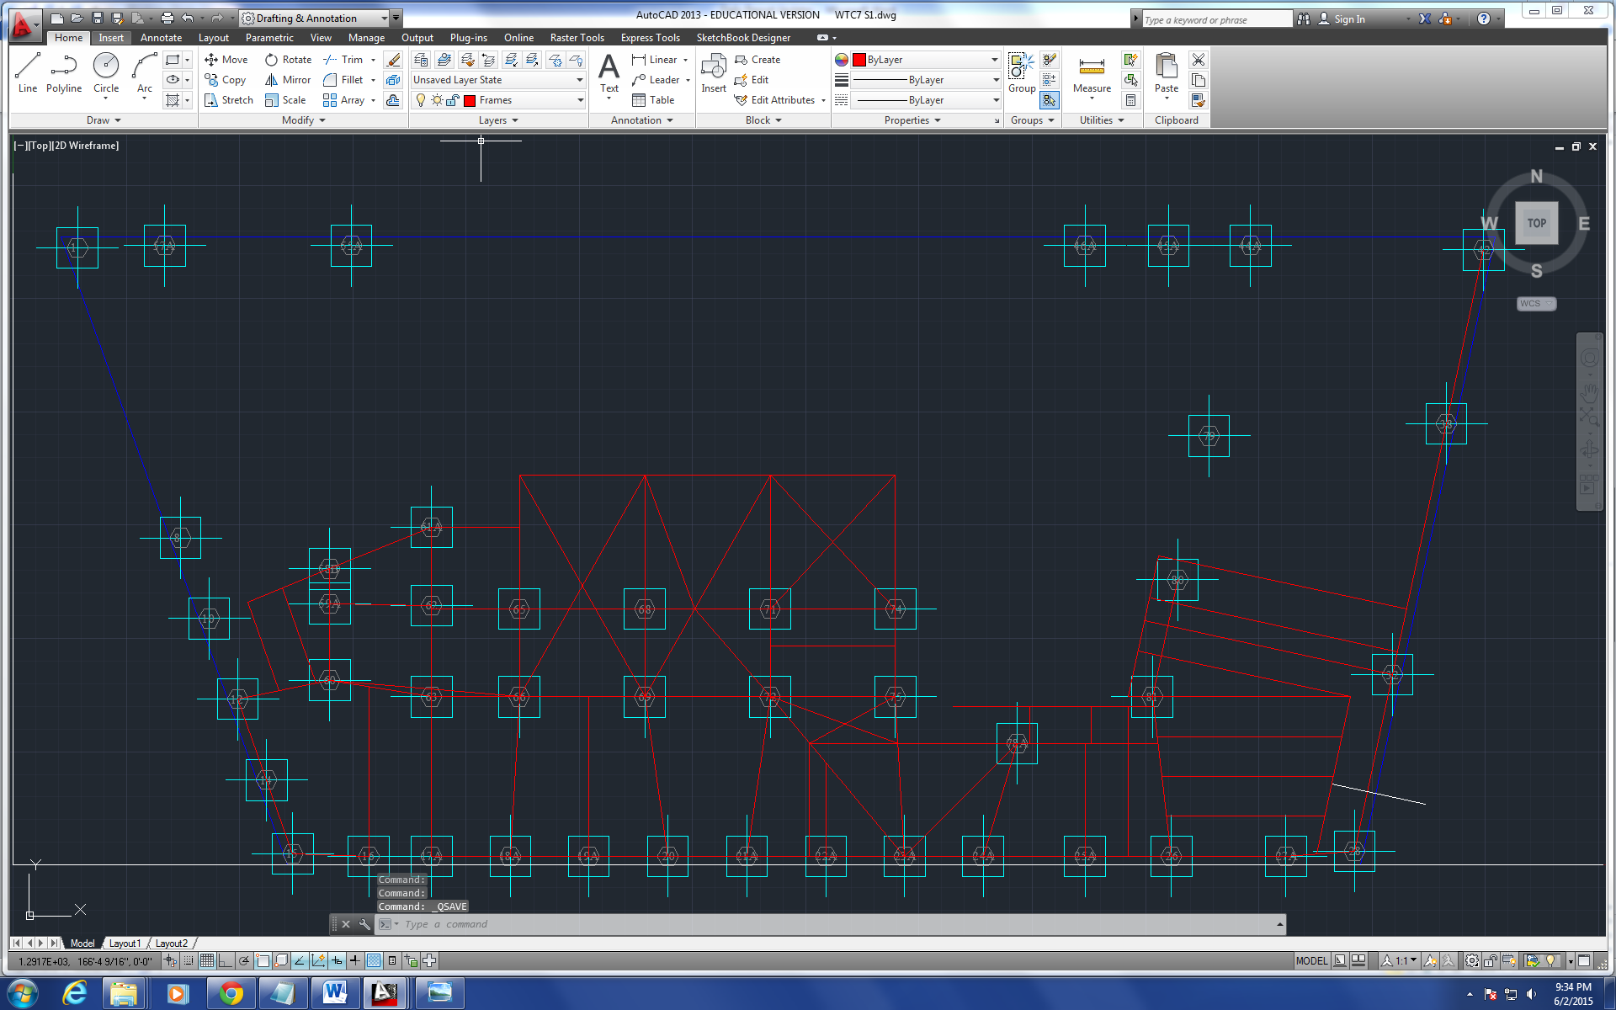
Figure 1
The drawing is very similar to the 12th floor framing plan drawing. However, only part of it can be drawn at the moment due to the missing blueprint of the electrical substation. Also, the detailing information such as the stairs, elevator shafts and bracing in small compartments are left for further refined drawings.

Analysis of the Cause of Collapse of World Trade Center 7
Progression of the Project Daily Report

Date: 06/02/2015 Working Hours: 8
Submitted by Zhili Quan
Today, the drawing of floor framing of the 2nd floor is finished. The following figure shows the framing plan.
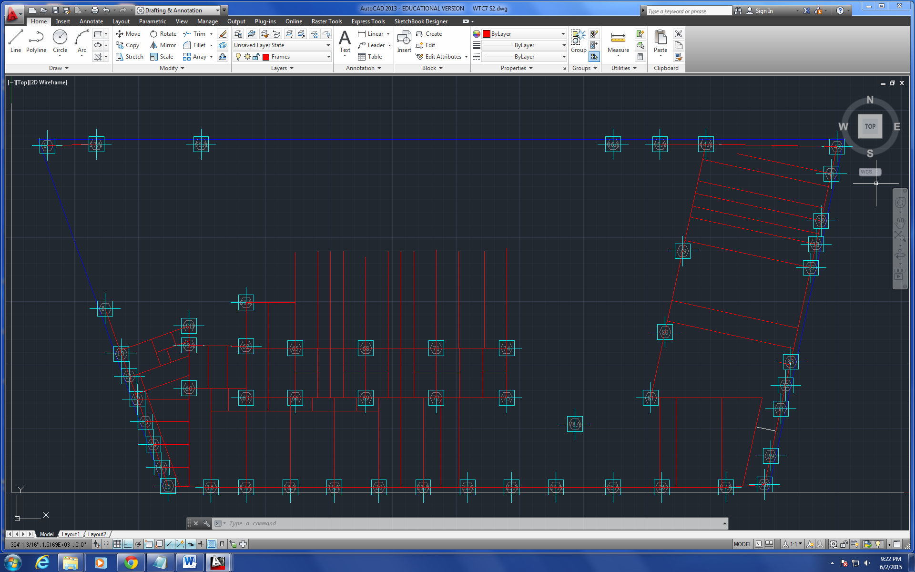
Figure 1
Again, only changes were made from the 1st floor framing, and only part of it can be drawn as well due to the missing blueprint of the electrical substation.
Student research assistant Zhili Quan has documented another potential correction for the 2nd floor framing plan. The correction is shown in the following diagram.
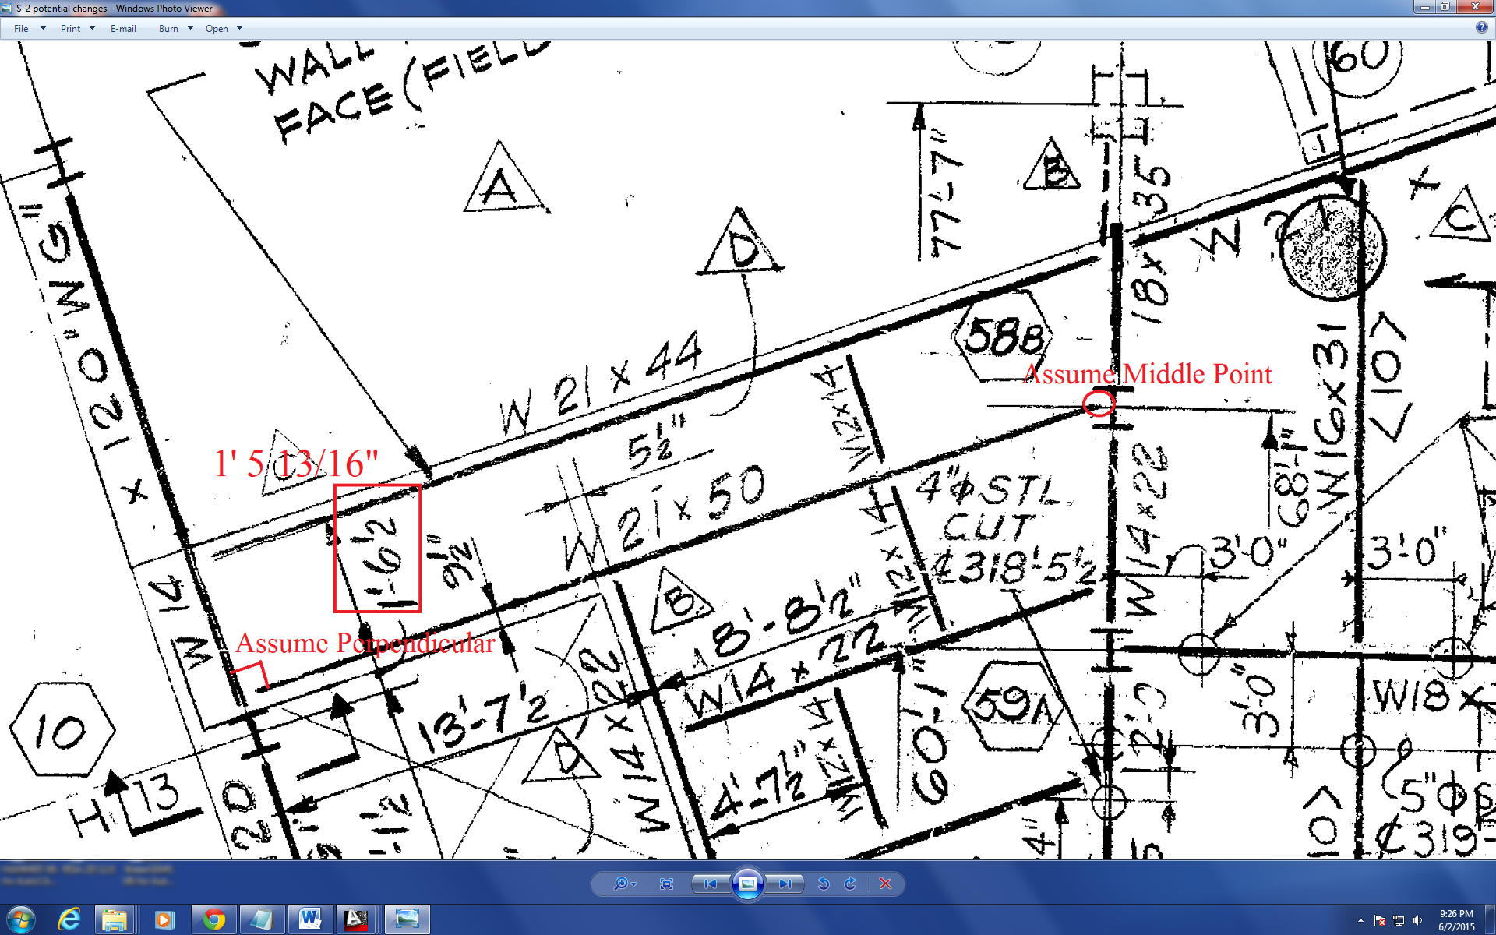
Figure 2
Dr. Leroy Hulsey and two student research assistants Zhili Quan and Feng Xiao had their daily meeting and they decided to draw the entire building’s floor framing and detailing with AutoCAD as soon as possible. Then build a model on SAP2000. The key is the convertible AutoCAD drawing into SAP2000.
The drawing on floor 3 has started and expected to be finished tomorrow.

Analysis of the Cause of Collapse of World Trade Center 7
Progression of the Project Daily Report

Date: 06/03/2015 Working Hours: 8
Submitted by Zhili Quan
Today, the drawing of floor framing of the 3nd floor is finished. The following figure shows the framing plan.
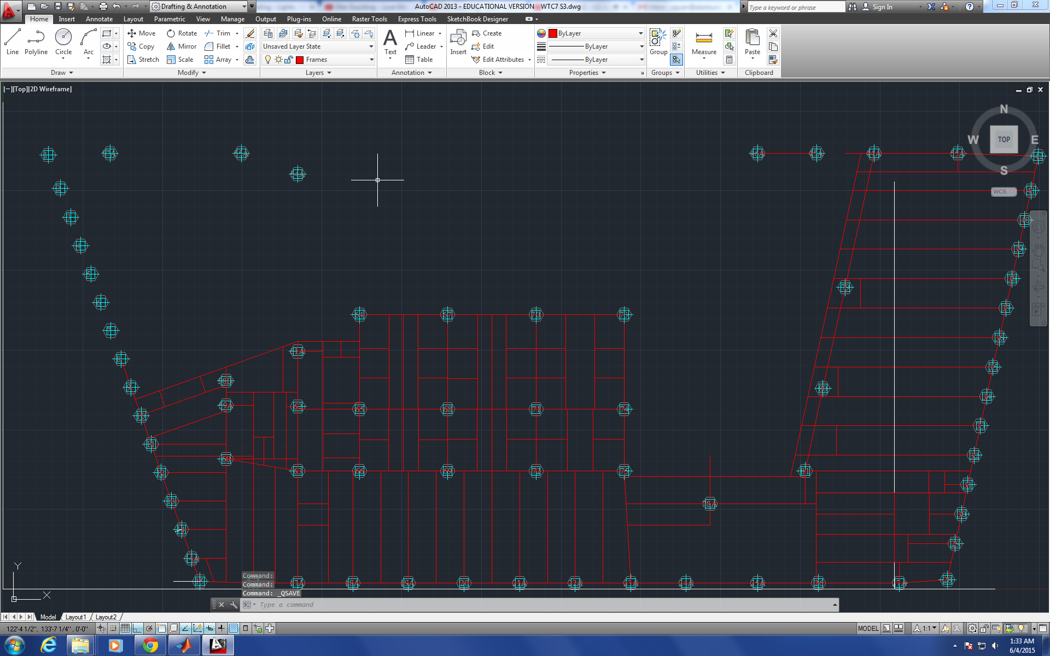
Figure 1
Again, only changes were made from the previous floor framing, and only part of it can be drawn as well due to the missing blueprint of the electrical substation.
There is potential issue about missing dimensions on minor frames. However, it could be that the missing dimensions not shown on the blueprint of the each floor framing plan drawing are shown on other drawings in the package.
The 4th floor framing plan drawing will get started tomorrow and hopefully get finished by then.

Analysis of the Cause of Collapse of World Trade Center 7
Progression of the Project Daily Report

Date: 06/04/2015 Working Hours: 8
Submitted by Zhili Quan
Today, the drawing of floor framing of the 4th floor is finished. The following figure shows the framing plan.
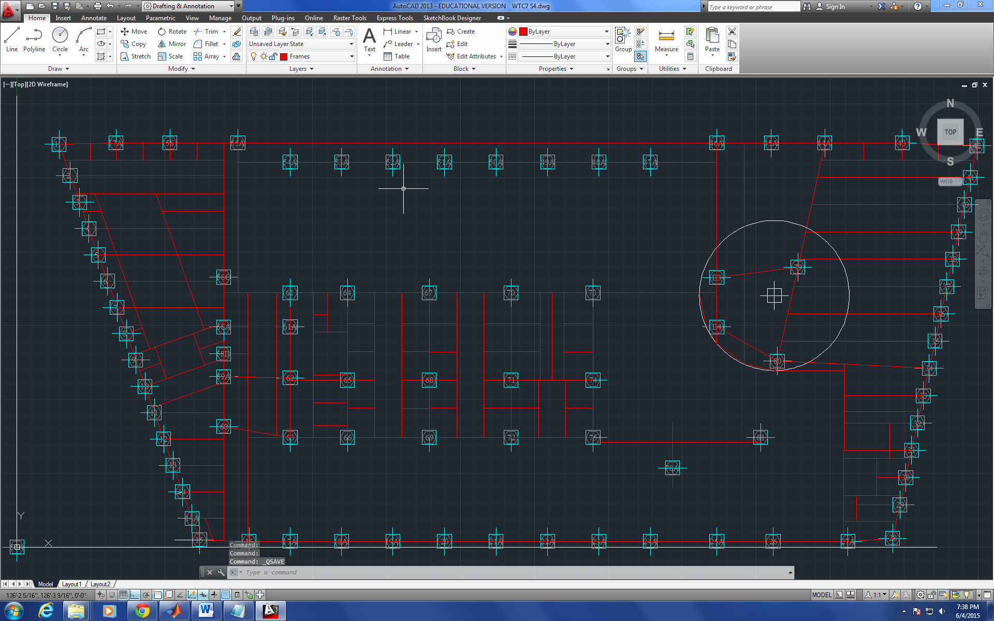
Figure 1
From the 4th floor on, the full drawing of the floor framing plan can be done regardless of the missing blueprints of the electrical substation.
Also, another potential dimension error was found and documented and to be confirmed. The following figure shows it.
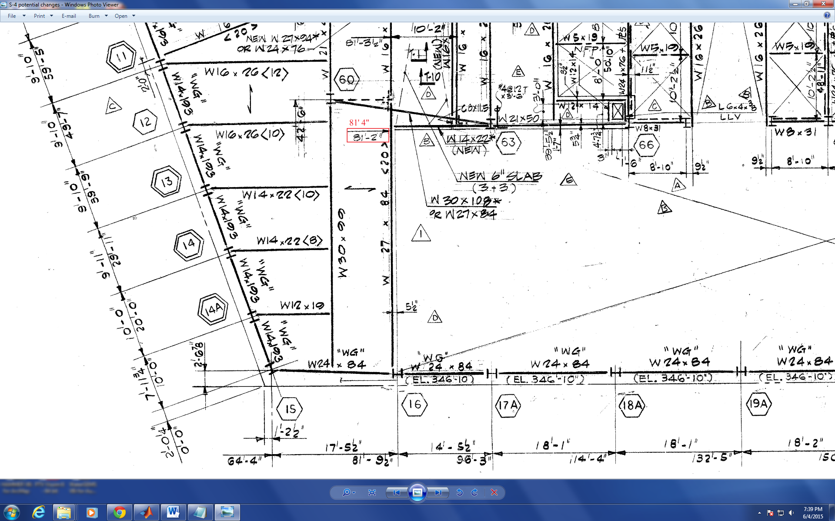
Figure 2
Dr. Hulsey had meeting with fellow research assistants Zhili Quan and Feng Xiao. He is trying to find information about the blueprints of electrical substation, the caisson foundation of the building and elevator shafts and stairs. He believes that all of these are crucial in determining the collapse of WTC 7.

Analysis of the Cause of Collapse of World Trade Center 7
Progression of the Project Daily Report

Date: 06/05/2015 Working Hours: 8
Submitted by Zhili Quan
Today, the drawing of the 5th floor framing plan has started and very close to be finished. The unfinished drawing is shown as below.
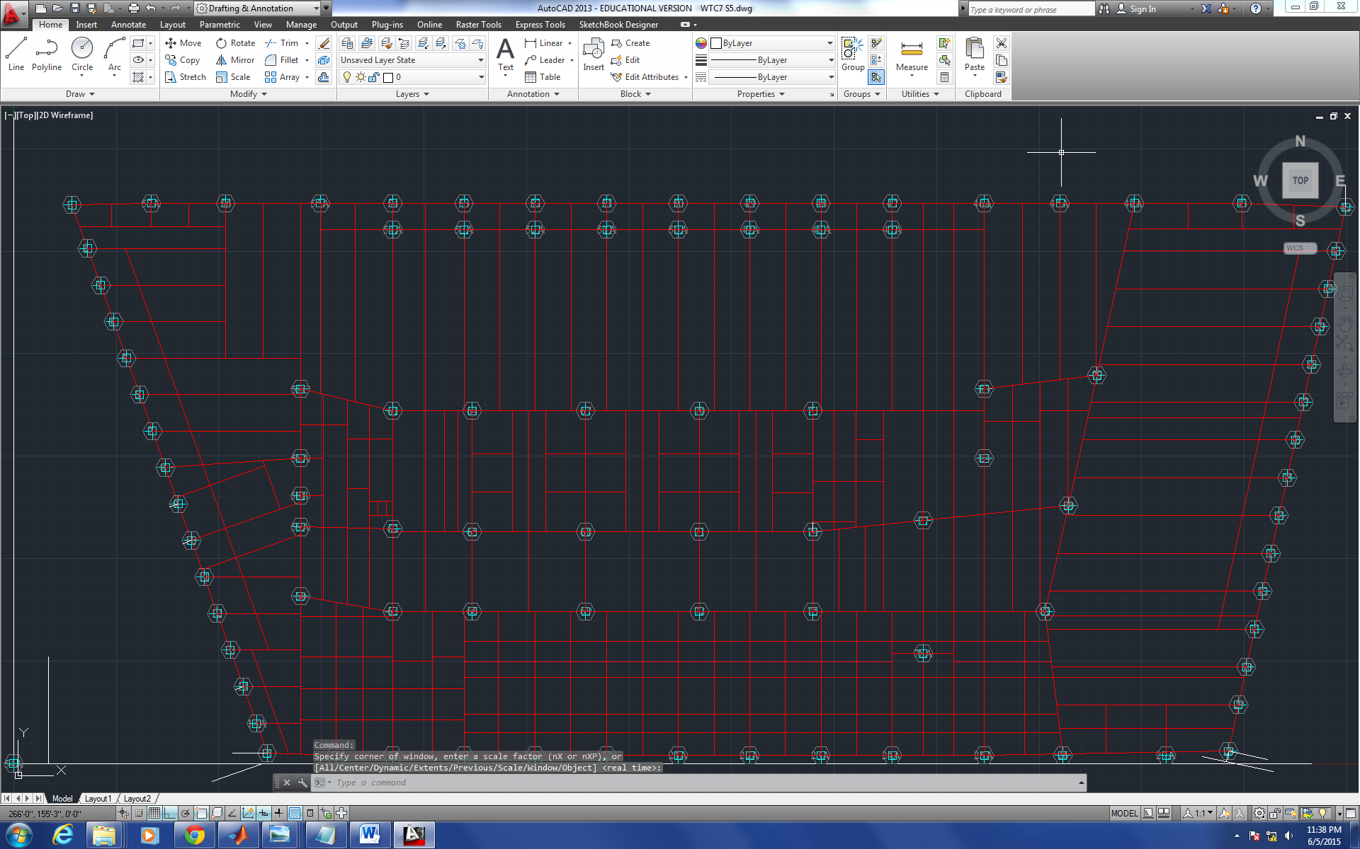
Figure 1
Also, a little dimension off of girders on the 5th floor framing plan is found and to be confirmed. The following figure shows it.
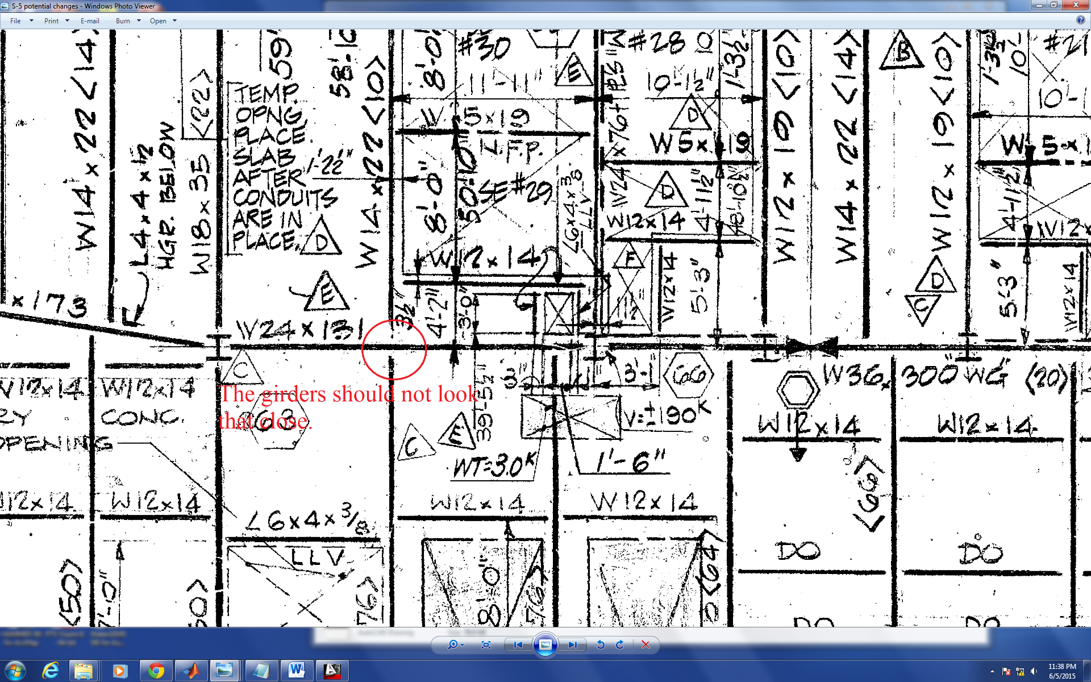
Figure 2
Dr. Hulsey discussed the potential of CAD and Finite Element Software Solidworks as the tool to analyze the stiffness of the connections. Learning how to Solidworks has become quite important for the project.

Analysis of the Cause of Collapse of World Trade Center 7
Progression of the Project Daily Report

Date: 06/08/2015 Working Hours: 8
Submitted by Zhili Quan
Today, the drawing of the 5th floor framing plan has been finished. The drawing of the 6th is also finished but more issues have been found. The following figure shows the 6th floor framing plan view.
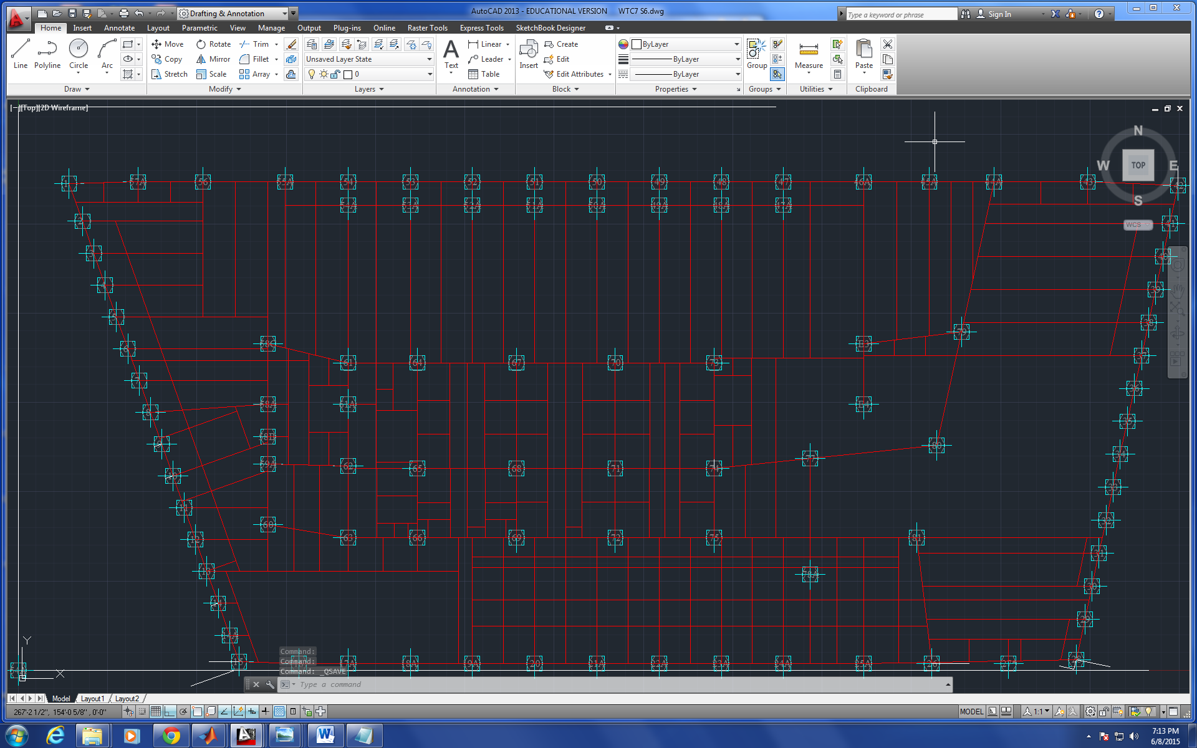
Figure 1
On the 6th floor framing plan view blueprint, several columns don’t have the same location as they have on the previous floors framing plan view blueprints. The distances are off by inches to up to one or two feet.
The issue has been documented and needs to be address later. The following figure shows the several contradictory column locations on the 6th floor blueprint.
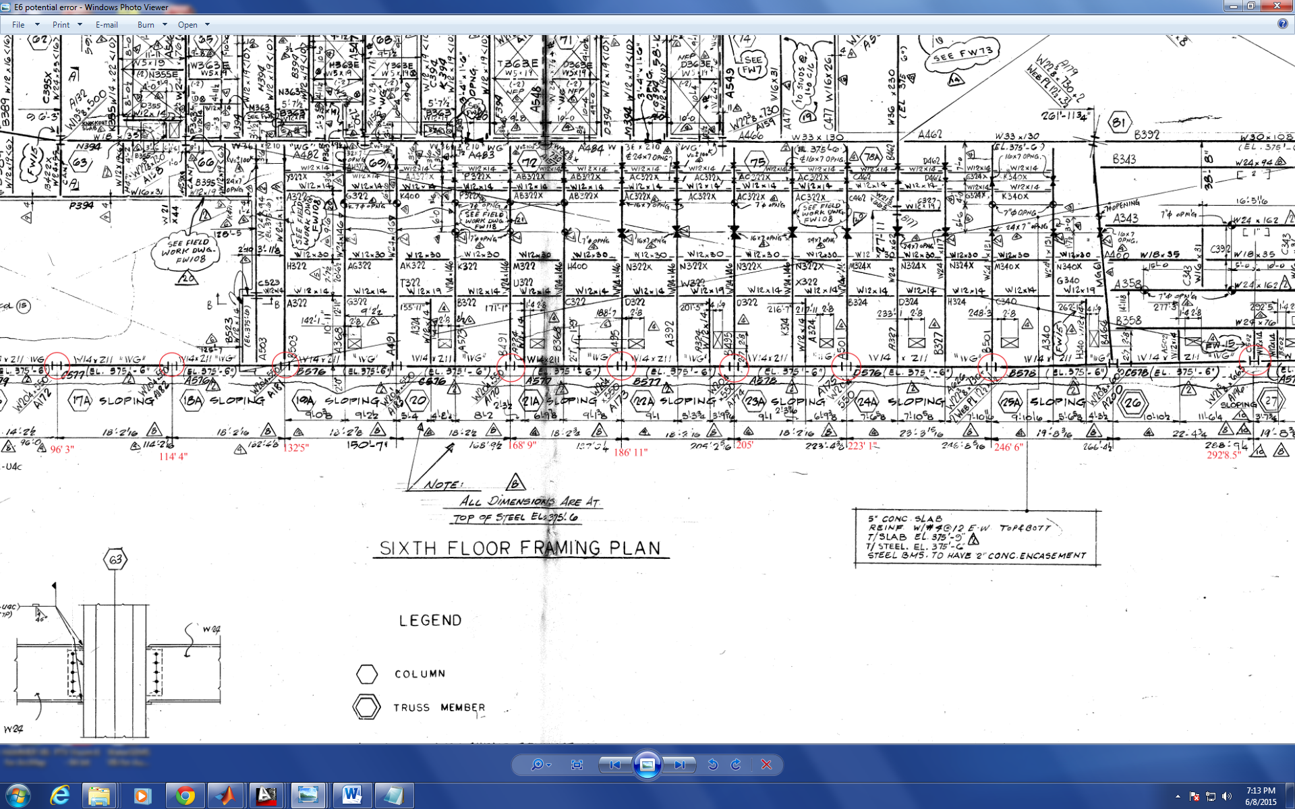
Figure 2
The drawing of the 7th floor has started and to be finished tomorrow.

Analysis of the Cause of Collapse of World Trade Center 7
Progression of the Project Daily Report

Date: 06/09/2015 Working Hours: 8
Submitted by Zhili Quan
Today, the drawing of the 7th floor framing plan is close to be finished. The following figure shows the 7th floor framing plan view.
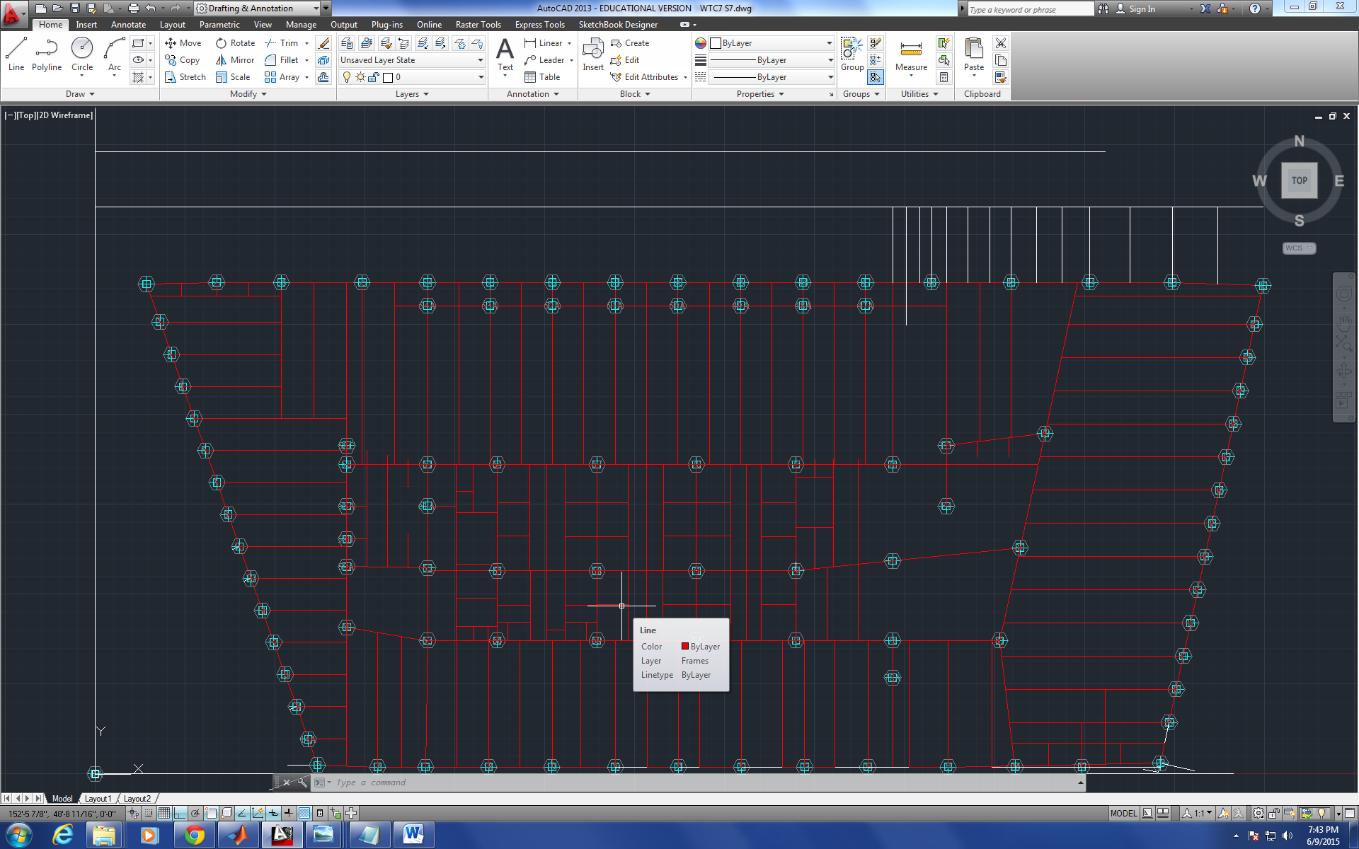
Figure 1
However, several columns of the 7th floor have contradictory locations between two different drawings for the floor. The drawings were finished at different time. Dr. Hulsey recommended using the drawing that was finished later.
Also, it seems that all AISC members are published online in DWG files. Therefore, it can potentially save a lot time by simply downloading and importing all the members into AutoCAD. Dr. Hulsey pointed out that everything should be compatible before put them together.

Analysis of the Cause of Collapse of World Trade Center 7
Progression of the Project Daily Report

Date: 06/10/2015 Working Hours: 8
Submitted by Zhili Quan
Today, the drawing of the 7th floor framing plan was finished. The drawing of the floor framing plan for floor 21 has started. Also, it turns out that the floor framing plans for floor 21 to 23 are exactly the same. The following figure shows the finished AutoCAD drawing of the 7th floor.
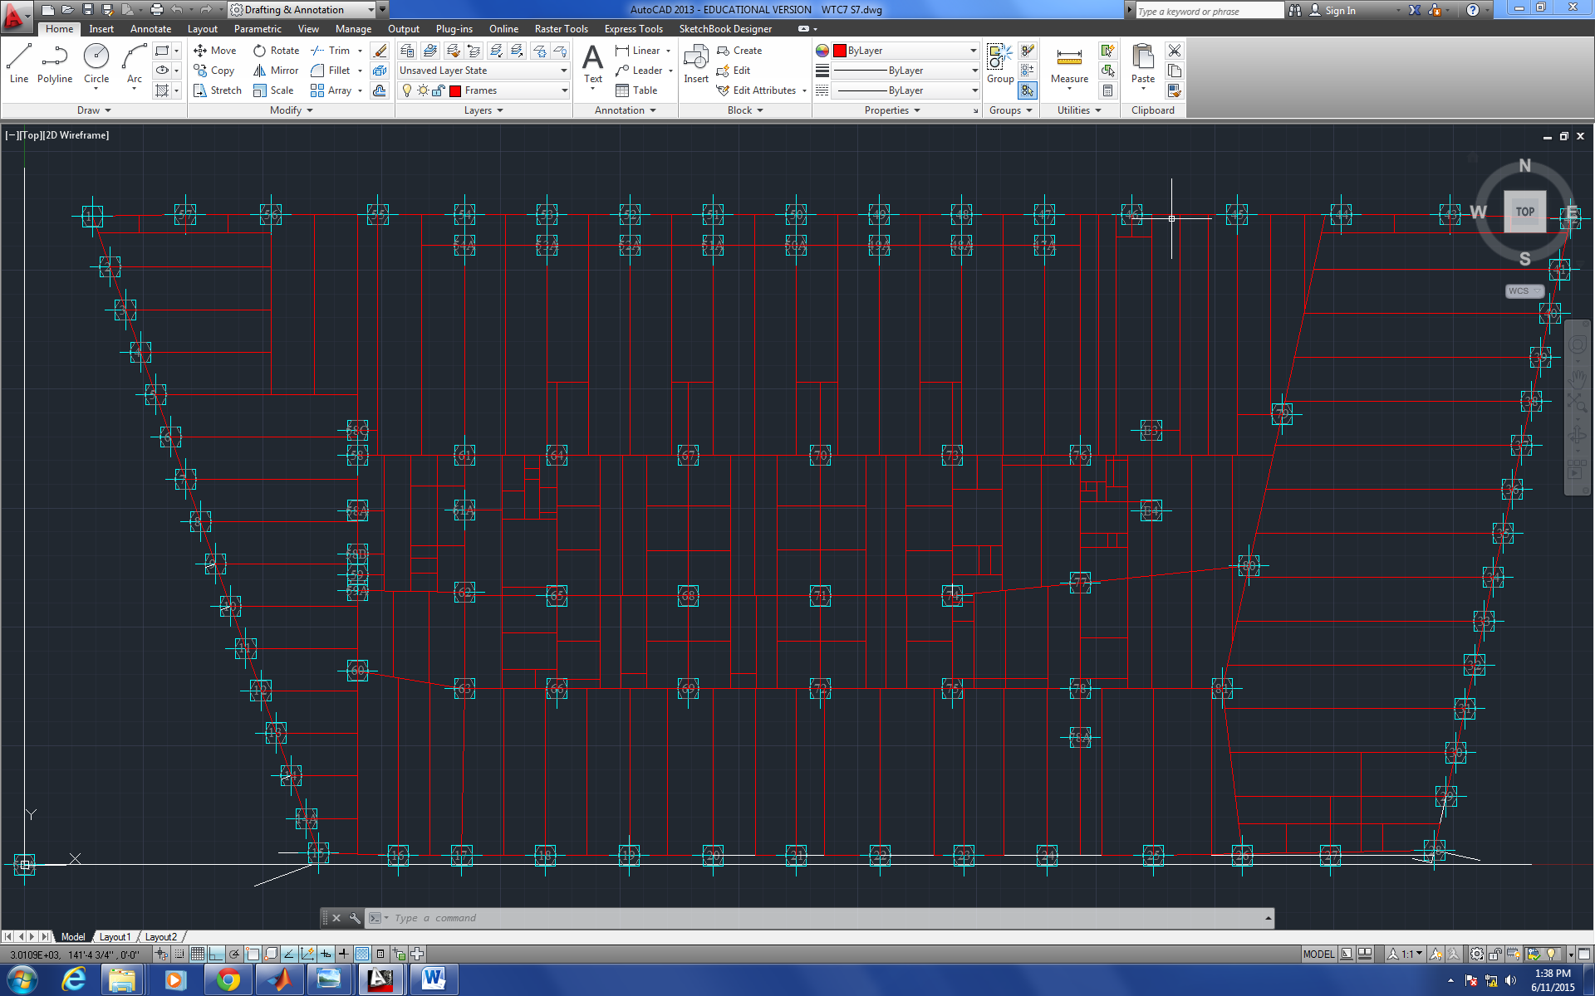
Figure 1
Dr. Hulsey helped solved couple of technical issues related to the drawing of the 7th floor today and it expedited the process. Dr. Hulsey also mentioned an article may be contributing to the foundation part of WTC 7 and he will show it to the fellow research assistants.

Analysis of the Cause of Collapse of World Trade Center 7
Progression of the Project Daily Report

Date: 06/11/2015 Working Hours: 8
Submitted by Zhili Quan
Today, the drawing of the 21th floor framing plan was finished. It is found that there is somehow minor difference between floor framing plan view between 21th floor and 22nd&23rd floors. The 21th floor framing plan view is presented in the following figure.
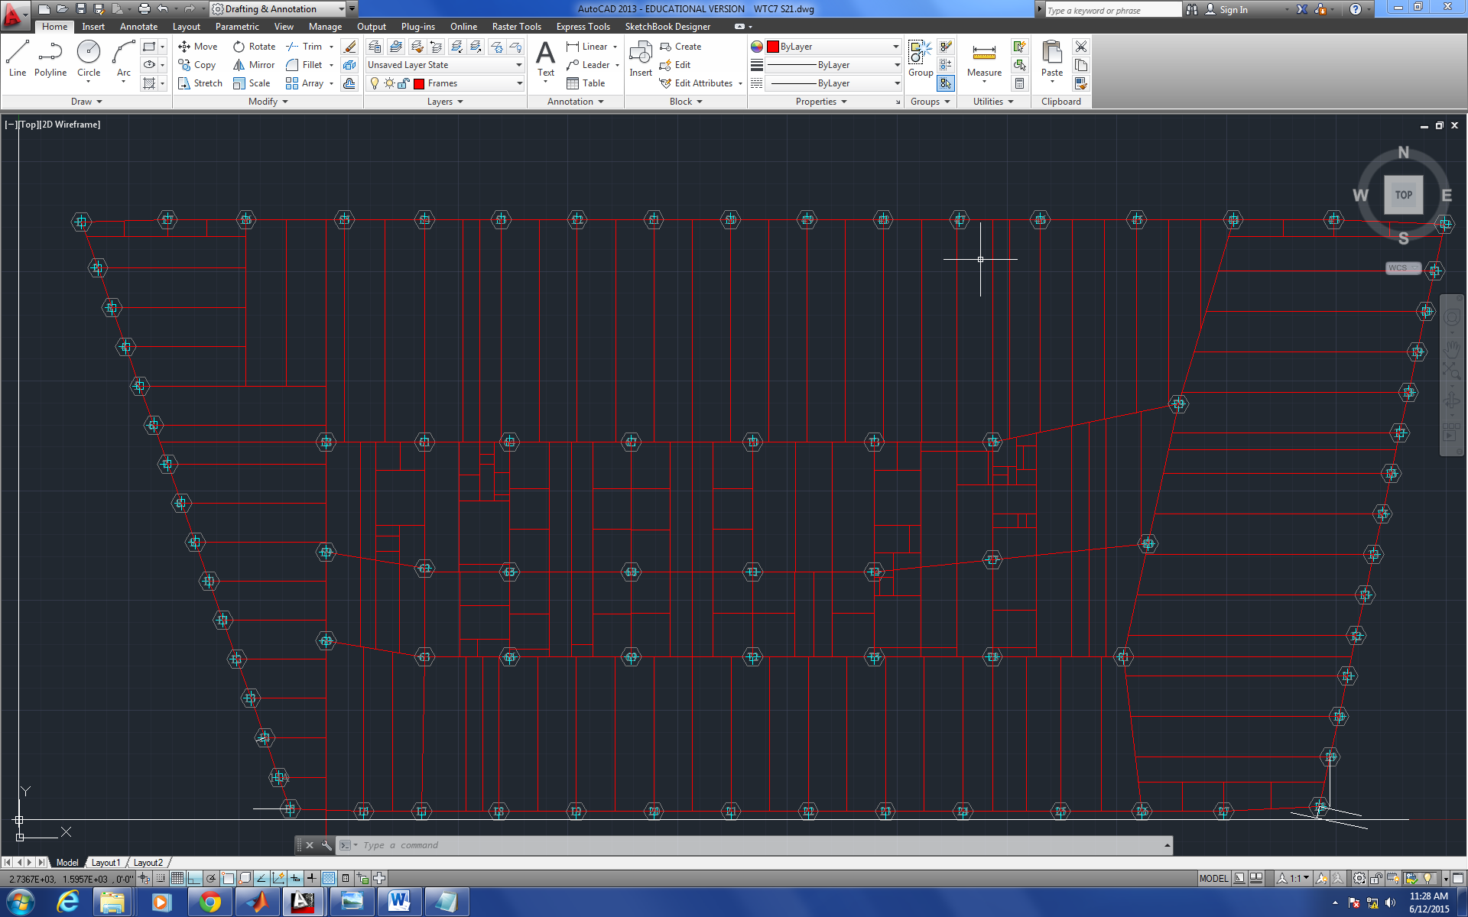
Figure 1
Dr. Hulsey forwarded some information on the caisson foundation and electrical substation of WTC7 to the research assistants Zhili Quan and Feng Xiao. The information can be helpful and will be studied. The 2D drawing phase is very close to be finished.

Analysis of the Cause of Collapse of World Trade Center 7
Progression of the Project Daily Report

Date: 06/12/2015 Working Hours: 8
Submitted by Zhili Quan
Today, the drawing of the 22nd&23rd floor framing plan was finished. The floor framing plan view is presented in the following figure.
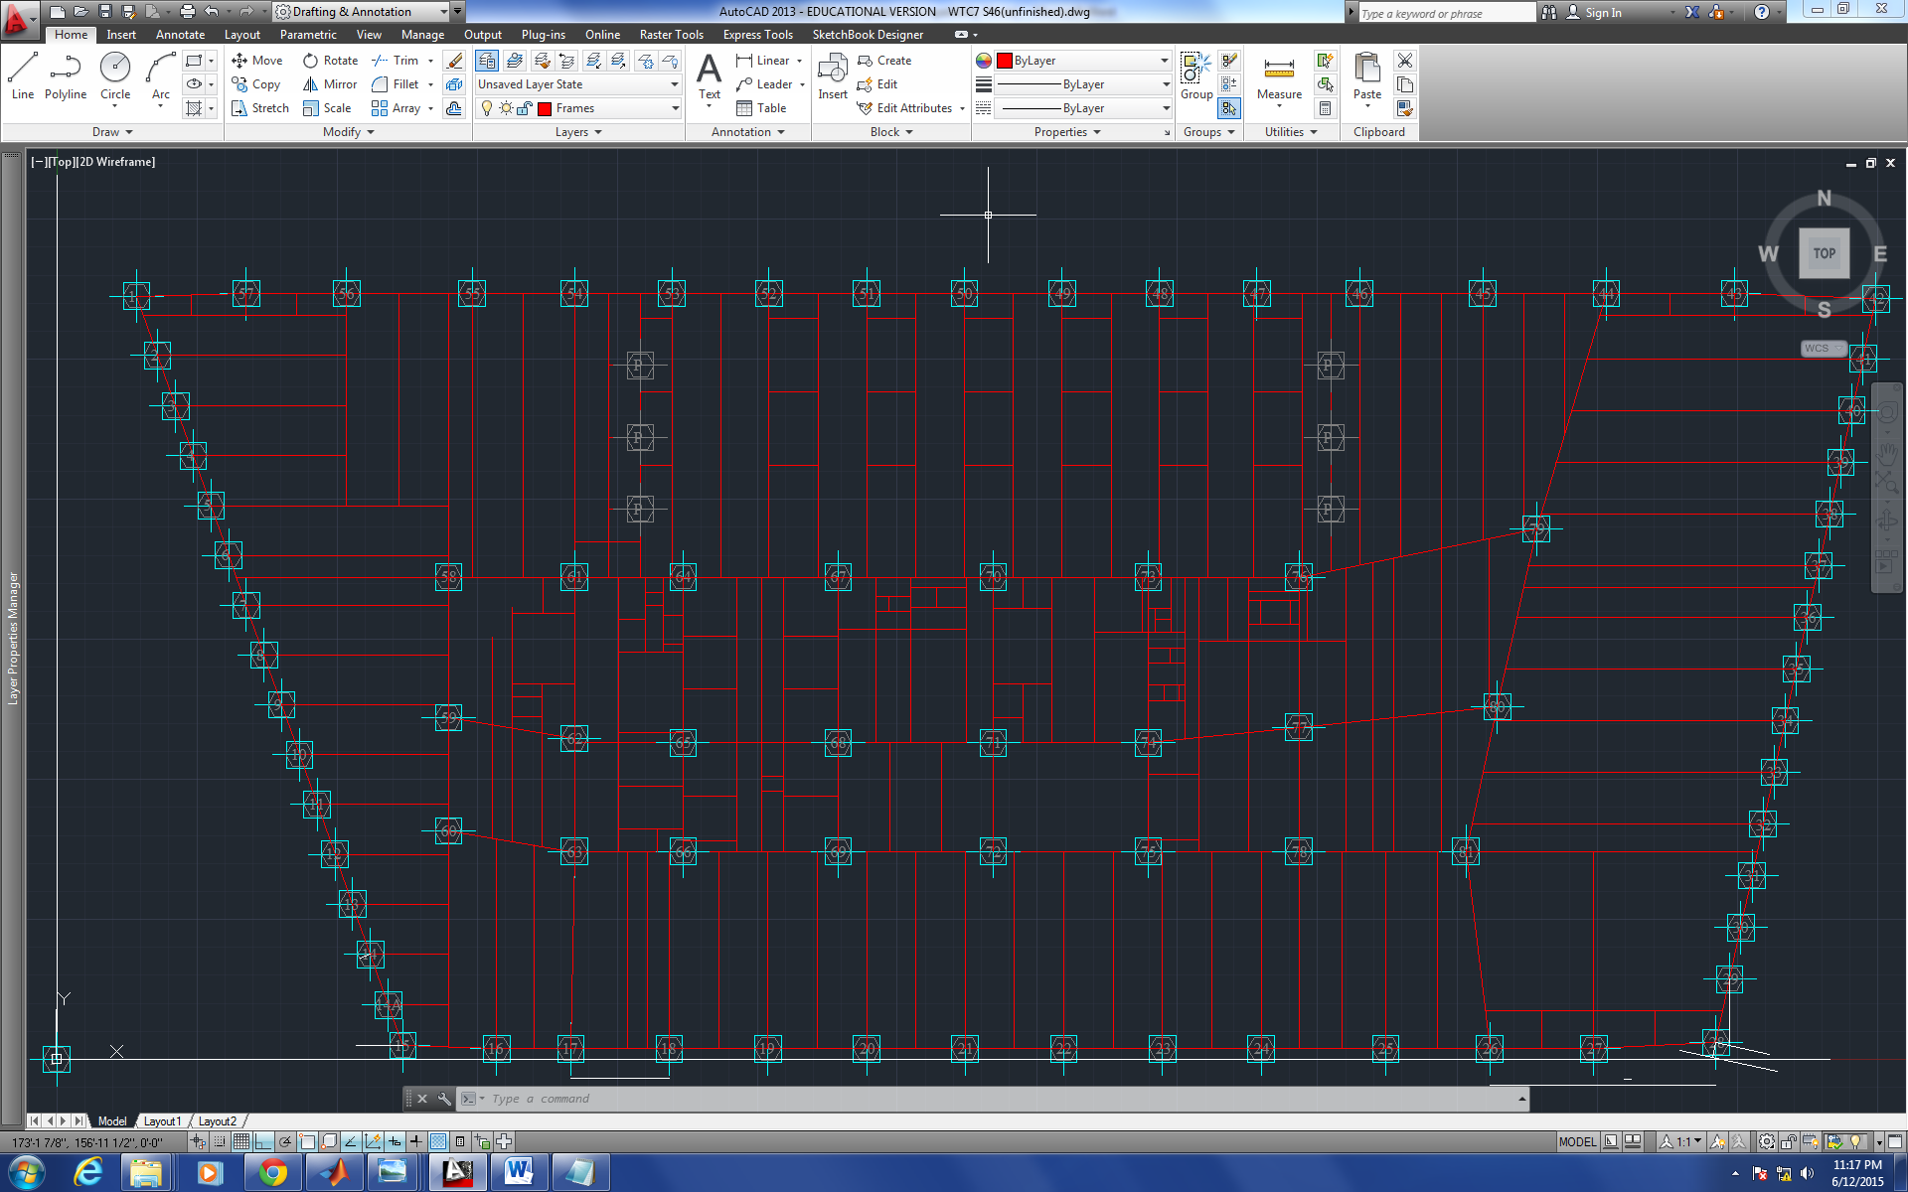
Figure 1
Dr. Hulsey suggested that it is crucial to study the paper he was given as soon as possible. AutoCAD 3D study should be underway soon to facilitate the 3D phase of the drawing of the building.

Analysis of the Cause of Collapse of World Trade Center 7
Progression of the Project Daily Report

Date: 06/15/2015 Working Hours: 8
Submitted by Zhili Quan
Today, the drawing of the 46th floor framing plan view was finished. The 47th floor drawing has also started and finished. The 46th floor framing plan view is presented in Figure 1 and the 47th is in Figure 2. Therefore, only one more drawing for the roof framing is left.
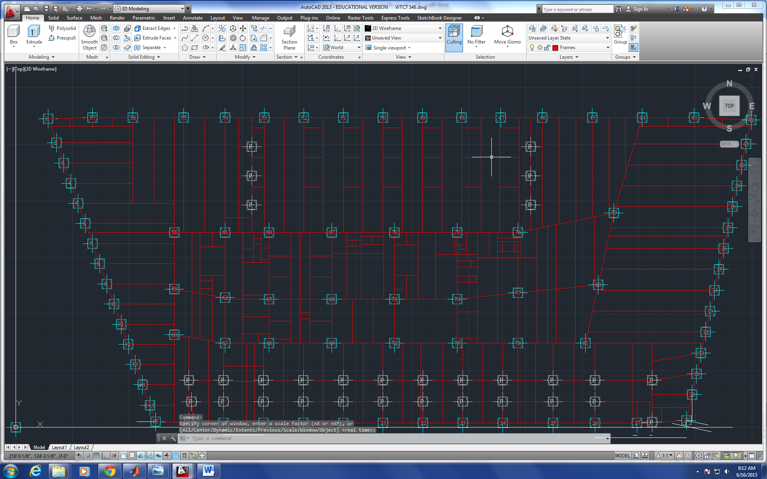
Figure 1
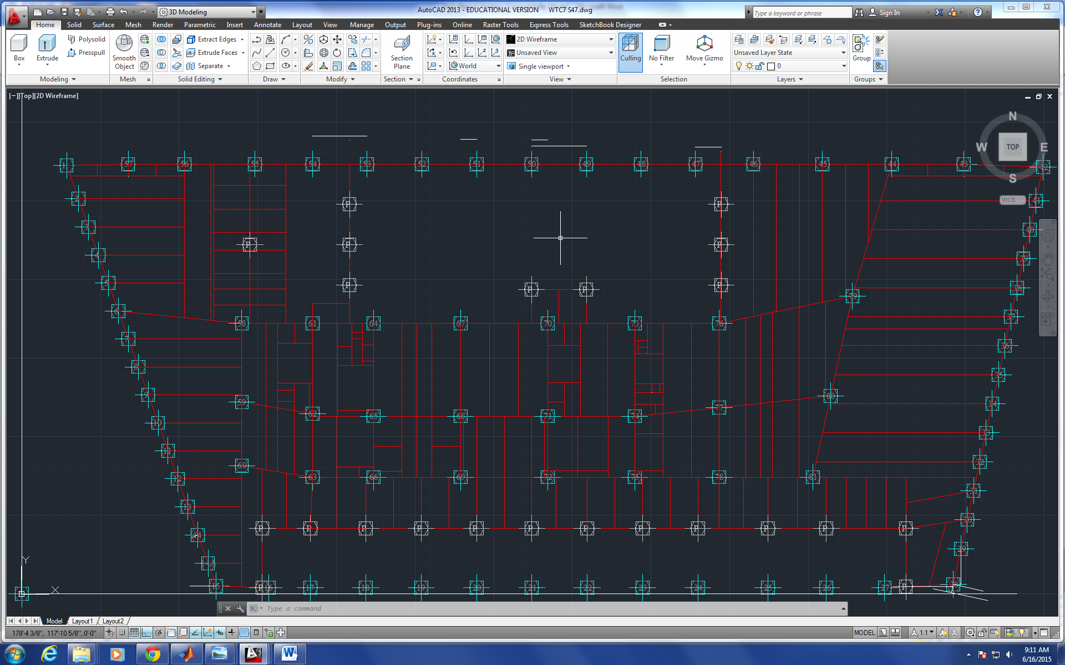
Figure 2
Dr. Hulsey suggested that it is of top priority no work related file to be lost due to any possible accident. He suggested fellow research assistants Zhili Quan and Feng Xiao to make a purchase request for 4 external hard-drives to make backup files for all the work done daily.
AutoCAD drawing in 3D is being studied and 3Ding the building is soon to be underway.

Analysis of the Cause of Collapse of World Trade Center 7
Progression of the Project Daily Report

Date: 06/16/2015 Working Hours: 8
Submitted by Zhili Quan
Today, a lot of literature review has been done on AutoCAD 3D drawing. Dr. Hulsey imparted yesterday it is significant to know how to change the orientation of the members in 3D space. He also suggested before starting putting the 3D model of WTC7 together, a simple test model building should be built and see what can be done with AutoCAD in 3D. The following figure shows the simple 2-story building with extruded members. 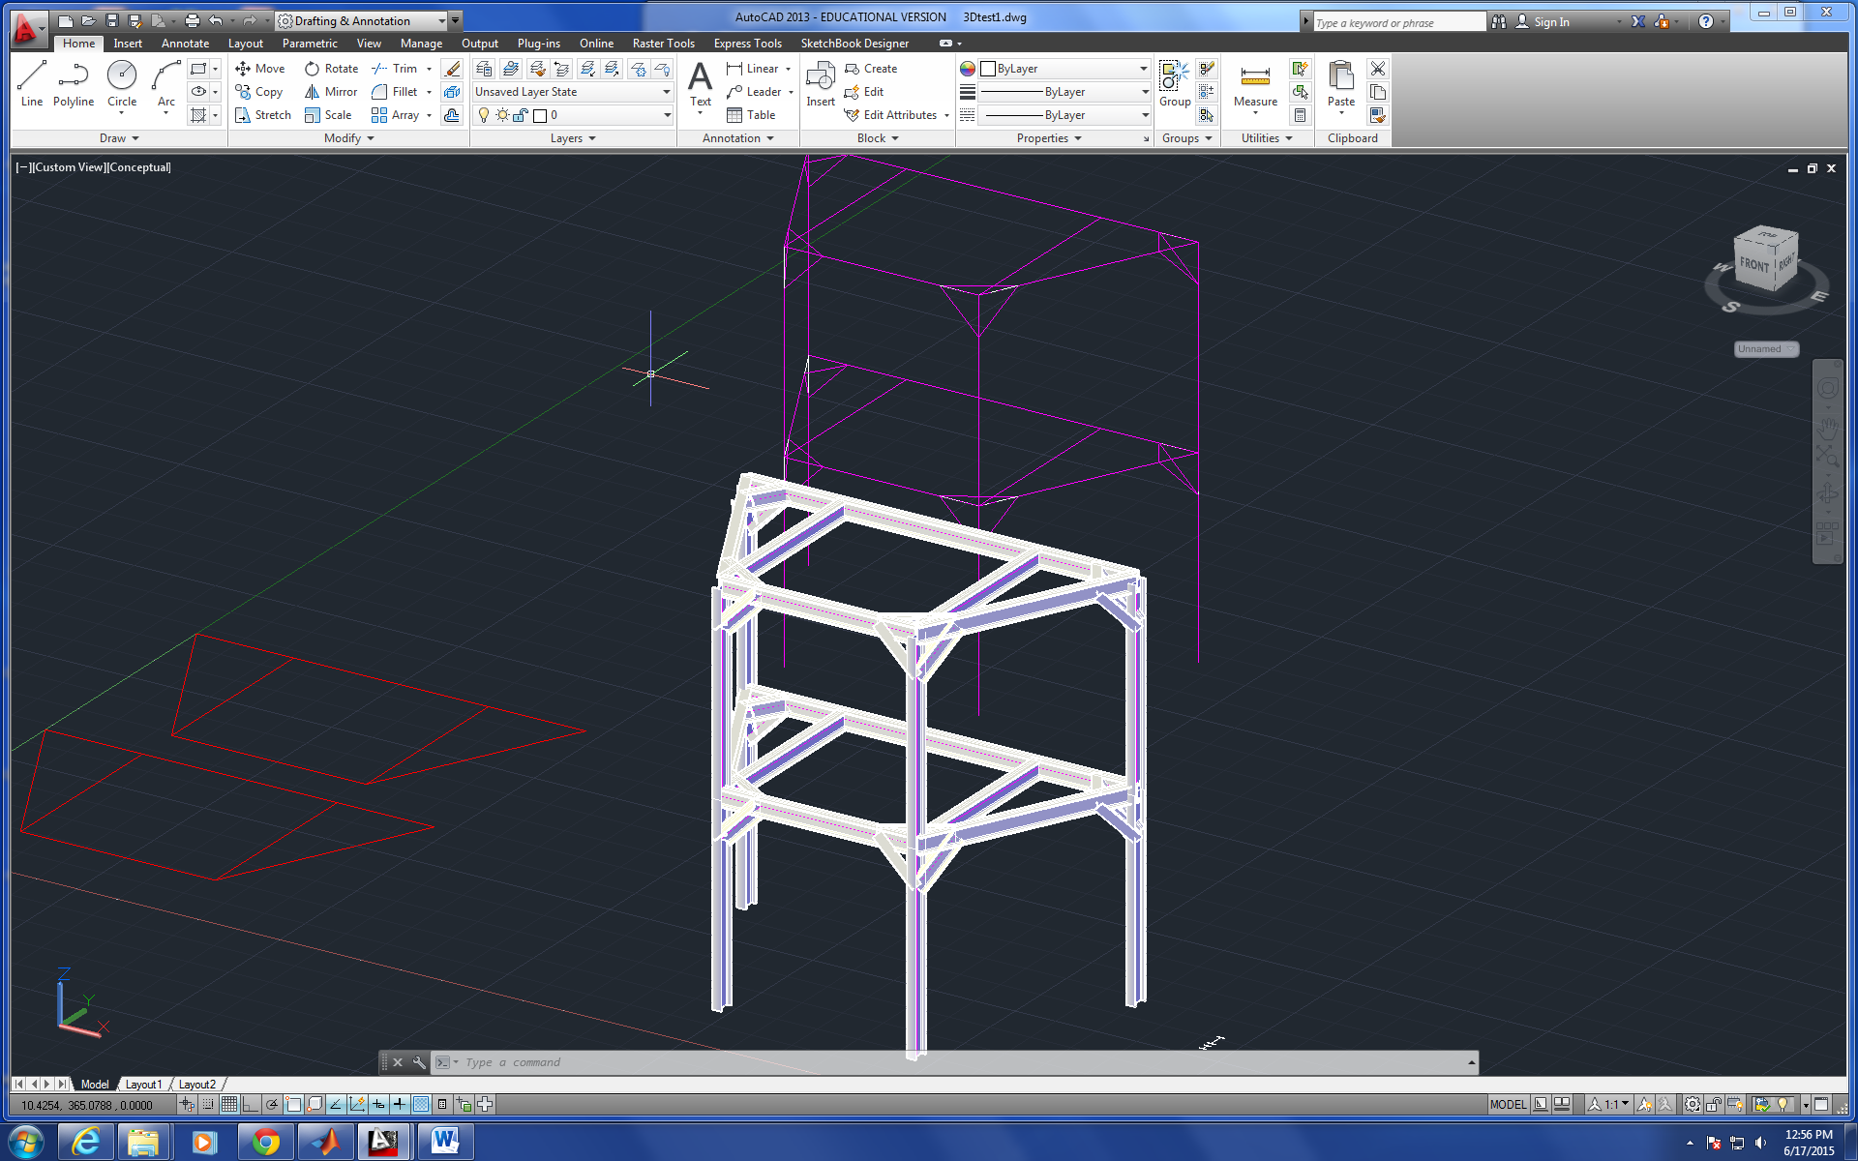
Figure 1
According to another Dr. Hulsey's, DWG drawings of AISC members may be found in open resources. It turned out all the AISC members have been made into DWG drwawings and published openly online for anybody to use.
A daily meeting between Dr. Hulsey and fellow research assistants Zhili Quan and Feng Xiao has concluded that 4 external harddrives will be purchased to story work related files daily to keep everything on track.

Analysis of the Cause of Collapse of World Trade Center 7
Progression of the Project Daily Report

Date: 06/17/2015 Working Hours: 8
Submitted by Zhili Quan
Today, more literature review was done on AutoCAD 3D drawing. Research assistant Zhili Quan thought of an idea to be potentially very helpful that is to label members with conspicuous colors. Figure 1 shows a W12X72 is lable in red. The idea can be very helpful when it comes to member checking.
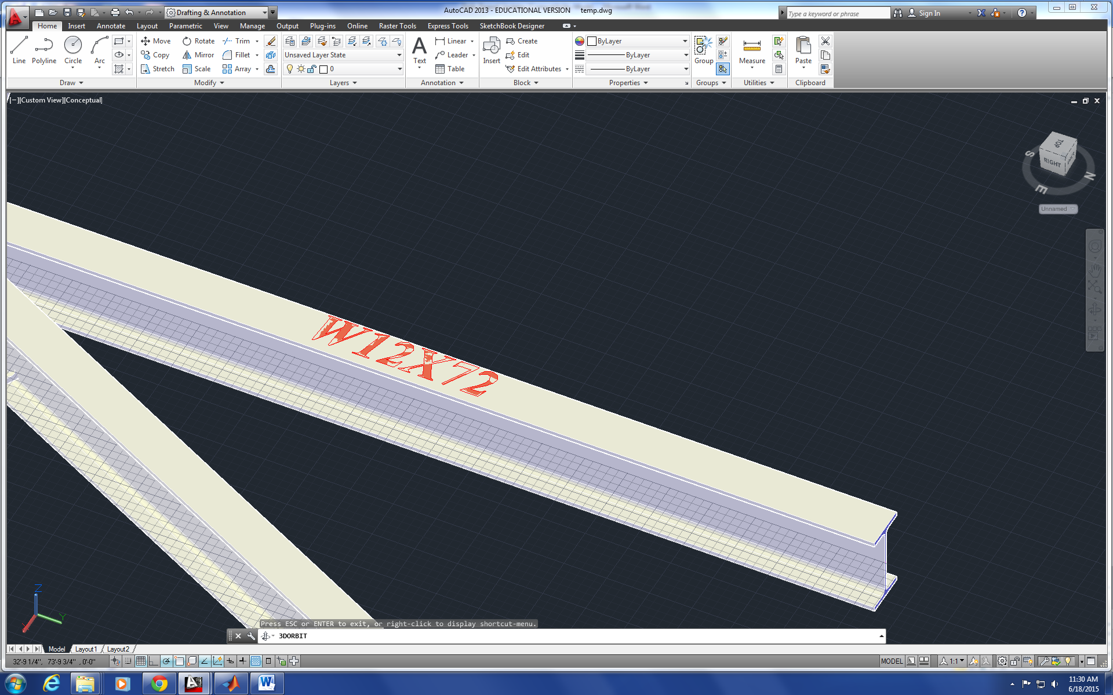Figure 1
Dr. Hulsey suggested during the daily meeting to build simple models of concrete slab floors that are 1) noncomposite 2) composite 3) partially composite in SAP2000 and ABAQUS separately and compare the numerical results of the two.

Analysis of the Cause of Collapse of World Trade Center 7
Progression of the Project Daily Report

Date: 06/18/2015 Working Hours: 8
Submitted by Zhili Quan
Today, more research on AutoCAD in 3D, and especially the structure assembling part. Some tentative 3D drawing on the 12th floor was done.
The drawing Looks good but the there is some more work needed to model the connections. Study on Solidworks will be done to see if AutoCAD 3D can be transferred into Solidworks exactly and vice versa.
Also, there is some doubts on some of the members on the building on the blueprints. Some of these members don't look like they even belong to the AISC manual. The numbers of the members are fractional numbers rather than integers. The following figure shows the some of the confusing member sizes. 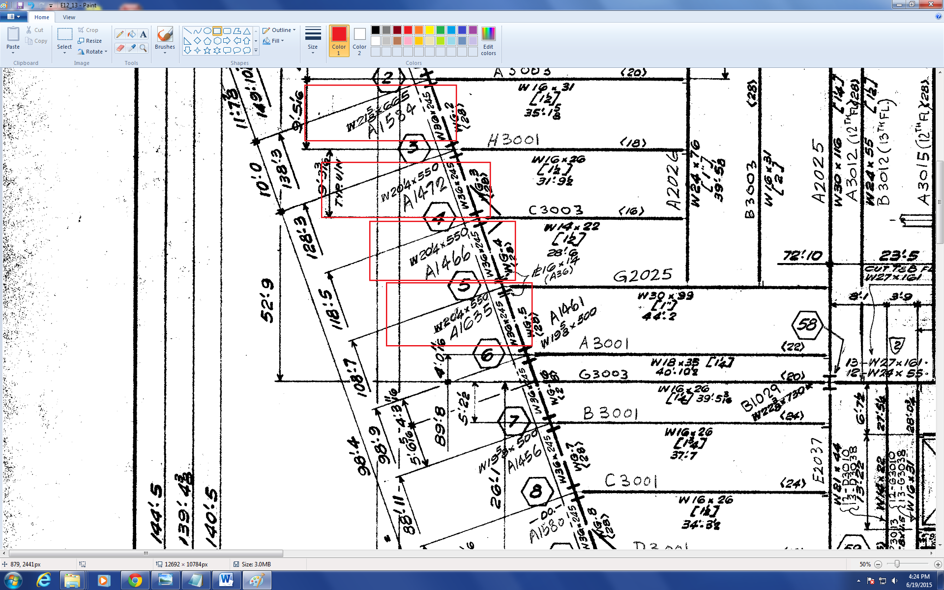
Figure 1
Apparently, that is something that has to be figured out and some research and literature review work have to be conducted.
Dr. Hulsey suggested a small demonstration on non/partial/composite concrete slab floor analysis should be underway soon to get the future work ready.

Analysis of the Cause of Collapse of World Trade Center 7
Progression of the Project Daily Report

Date: 06/19/2015 Working Hours: 8
Submitted by Zhili Quan
Today, the tentative drawing of the 12th&13th floors of WTC7 by AutoCAD in 3D with extruded members is finished. All the members are labelled with the corresponding sizes.
Figure 1 shows the finished work on the 12th&13th floors.
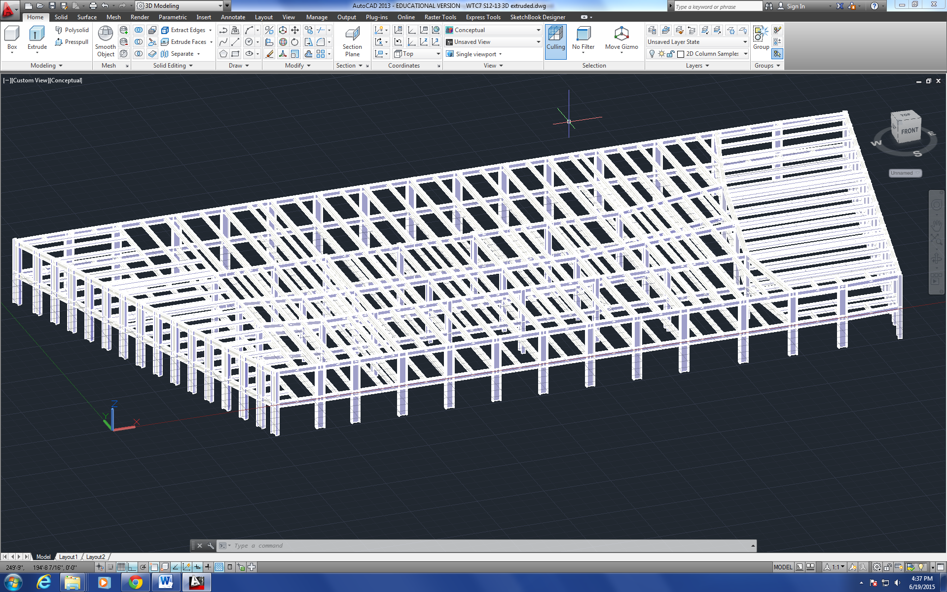
Figure 1
Some research on the compatibility and convertibility between AutoCAD and Solidworks was done and it turns out that they are perfectly convertible even in 3D scenarios.

Analysis of the Cause of Collapse of World Trade Center 7
Progression of the Project Daily Report

Date: 06/22/2015 Working Hours: 8
Submitted by Zhili Quan
Today, literature review was done on Steel Design and Reinforced Concrete. Dr. Hulsey has suggested that before analyzing the entire building, at least one simple cases of concrete slab with steel beam underneath should be analyzed. The structure should be analyzed as non-composite/composite and partially composite.
Also, the camera crew has arrived and helped set up the camera so daily video report can be recorded. Research student Zhili Quan and Feng Xiao and Dr. Leroy Hulsey made a test video report all together during the daily meeting with the help of the camera crew after everything about the camera was explained.

Analysis of the Cause of Collapse of World Trade Center 7
Progression of the Project Daily Report

Date: 06/23/2015 Working Hours: 8
Submitted by Zhili Quan
Today, more literature review was done on Steel Design and Reinforced Concrete. A very simple study of concrete slab with Wide flange beam underneath was studied and put into analysis. The tentative choice for the beam is W12X72 and the concrete slab is chosen with 5.5” thickness, 10’ width and 12’ span.
Research assistant Zhili Quan did the non-composite case on the study and wrote a MATLAB program on it. The following script shows the code:
%Concrete Slab dimensions:
%L: 12ft span floor;
%Wc: weight of concrete 145lbs/ft^3;
%fc: compressive strength @28days, 3500psi;
%be: effective width, 10ft;
%hf: flange height(slab thickness), 5.5inches;
%Ic: second moment of area of the concrete slab, be*hf^3/12;
%WcL: linear weight of concrete, Wc*hf*be(lbs/ft);

L=12*12;Wc=145;fc=3500;be=10*12;hf=5.5;Ic=be*hf^3/12;WcL=Wc*hf/12*be;

%Concrete Properties:
%Ec: concrete young's modulus(psi);
Ec=33*Wc^1.5*(fc)^0.5;

%W Beam dimensions:
%L: 12ft span floor;
%tw: thickness of the web, 0.43in;
%tf: thickness of the flange, 0.67in;
%bf: width of the flange, 12.04inches;
%d: height of the beam, 12.25inches;
%Ws: weight of the beam, 72lbs/ft;
%As: area of the beam,
%Ixx: major second moment of area of the beam, 597inches^4;
%Iyy: minor second moment of area of the beam, 195inches^4;
tw=0.43;tf=0.67;bf=12.04;d=12.25;Ws=72;Ixx=597;Iyy=195;

%Steel Properties:
%Ec: concrete young's modulus(psi);n: young's modulus ratio;
Es=29000000;n=Es/Ec;

%integrate beam equations 4 times, q is net linear weight(psi/ft);
syms q x c1 c2 c3 c4;
Eq1=q*x^4/24+c1*x^3/6+c2*x^2/2+c3*x+c4;
Eq2=q*x^3/6+c1*x^2/2+c2*x+c3;
Eq3=q*x^2/2+c1*x+c2;
Eq4=q*x+c1;
%All Eqs are multiplied by EI;
%z=Eq1;theta=Eq2;M=Eq3;V=Eq4;

%Simply supported

%1. Non-composite
%analysis of concrete:
%B.C.
%z(0)=0;
x=0;q=WcL;eq1=eval(Eq1);
%z(L)=0;
x=L;q=WcL;eq2=eval(Eq1);
%M(0)=0;
x=0;q=WcL;eq3=eval(Eq3);
%M(L)=0;
x=L;q=WcL;eq4=eval(Eq3);
c=solve([eq1==0,eq2==0,eq3==0,eq4==0],c1,c2,c3,c4);
%zc: deformation of concrete slab;
x=0:L/100:L;q=WcL;
zc=(q*x.^4/24+eval(c.c1)*x.^3/6+eval(c.c2)*x.^2/2+eval(c.c3)*x+eval(c.c4))/Ec/Ic;

%analysis of W beam:
%B.C.
%z(0)=0;
x=0;q=WcL+Ws;eq1=eval(Eq1);
%z(L)=0;
x=L;q=WcL+Ws;eq2=eval(Eq1);
%M(0)=0;
x=0;q=WcL+Ws;eq3=eval(Eq3);
%M(L)=0;
x=L;q=WcL+Ws;eq4=eval(Eq3);
c=solve([eq1==0,eq2==0,eq3==0,eq4==0],c1,c2,c3,c4);
%zs: deformation of W beam;
x=0:L/100:L;q=WcL+Ws;
zs=(q*x.^4/24+eval(c.c1)*x.^3/6+eval(c.c2)*x.^2/2+eval(c.c3)*x+eval(c.c4))/Es/Ixx;

%2. Composite
%analysis of the structure(concrete as a linear material):

%analysis of the structure(use whitney block):

%3. Partially Composite

%Fixed at both ends

More code is expected to be written on other cases for the study.
However, some technical problems were encountered while trying to analyze the composite case. During the daily meeting with Dr. Hulsey, the problems were solved and the direction on the case has been decided. He also thinks it is going to be better if a specific concrete slab and steel beam structure of the WTC7 building is chosen and analyzed.
Dr. Hulsey also suggested there will be no video recording until the noise problem while recording is solved.

Analysis of the Cause of Collapse of World Trade Center 7
Progression of the Project Daily Report

Date: 06/24/2015 Working Hours: 8
Submitted by Zhili Quan
Today, the MATLAB code to calculate the simple case of non/composite steel beam with concrete slab was finished. The code is given below:
%Concrete Slab dimensions:
%L: 52'9" span floor;
%Wc: weight of concrete 145lbs/ft^3;
%fc: compressive strength @28days, 3500psi;
%be: effective width, 9'6.25"ft;
%hf: flange height(slab thickness), 5.5inches;
%Ic: second moment of area of the concrete slab, be*hf^3/12;
%WcL: linear weight of concrete, Wc*hf*be(lbs/ft);

L=52*12+9;Wc=145;fc=3500;be=9*12+6.25;hf=5.5;Ic=be*hf^3/12;WcL=Wc*hf/12*be/12/12;

%Concrete Properties:
%Ec: concrete young's modulus(psi);
Ec=33*Wc^1.5*(fc)^0.5;

%W Beam dimensions:
%L: 52'9" span floor;
%tw: thickness of the web, 0.43in;
%tf: thickness of the flange, 0.67in;
%bf: width of the flange, 12.04inches;
%d: height of the beam, 12.25inches;
%Ws: weight of the beam, 72lbs/ft;
%As: area of the beam,
%Ixx: major second moment of area of the beam, 597inches^4;
%Iyy: minor second moment of area of the beam, 195inches^4;
tw=0.395;tf=0.505;bf=7.005;d=23.57;Ws=55/12;Ixx=1350;Iyy=29.1;As=16.2;

%Steel Properties:
%Ec: concrete young's modulus(psi);n: young's modulus ratio;
Es=29000000;n=Es/Ec;

%integrate beam equations 4 times, q is net linear weight(psi/ft);
syms q x c1 c2 c3 c4;
Eq1=q*x^4/24+c1*x^3/6+c2*x^2/2+c3*x+c4;
Eq2=q*x^3/6+c1*x^2/2+c2*x+c3;
Eq3=q*x^2/2+c1*x+c2;
Eq4=q*x+c1;
%All Eqs are multiplied by EI;
%z=Eq1;theta=Eq2;M=Eq3;V=Eq4;

%Assume Adequate Bracing and Linear-elastic material before yield
%strength!!!

%Simply supported

%1. Non-composite
%analysis of concrete:
%B.C.
%z(0)=0;
x=0;q=WcL;eq1=eval(Eq1);
%z(L)=0;
x=L;q=WcL;eq2=eval(Eq1);
%M(0)=0;
x=0;q=WcL;eq3=eval(Eq3);
%M(L)=0;
x=L;q=WcL;eq4=eval(Eq3);
c=solve([eq1==0,eq2==0,eq3==0,eq4==0],c1,c2,c3,c4);
%zc: deformation of concrete slab;
x=0:L/100:L;q=WcL;
zc=(q*x.^4/24+eval(c.c1)*x.^3/6+eval(c.c2)*x.^2/2+eval(c.c3)*x+eval(c.c4))/Ec/Ic;

%analysis of W beam:
%B.C.
%z(0)=0;
x=0;q=WcL+Ws;eq1=eval(Eq1);
%z(L)=0;
x=L;q=WcL+Ws;eq2=eval(Eq1);
%M(0)=0;
x=0;q=WcL+Ws;eq3=eval(Eq3);
%M(L)=0;
x=L;q=WcL+Ws;eq4=eval(Eq3);
c=solve([eq1==0,eq2==0,eq3==0,eq4==0],c1,c2,c3,c4);
%zs: deformation of W beam;
x=0:L/100:L;q=WcL+Ws;
zs=(q*x.^4/24+eval(c.c1)*x.^3/6+eval(c.c2)*x.^2/2+eval(c.c3)*x+eval(c.c4))/Es/Ixx;
S=Ixx/(d/2);

%2. Composite(transforming structure into a fictious homogeneous structure)
%analysis of the structure(concrete as a linear material):
%find centroid of the structure from the bottom the W beam(NC is distance from bottom to neutral axis)
NC=(tf/2*bf*tf+tw*(d-2*tf)*d/2+tf*bf*(d-tf/2)+hf*be/n*(d+hf/2))/(As+hf*be/n);
%fine second moment of area of the transformed section with respect to the
%centroid(It)
Itp=(tf/2)^2*bf*tf+tw*(d-2*tf)*(d/2)^2+tf*bf*(d-tf/2)^2+hf*be/n*(d+hf/2)^2;
It=Itp-(As+hf*be/n)*NC^2;
%B.C.
%z(0)=0;
x=0;q=WcL+Ws;eq1=eval(Eq1);
%z(L)=0;
x=L;q=WcL+Ws;eq2=eval(Eq1);
%M(0)=0;
x=0;q=WcL+Ws;eq3=eval(Eq3);
%M(L)=0;
x=L;q=WcL+Ws;eq4=eval(Eq3);
c=solve([eq1==0,eq2==0,eq3==0,eq4==0],c1,c2,c3,c4);
%zt: deformation of the composite structure;
x=0:L/100:L;q=WcL+Ws;
zt=(q*x.^4/24+eval(c.c1)*x.^3/6+eval(c.c2)*x.^2/2+eval(c.c3)*x+eval(c.c4))/Es/It;
St=It/(d+hf-NC);
Sb=It/NC;

%3. Partially Composite

%Fixed at both ends

The code also covers how to analyze simply supported steel beam with concrete slab on top, composite and non-composite situations. Other boundary conditions are to be studied in the future.
The case was chosen specifically on a girder from the 12th floor framing of WTC7. The girder is show in Figure 1.
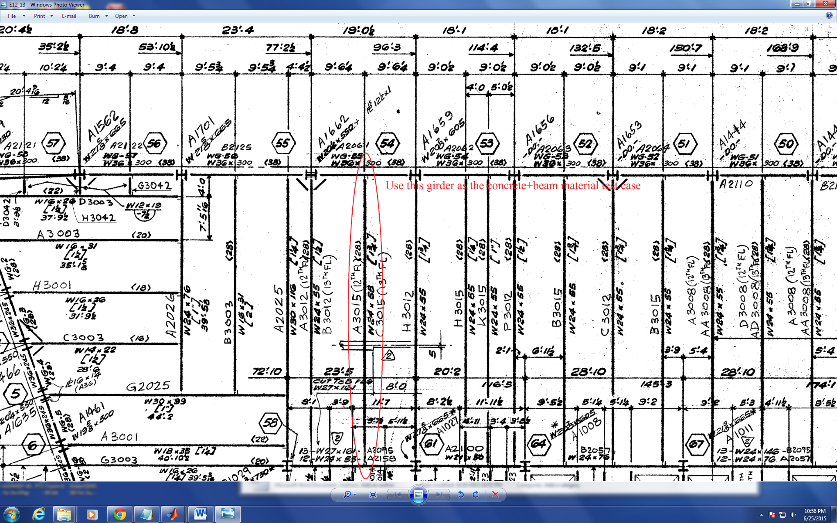
Figure 1

Analysis of the Cause of Collapse of World Trade Center 7
Progression of the Project Daily Report

Date: 06/25/2015 Working Hours: 8
Submitted by Zhili Quan
Today, research assistant Zhili Quan did study on the composite beam section in AISC Manual after Dr. Hulsey’s suggestion to check the exact numerical value for elastic moment inertia of the chosen case’s composite steel beam stud-welded with concrete slab with the value given in AISC Manual. The value calculated was 3837 in⁴ and the largest value in the manual for the same structure is 3770 in⁴ which is for the lower-bound elastic moment of inertia. The difference is less than 2%. Also, some literature review on how to model composite steel beam with concrete slab on SAP2000 was done.
Figure 1 shows the plan view of the simple case of steel beam with concrete slab. The dimensions and properties of the material are all given on the figure.
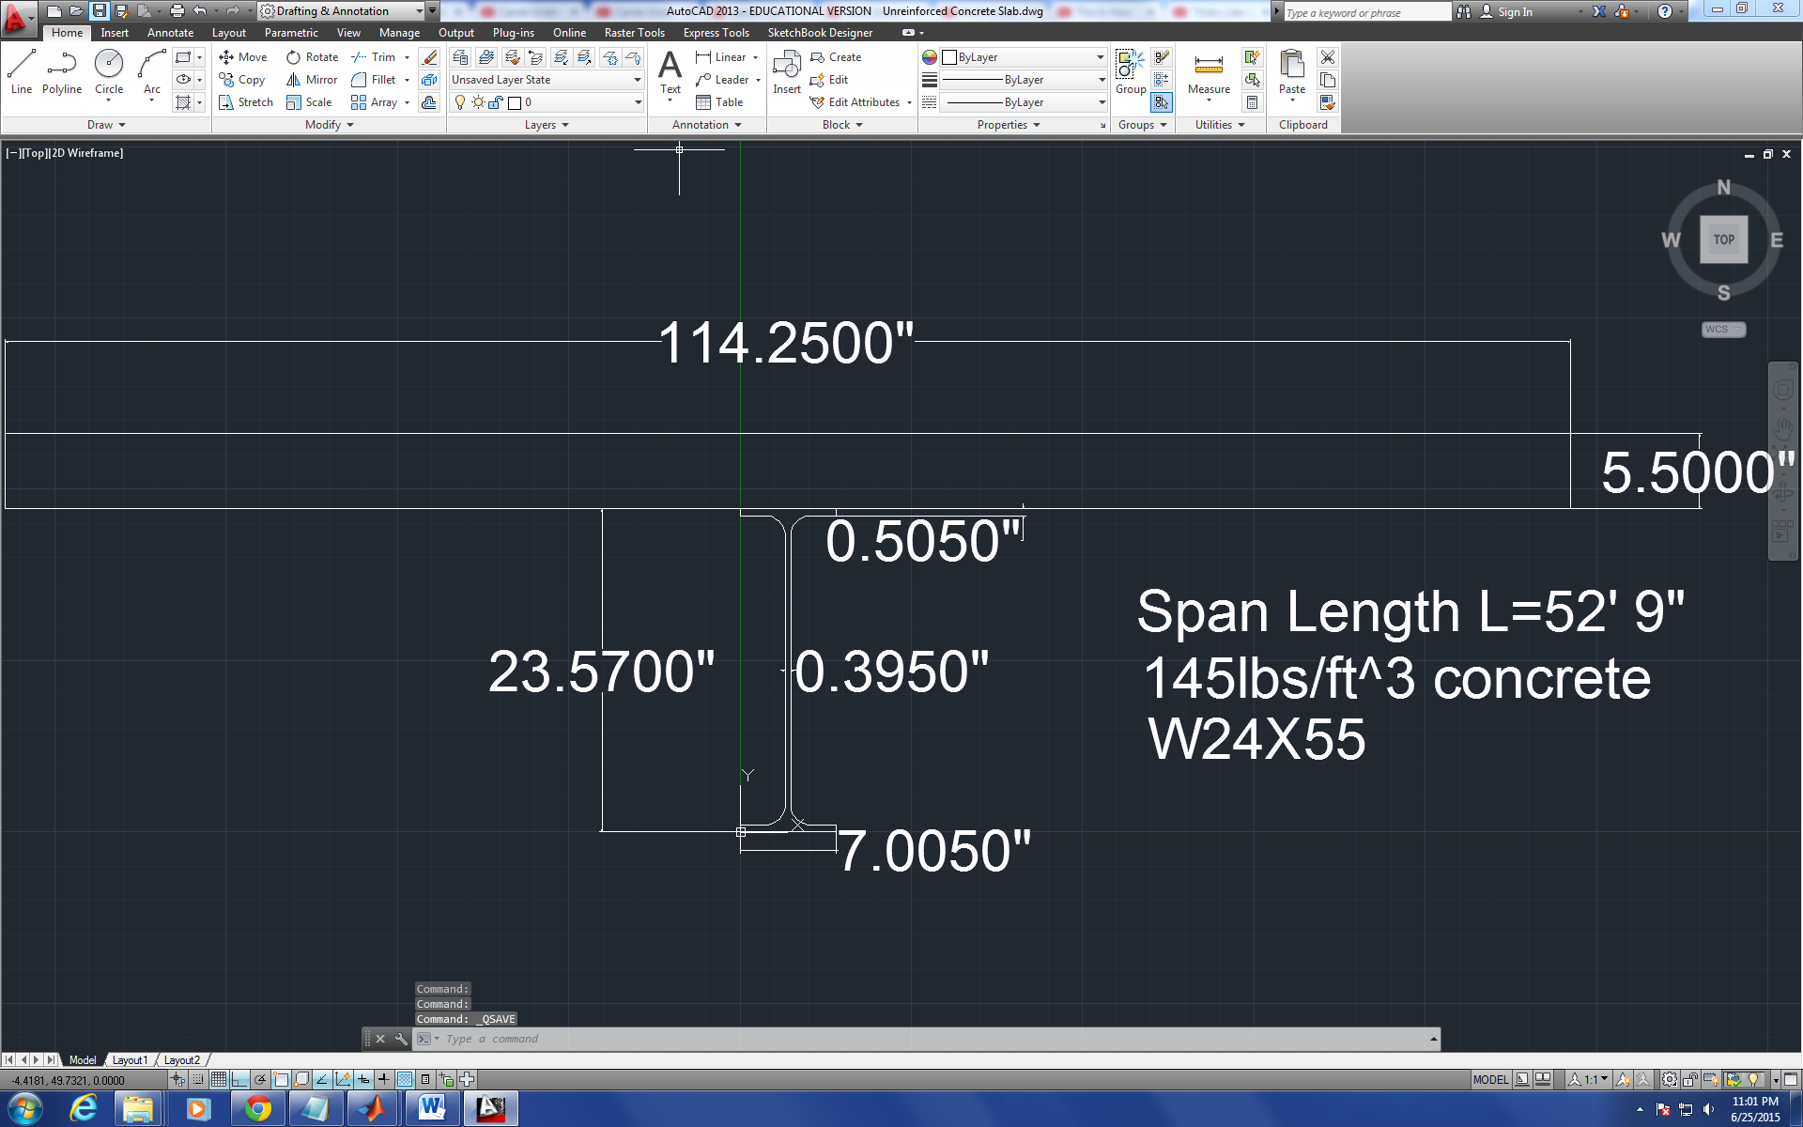
Figure 1

During the daily meeting, Dr. Hulsey suggested to find the correct version of AISC Manual, ANSI and ACI code to find the procedures the engineers followed to design WTC7. Also, check the limit on SAP2000 to see how well it handles massive structure analysis like analysis on WTC7. In addition, there is a need to learn how to calculate geometrical properties of material such as area, location of centroid or second moment of area on Solidworks.

Analysis of the Cause of Collapse of World Trade Center 7
Progression of the Project Daily Report

Date: 06/26/2015 Working Hours: 8
Submitted by Zhili Quan
Today, numerical analysis on the chosen simple case of composite W steel beam with concrete slab was done on SAP2000. 5 different models using 5 different assumptions were made on SAP2000. The 1st one was non-composite W Beam. The 2nd one was using "Seciton Deisigner" feature in SAP2000 to design a composite steel beam with concrete slab on top but a random located centroid for the composite structure. The 3rd one was with the right location of the centroid of the composite beam. The 4th one was building the transformed section and using that as the fictitious beam under loading. The 5th one was to use "link" elements to connect the concrete slab and the W beam as they were rigidly connected. The results were compared with the hand-calculation results done by MATLAB. The results turned out to be very close. However, there is still some debate left about which way is the fittest method.
Figure 1 shows the dimensions and properties of the composite, including the spanning length.
Figure 1
Figure 2 shows the 5 SAP2000 models, both the nominal shapes of the beams and the deflections.

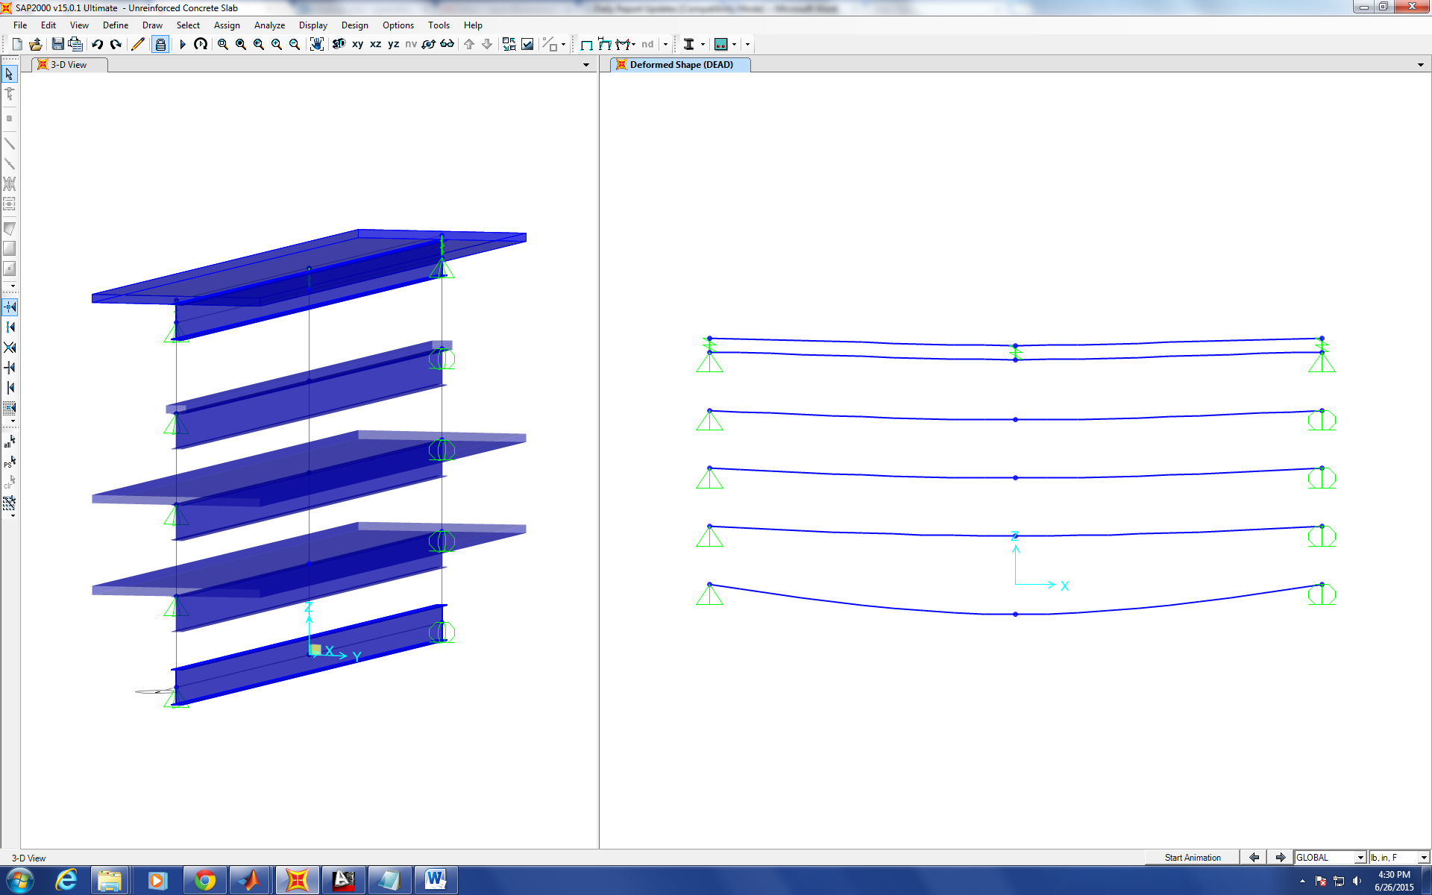
Figure 2

Analysis of the Cause of Collapse of World Trade Center 7
Progression of the Project Daily Report

Date: 06/29/2015 Working Hours: 8
Submitted by Zhili Quan
More research work on Solidworks was done. Comparison of the results between hand calculation and SAP2000 on the chosen simple case of composite and non-composite beams was listed in Table 1.
Table 1
Hand Calculation | Deflection | I (Equivalent Second Moment of area)
Non-composite Beam | 3.0603 inches | 1350 inch⁴
Composite Beam | 1.0766 inches | 3837 inch⁴
SAP2000 | Deflection | I (Equivalent Second Moment of Area)
Non-composite Beam | 3.0879 inches | 1350 inch⁴
Composite Beam (Concrete Slab+W-beam) | 0.9845 inch | 4281 inch⁴
Composite Beam (Transformed Section all in Steel) | 0.9845 inch | 4281 inch⁴
Composite Beam (Concrete Slab connected with W-beam with Rigid Links) | 0.752 inch

Plots will be made to compare the results in deflections, moments and strains across the beam.
During the meeting with Dr. Hulsey, it was pointed out that instead using "beam" elements for both the W beam and the concrete slab, "shell" or "solid" elements should be used mixed with "beam" elements. Dr. Hulsey also suggested to email AISC, ACI and ASCE organizations to find out the documents around in the years of 1985 and 1986 when the building was designed. Also, he suggested to email the inventors of SAP2000 what is the limitation on it in terms of modelling a 47-story building with massive amount of slabs, girders, beamsand connections, especially when it comes to using "shell" and "solid" elements.

Analysis of the Cause of Collapse of World Trade Center 7
Progression of the Project Daily Report

Date: 06/30/2015 Working Hours: 8
Submitted by Zhili Quan
Started and almost finished the drawing of the roof framing plan view in AutoCAD.
Figure 1 shows the plan view of the roof framing of WTC7.
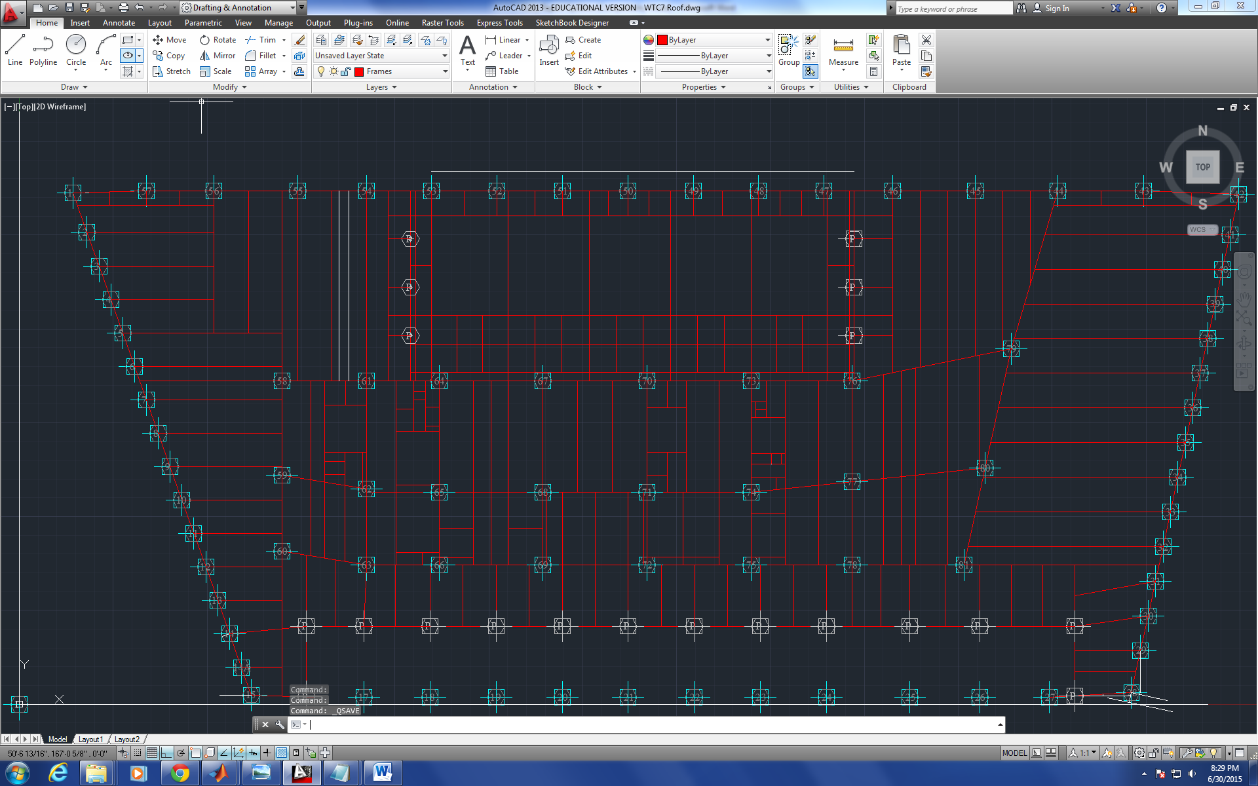
Figure 1
During the meeting with Dr. Hulsey, he thought it would be a good idea to make a spreadsheet of
all the built-up columns, including all their geometric properties such as area, second moment of area in major and minor axes. He also suggested to use SAP2000 the "flab slab" elements to model composite beams. In addition, he wanted to find out who should we contact to purchase the nonlinear analysis package on Soliworks.

Analysis of the Cause of Collapse of World Trade Center 7
Progression of the Project Daily Report

Date: 07/01/2015 Working Hours: 8
Submitted by Zhili Quan

Today, the roof framing plan view was finished on AutoCAD. That was the last drawing of all the floors of the building. So far, all the major 2D drawings have been finished.
Figure 1 shows the finished plan view of the roof framing of WTC7.
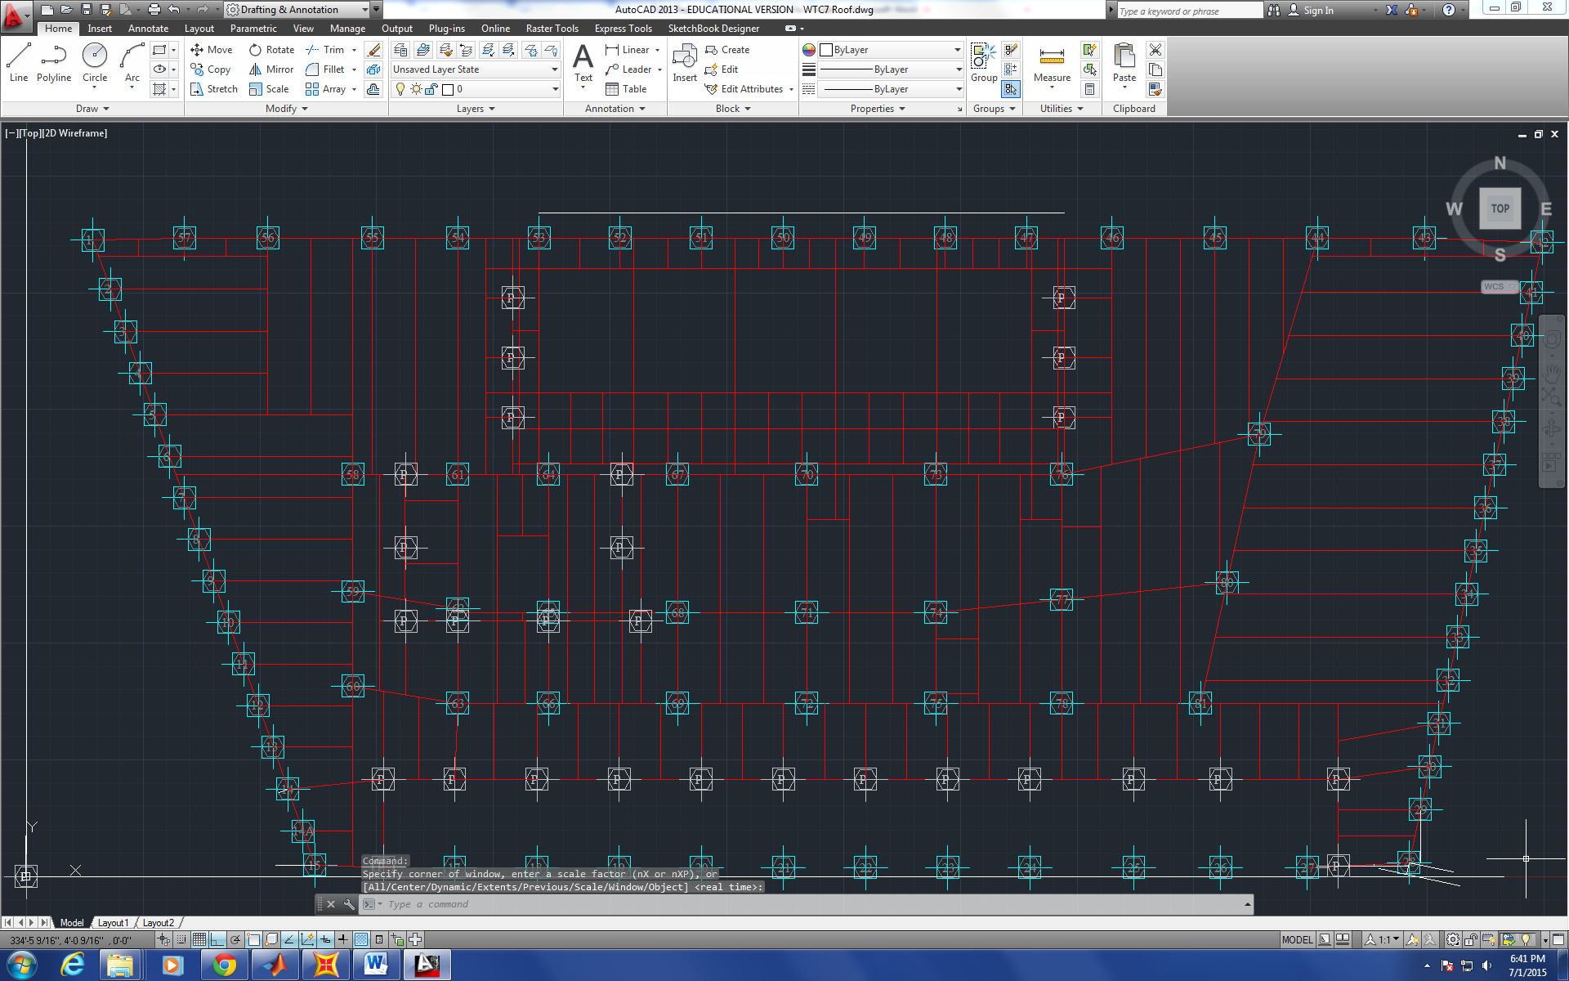
Figure 1
Dr. Hulsey brought in a video camera to record the daily conference. The result turned out to be very good. He also layed out a couple things to be done, including make a list of all the members of WTC7 and keep working on the test case of a simple composite beam and try to add another steel beam and make the concrete slab wide to making the composite beam continuous. Then check the results between SAP2000 and Abaqus. Also, emails have been sent to ACI, ANSI, ASCI to ask for the available codes or standards around the year of 1985, and another email has been sent to CSIAMERICA to check the limitation on SAP2000 V15 in terms of analyzing an over 40-story building with the dimension about300ft by 150ft, and using "shell" and "solid" elements connected with "beam" elements.

Analysis of the Cause of Collapse of World Trade Center 7
Progression of the Project Daily Report

Date: 07/02/2015 Working Hours: 8
Submitted by Zhili Quan

Today, some research has been done on SAP2000, including the use of links, meshing objects, putting special joints on objects (1, 2&3D elements) and the use of “shell” elements.
A very simple case of the composite beam with concrete slab and W-beam was done on SAP2000 V15 with “shell” element representing the concrete slab and “beam” element representing the W-beam. The two elements were connected by rigid links at both ends. Figure 1 shows the model.
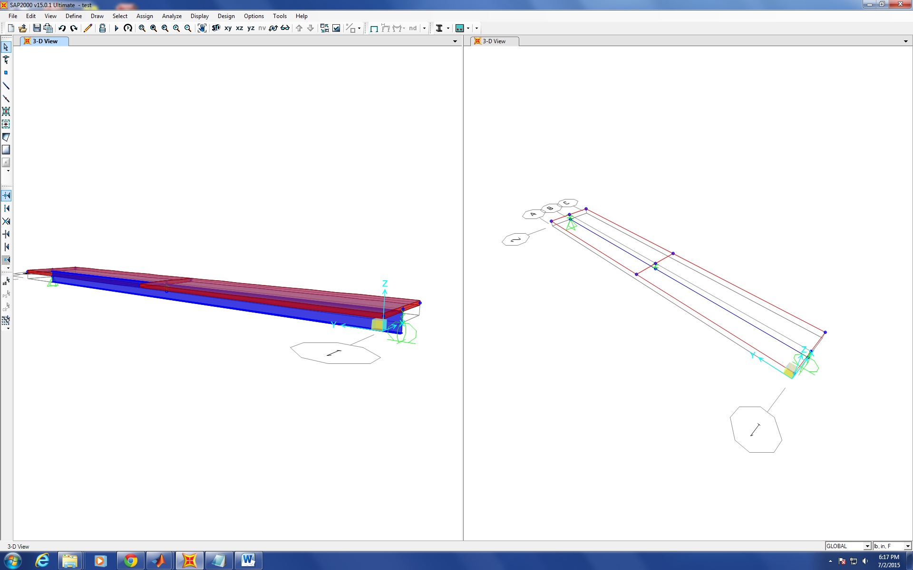
Figure 1
There’s still a lot work needed to do to modify and complete the model. There has to be at least another link in the middle of the composite connecting the slab and the beam. In addition, “mesh” feature needs to be used on the two elements and see how they can be connected after meshing.
Analysis of the Cause of Collapse of World Trade Center 7
Progression of the Project Daily Report

Date: 07/03/2015 Working Hours: 8
Submitted by Zhili Quan

Today, a tentative model was done on SAP2000. In the case, the model was built for the chosen simple case of composite beam consisting of concrete slab on top and W-beam on bottom. Unlike the previous study, in which both the concrete slab and W-beam were analyzed as "beam" elements, the concrete slab was analyzed as "shell" (“thin” or “thick”) element and the W-beam was analyzed as "beam" element. The concrete slab was meshed into sub-elements and each element was rigidly connected to W-beam underneath with link elements that are fixed in all 6 degrees of freedom. Figure 1 gives the modelling diagram and the deflection diagram under self-weight loading.
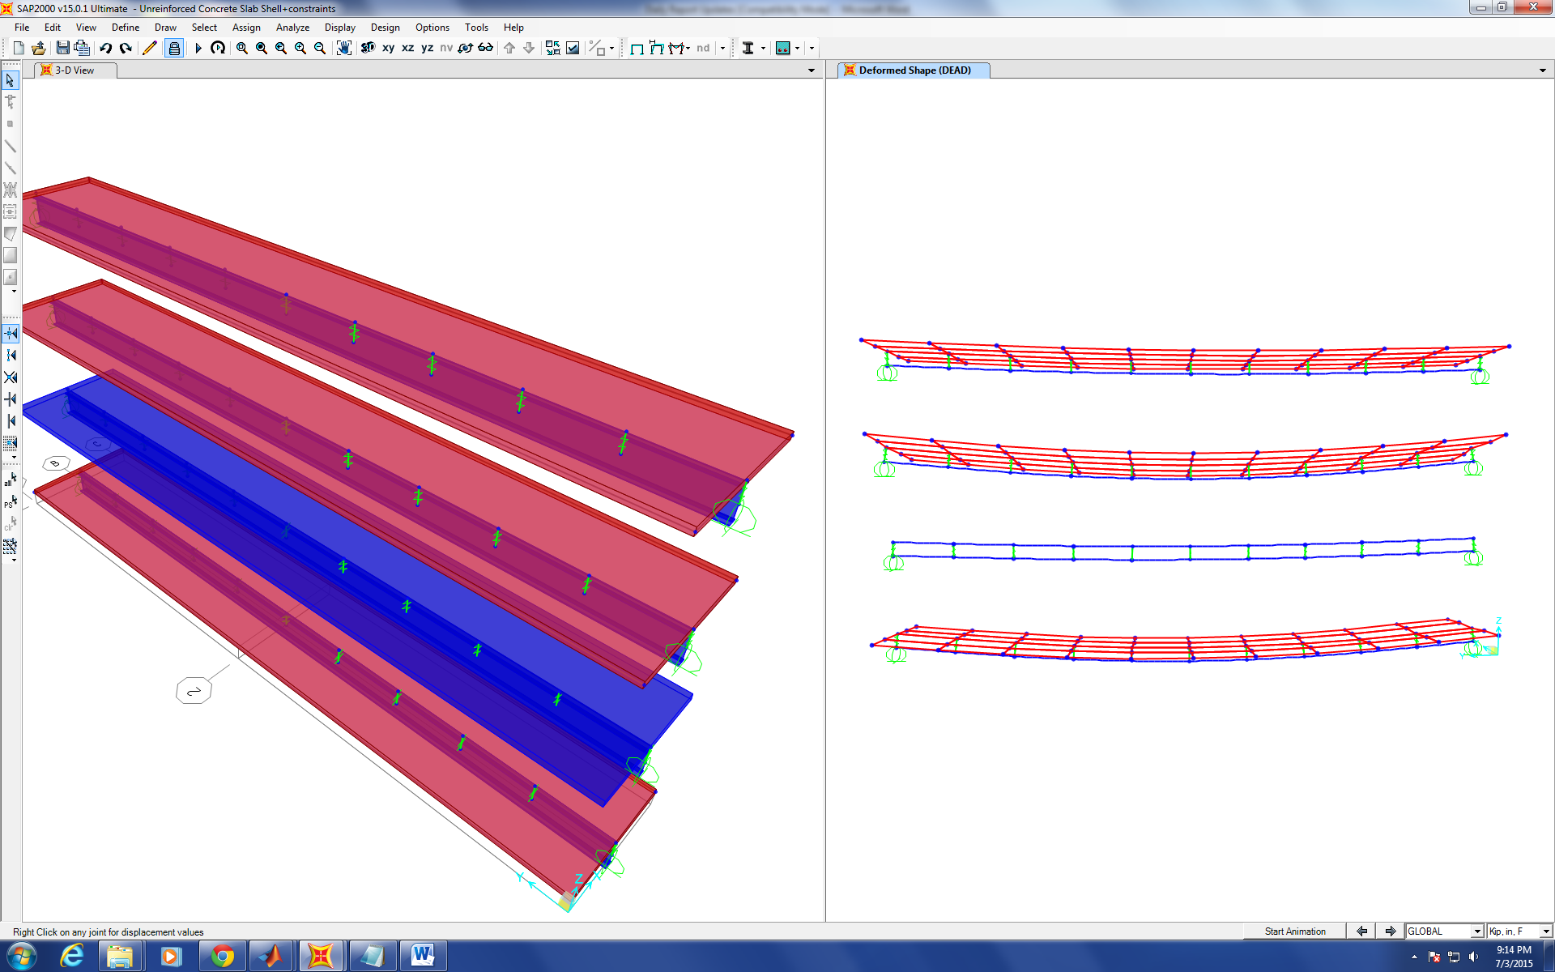
Figure 1
However, the difference between the two different modelling techniques turn out to be very small, less than 1%. Next, model will be built on Solidworks to compare the results. Also, continuous beams will be studied as well.
Analysis of the Cause of Collapse of World Trade Center 7
Progression of the Project Daily Report

Date: 07/06/2015 Working Hours: 8
Submitted by Zhili Quan

Today, a lot of research was done on Solidworks, and some basic modelling was done as well. Apparently, FEA modelling is very complicated when it comes to setting up the most appropriate boundary conditions that represent the real physical situations. The following figures show a very simple beam design that represents a simply supported beam under uniform loading.

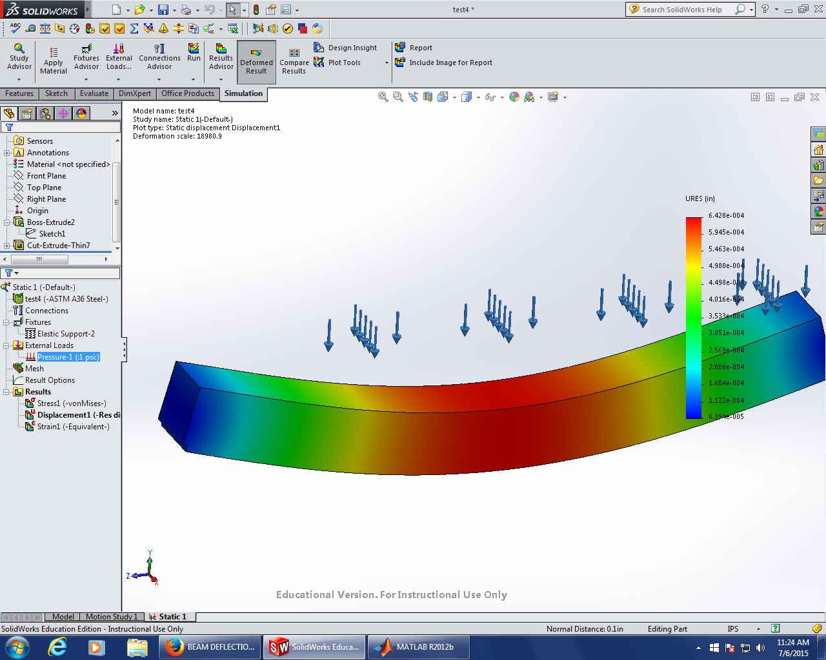
Figure 1
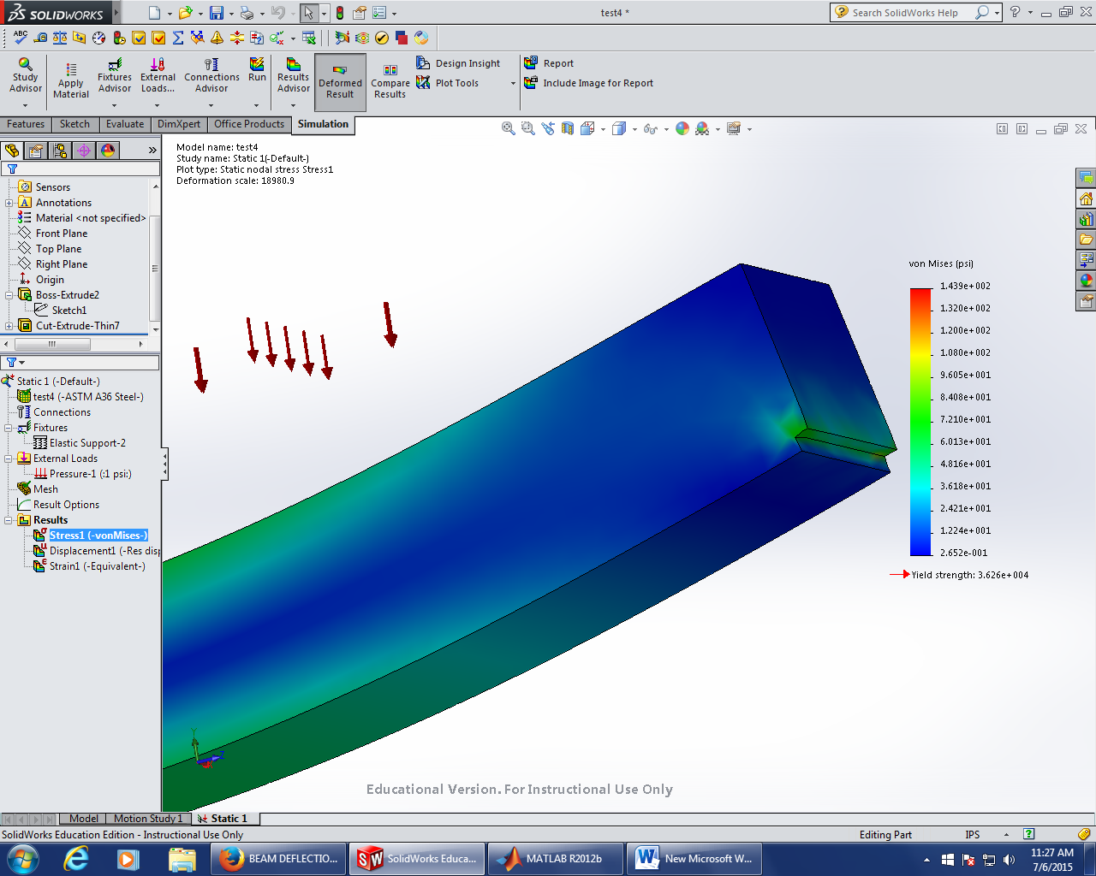
Figure 2
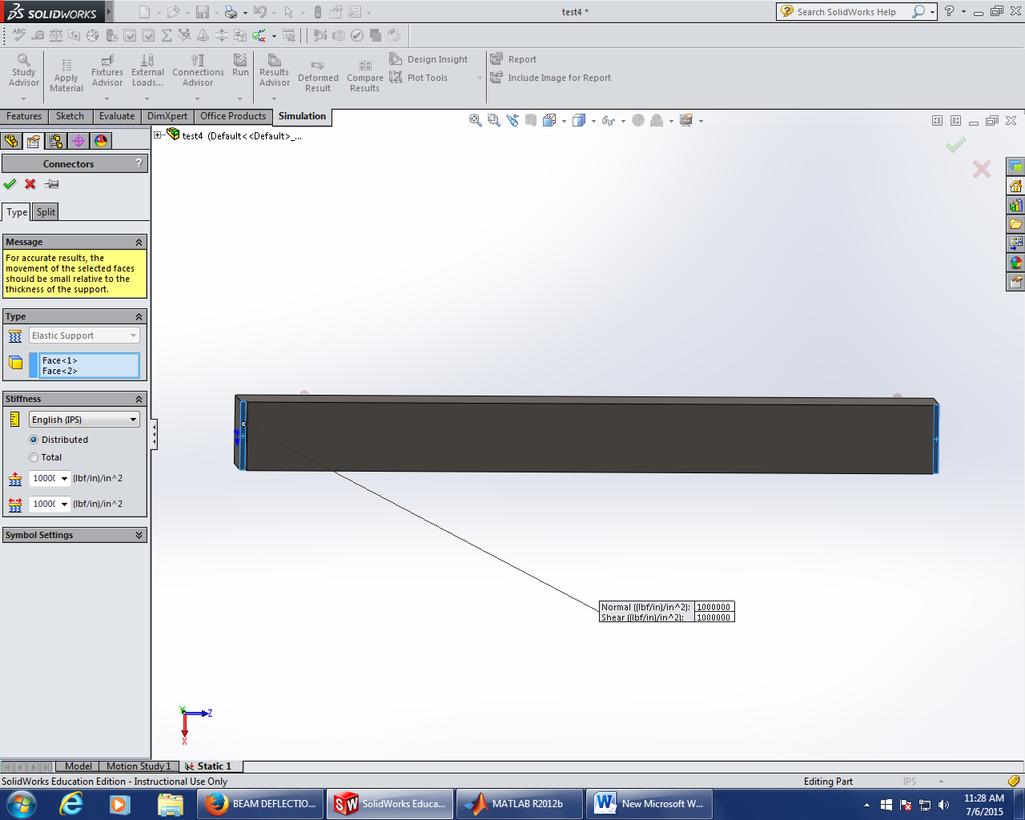
Figure 3
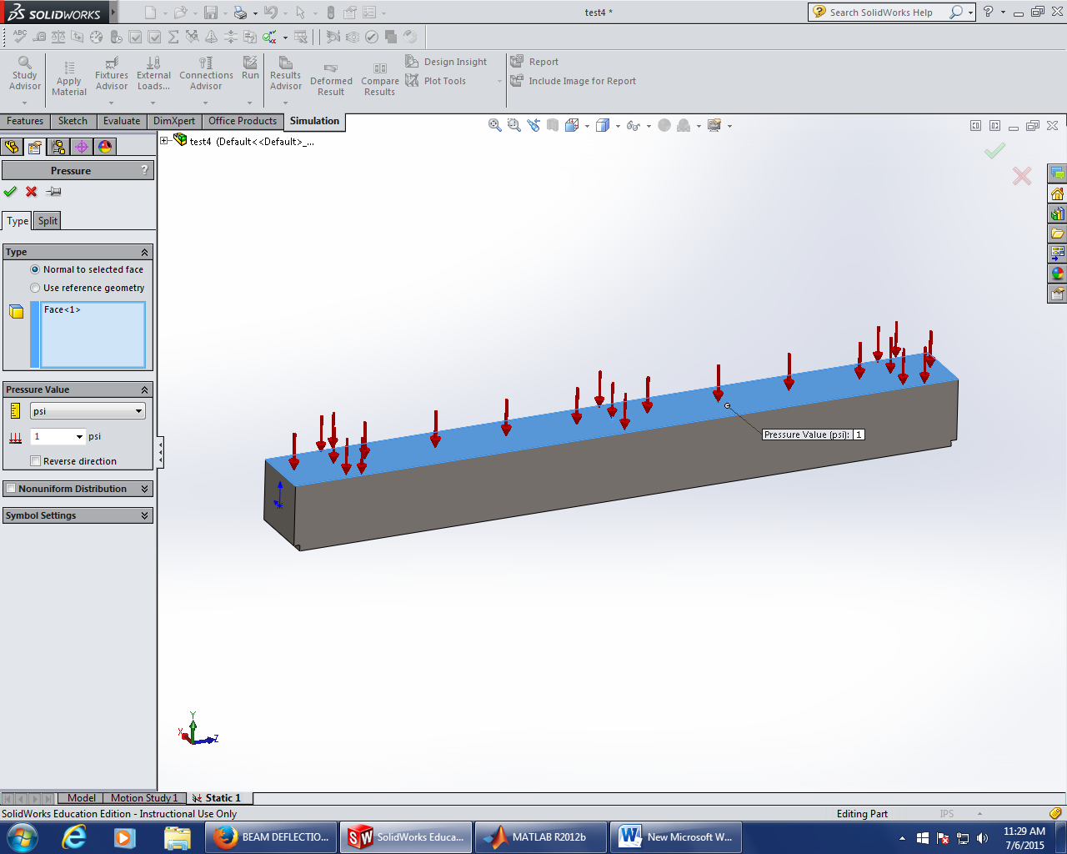
Figure 4

Analysis of the Cause of Collapse of World Trade Center 7
Progression of the Project Daily Report

Date: 07/07/2015 Working Hours: 8
Submitted by Zhili Quan

Today, a lot of modeling on Solidworks was done. A lot about FEA(Finite Element Analysis) on Solidworks was discovered. Apparently, for FEA, setting up the correct boundary condition is of the most importance and especially for structural analysis.
The following figures show the modeling of a W24X55 beam, including the meshing, the results with different boundary conditions and the time it usually took to run a assembled analysis.
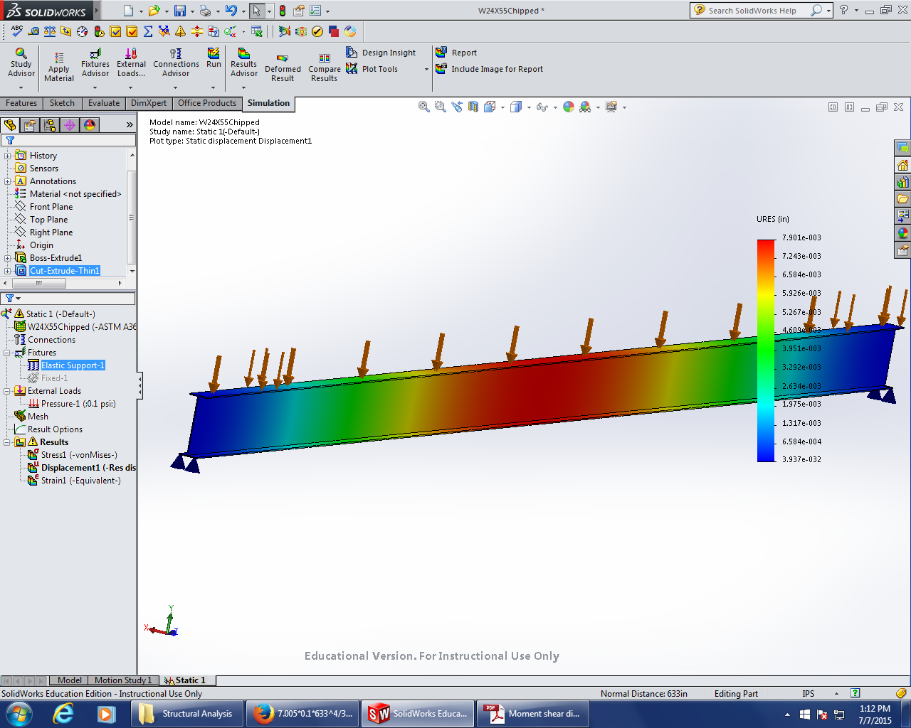
Figure 1
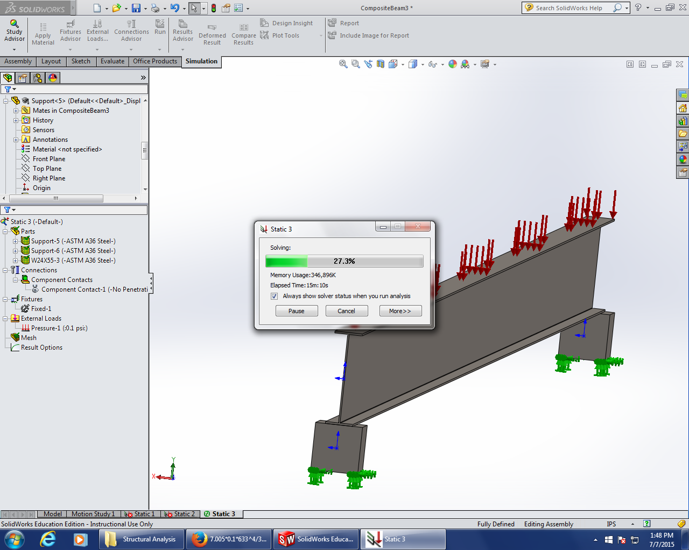
Figure 2
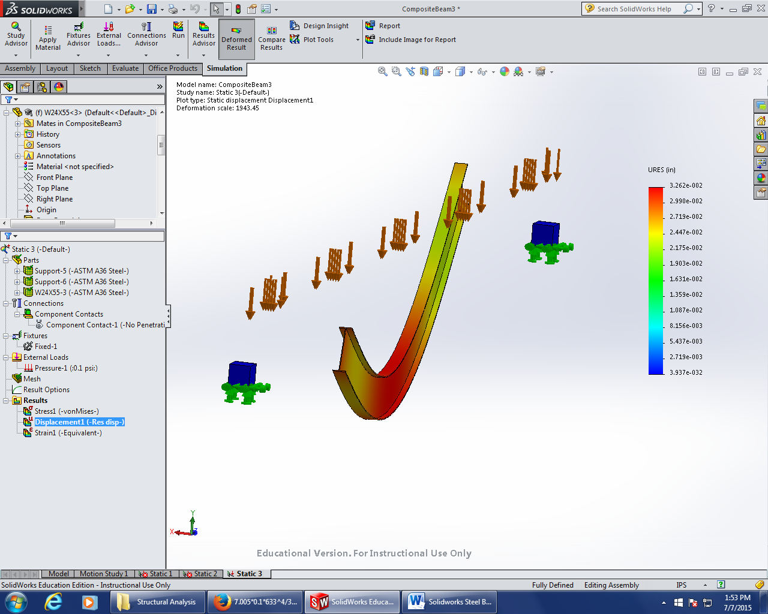
Figure 3
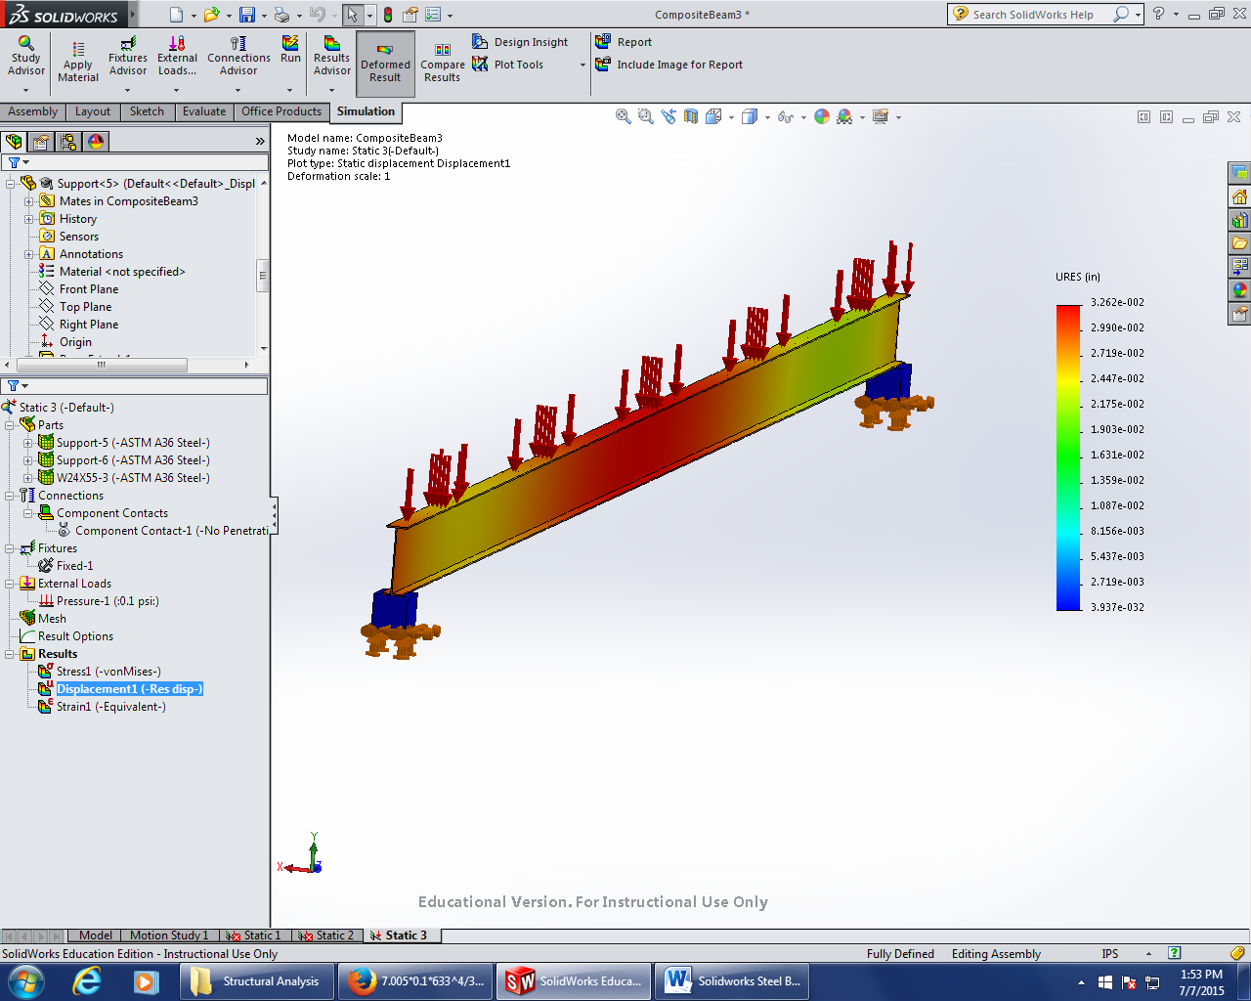
Figure 4
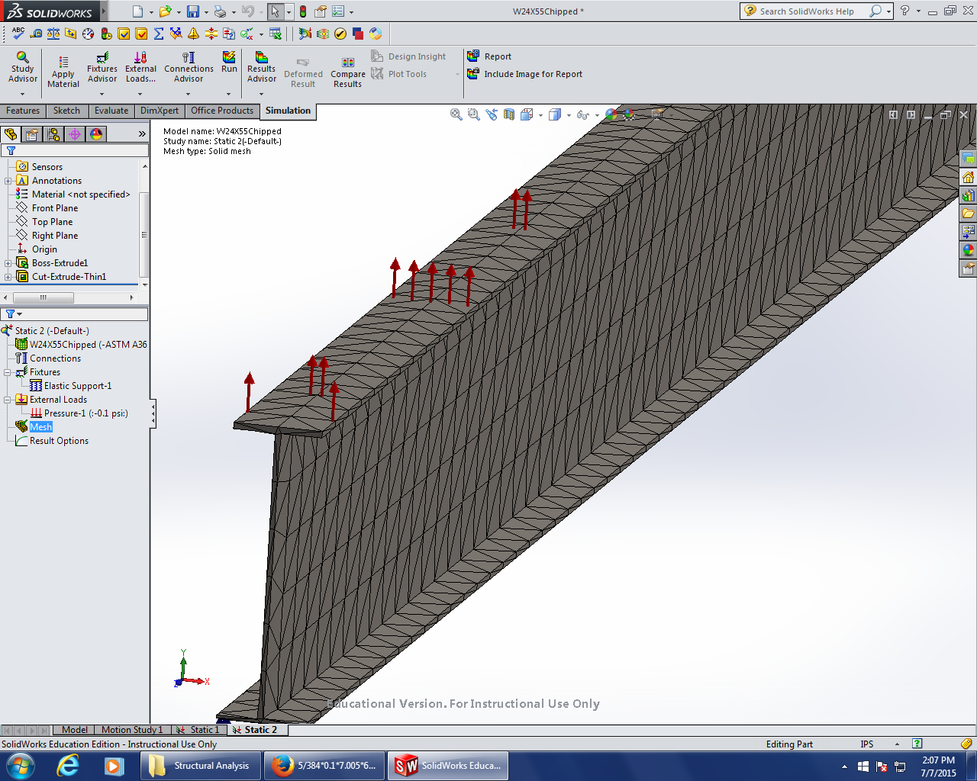
Figure 5

Analysis of the Cause of Collapse of World Trade Center 7
Progression of the Project Daily Report

Date: 07/08/2015 Working Hours: 8
Submitted by Zhili Quan

Today, a little modelling on Solidworks was done and apparently it is not easy to match the model boundary conditions with physical boundary conditions. There is more work needed to be done to understand how Solidworks does its numerical analysis.
Moreover, did a lot of modelling on SAP2000 on the analysis of composite beams. Put the case into different categories, such as different modelling elements ("beam" elements and "shell" elements), different meshing (from rough to medium to fine) and different composite beam dimensions. The results turned out to be as expected according to the theoretical results by mechanics of material and found certain patterns of convergence from rough meshing to fine meshing. Next step is to find the strain and moment in the elements and to put 12th&13th floors together and isolate them, and to see how they will react under certain loading.
The follow table and figures show today’s work.

Table 1: Coefficient of Composite Beams Analyzed
SAP2000 V15 | (Self-weight Loading)
Concrete Weight 145lbs/ft^3 | Concrete 28day Strength 3500psi | Span Length 633 inches
Concrete Slab Width (in) | Concrete Slab Depth (in) | W24X55 (I(max.)) (in^4)
114.25 | 5.5 | 1350
Composite Beam Response (max. deflection@CL)
ConcreteSlab+W-beam (in) | Transform Pure Steel X-section (in)
0.9845 | 0.9845
"Beam" Element for ConcreteSlab
Results(max. deflection@CL) (in) | Number of Links | Number of Elements
1.3204 | 3 | 1*2=2
1.0593 | 5 | 1*4=4
1.0105 | 7 | 1*6=6
0.9929 | 9 | 1*8=8
0.9843 | 11 | 1*10=10
"Shell" Element for ConcreteSlab
Results(max. deflection@CL) (in) | Number of Links | Number of Elements
1.1532 | 3 | 2*2=4
1.0242 | 5 | 2*4=8
1 | 7 | 2*6=12
0.9912 | 9 | 2*8=16
0.9868 | 11 | 2*10=20
"Shell" Element for ConcreteSlab
Results(max. deflection@CL) (in) | Number of Links | Number of Elements
1.1526 | 3 | 4*2=8
1.0238 | 5 | 4*4=16
0.9998 | 7 | 4*6=24
0.991 | 9 | 4*8=32
0.9866 | 11 | 4*10=40

Figure 1: Response of the Composite Beam vs. Number of Rigid Links for Different Elements

Figure 2 to Figure 4 show the different meshing techniques and different elements used to model the composite beams.
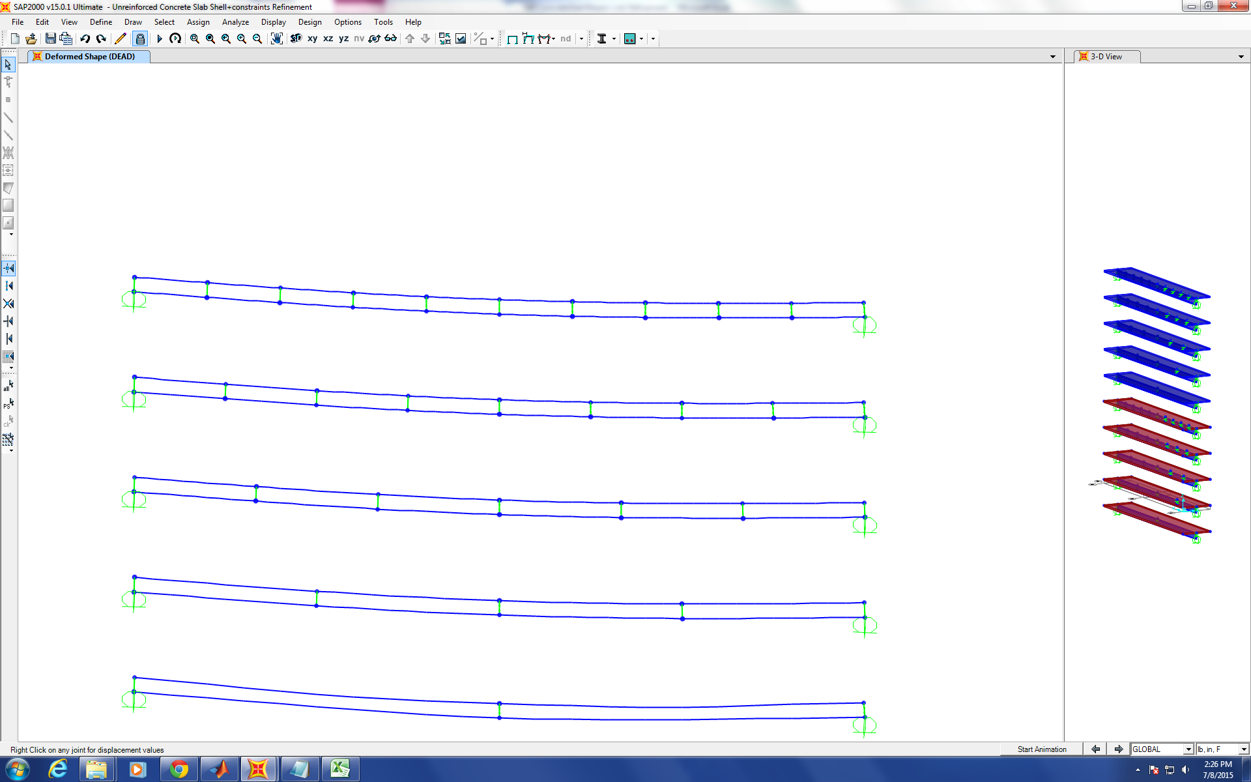
Figure 2
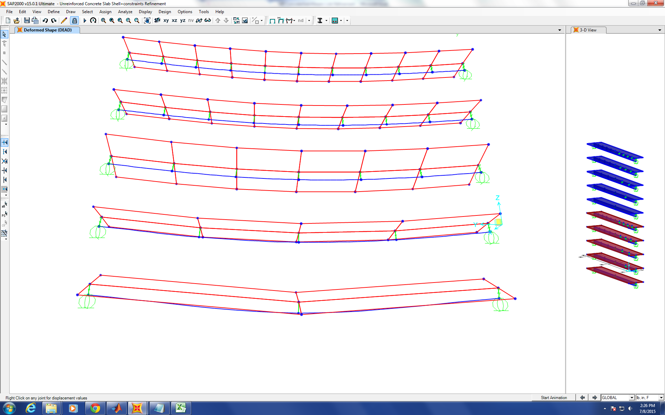
Figure 3
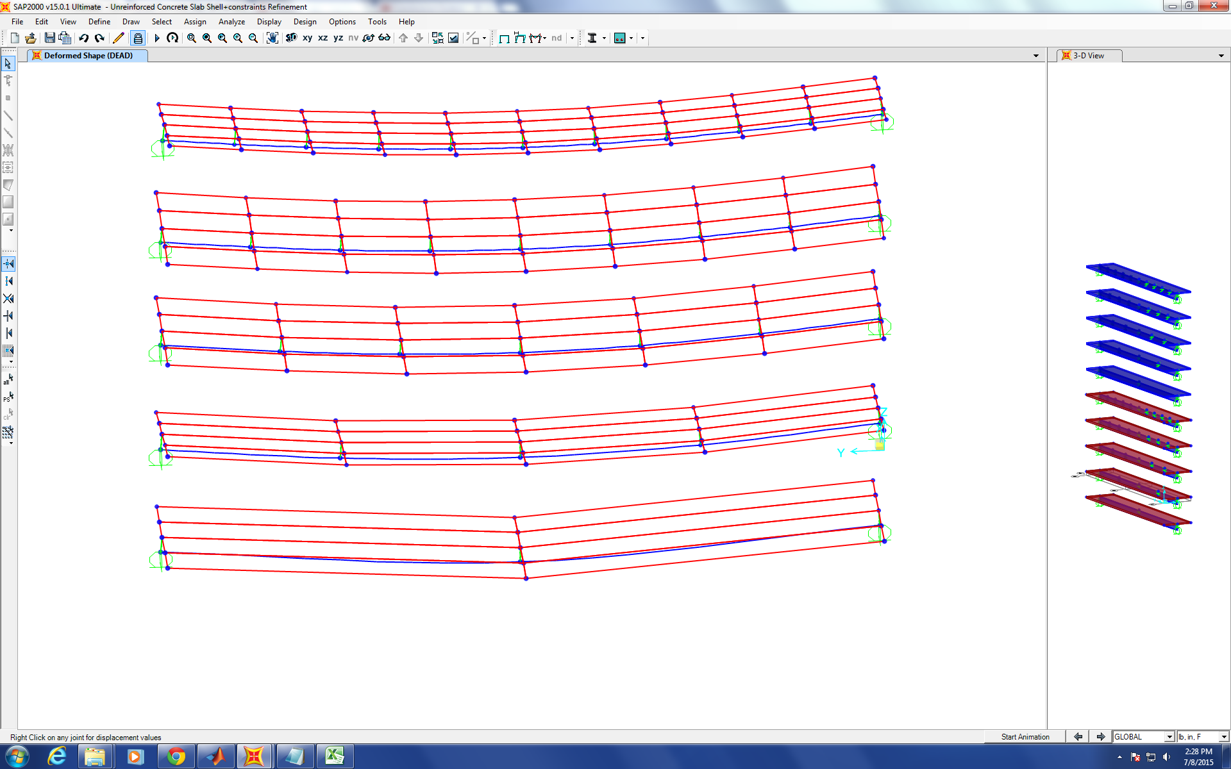
Figure 4

Analysis of the Cause of Collapse of World Trade Center 7
Progression of the Project Daily Report

Date: 07/09/2015 Working Hours: 8
Submitted by Zhili Quan

Today, more modelling on SAP2000 V15 was done. More links between the W-beam and the concrete slab were used to model the behavior of the composite beam. In two different scenarios, rigid links were used in the middle vs. rigid links weren’t used in the middle, the results were very different. Apparently, with a link at the middle point connecting a W-beam and a concrete slab, the results converge way faster and the results are more accurate.
The following figure shows the model analyzed on SAP2000.

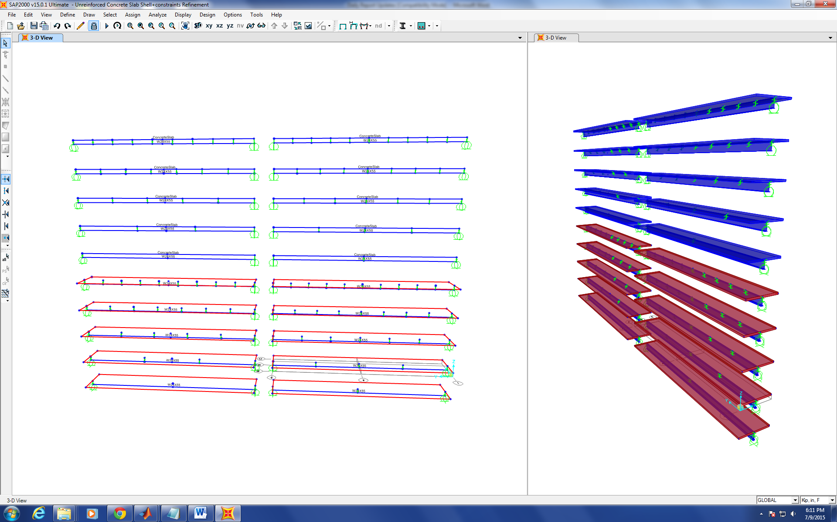
Figure 1
There will be some study to be done on how SAP2000 calculates its second moment of area.

Analysis of the Cause of Collapse of World Trade Center 7
Progression of the Project Daily Report

Date: 07/10/2015 Working Hours: 8
Submitted by Zhili Quan

Today, some test modelling on SAP2000 was done. It was found that the shell and plate elements respond the same if they act alone without rigidly connected with a “beam” element to increase the stiffness, as long as the loading condition and boundary condition are the same.
However, they react differently when connected with rigid links as to model composite beam consisting of a concrete slab and a W-beam. More testing has to be done to find out the cause of this behavior.
Also some checking on SAP2000's capability of calculating second moment of area of the frame sections was done, and the results turned out to be identical with the hand calculation. Some literature review on how to interpret moment, shear and stresses among different members such as "beam" and "shell" elements on SAP2000 was also studied.
During the daily meeting, Dr. Hulsey informed that it is time to put two floors together to test the response of each floor with respect to another.
Figure 1 shows the stress analysis on SAP2000.
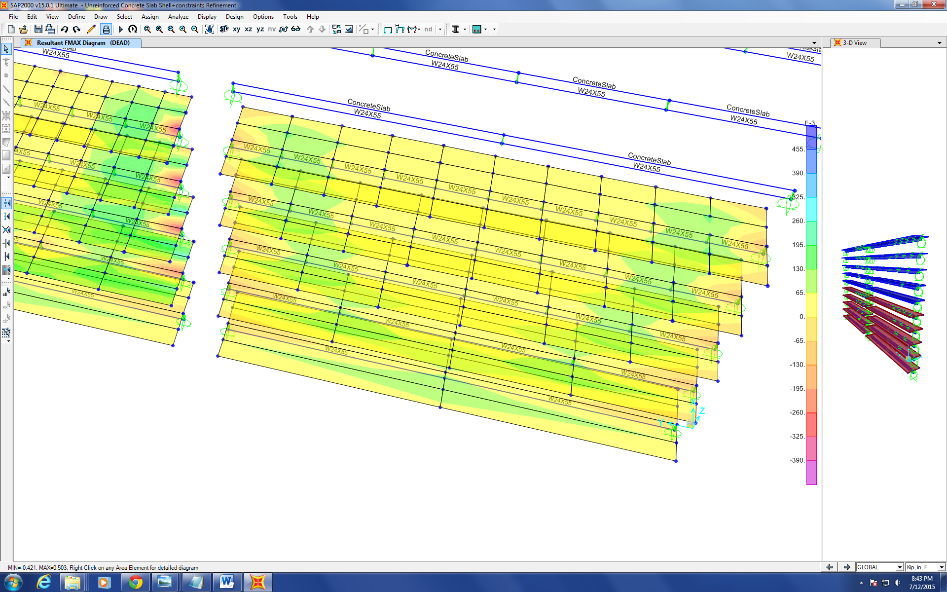
Figure 1

Analysis of the Cause of Collapse of World Trade Center 7
Progression of the Project Daily Report

Date: 07/13/2015 Working Hours: 8
Submitted by Zhili Quan

Today, attempt to transferred AutoCAD drawing of the 12th&13th floors’ frame lines into SAP2000 drawing was done. Figure 1 shows the transferred drawing on Sap2000 V15.
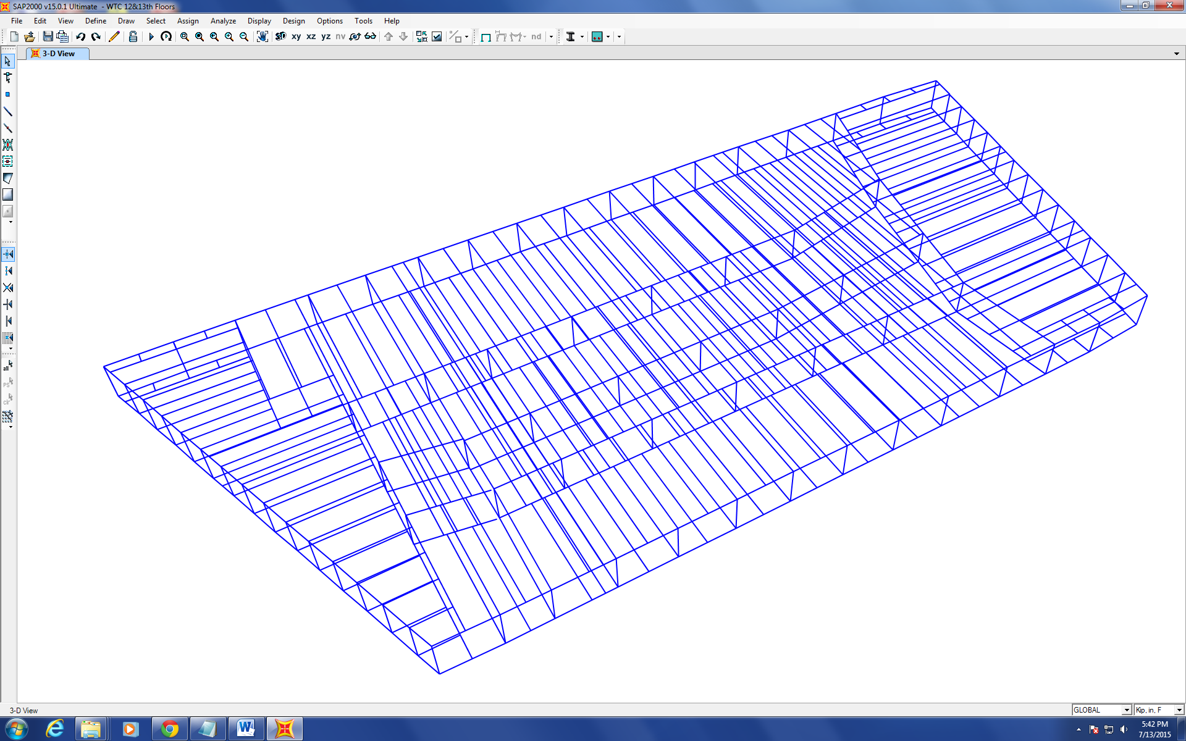
Figure 1
However, it was later found that the distance between the centroid of the concrete slab floor and the centroid of the member makes a fair amount of difference on the deflection calculated.
Figure 2 shows the difference in deflection caused by difference distances between the centroid of the concrete slab floor and the centroid of the member.
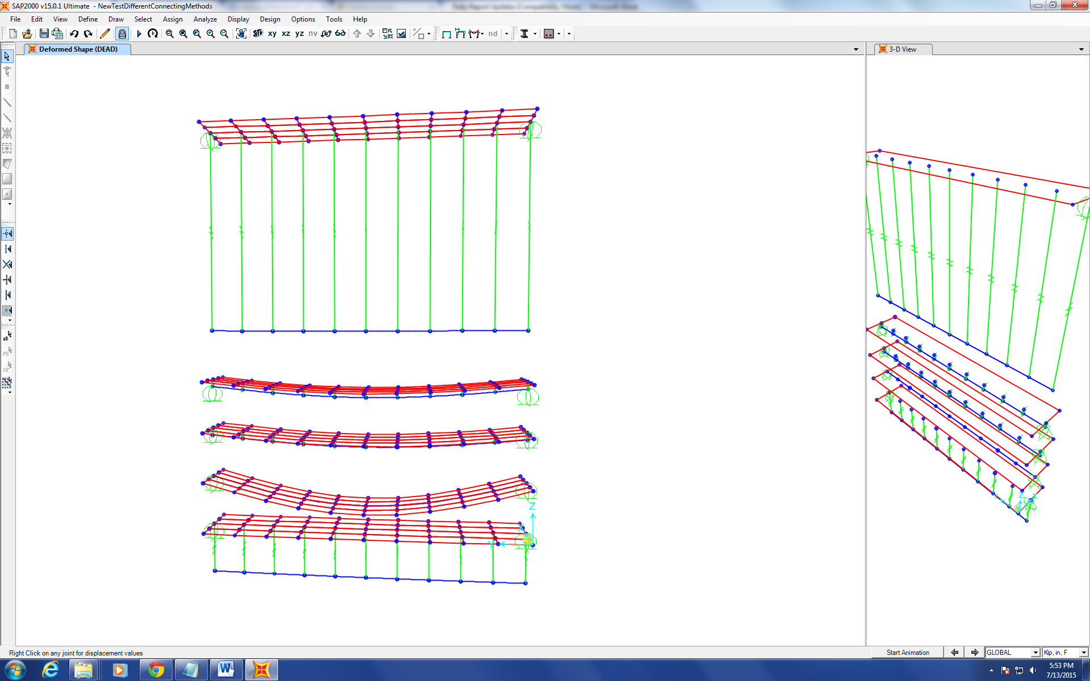
Figure 2

Analysis of the Cause of Collapse of World Trade Center 7
Progression of the Project Daily Report

Date: 07/14/2015 Working Hours: 8
Submitted by Zhili Quan

Today, a lot of effort was made trying to put the 12th&13th floors together. In the middle of doing it, a lot of technical issues emerged and subsequently, the plans were changed various times. During the meeting with Dr. Hulsey, he suggested to make the distance between every member's centroid and the concrete slab’s centroid the same so it would be faster than to model it exactly and it would save a lot of time. It was getting done that for a while until fellow research assistant Feng Xiao thought of another mechanism that might be much better. He suggested to use “shell” or “beam” element offset function in SAP2000 to model the floors’ framing. The idea will be discussed with Dr. Hulsey tomorrow during the meeting.
Figure 1 shows the plan Dr. Hulsey came up with by offsetting all members that belong to the same floor the same with respect to the concrete slab.
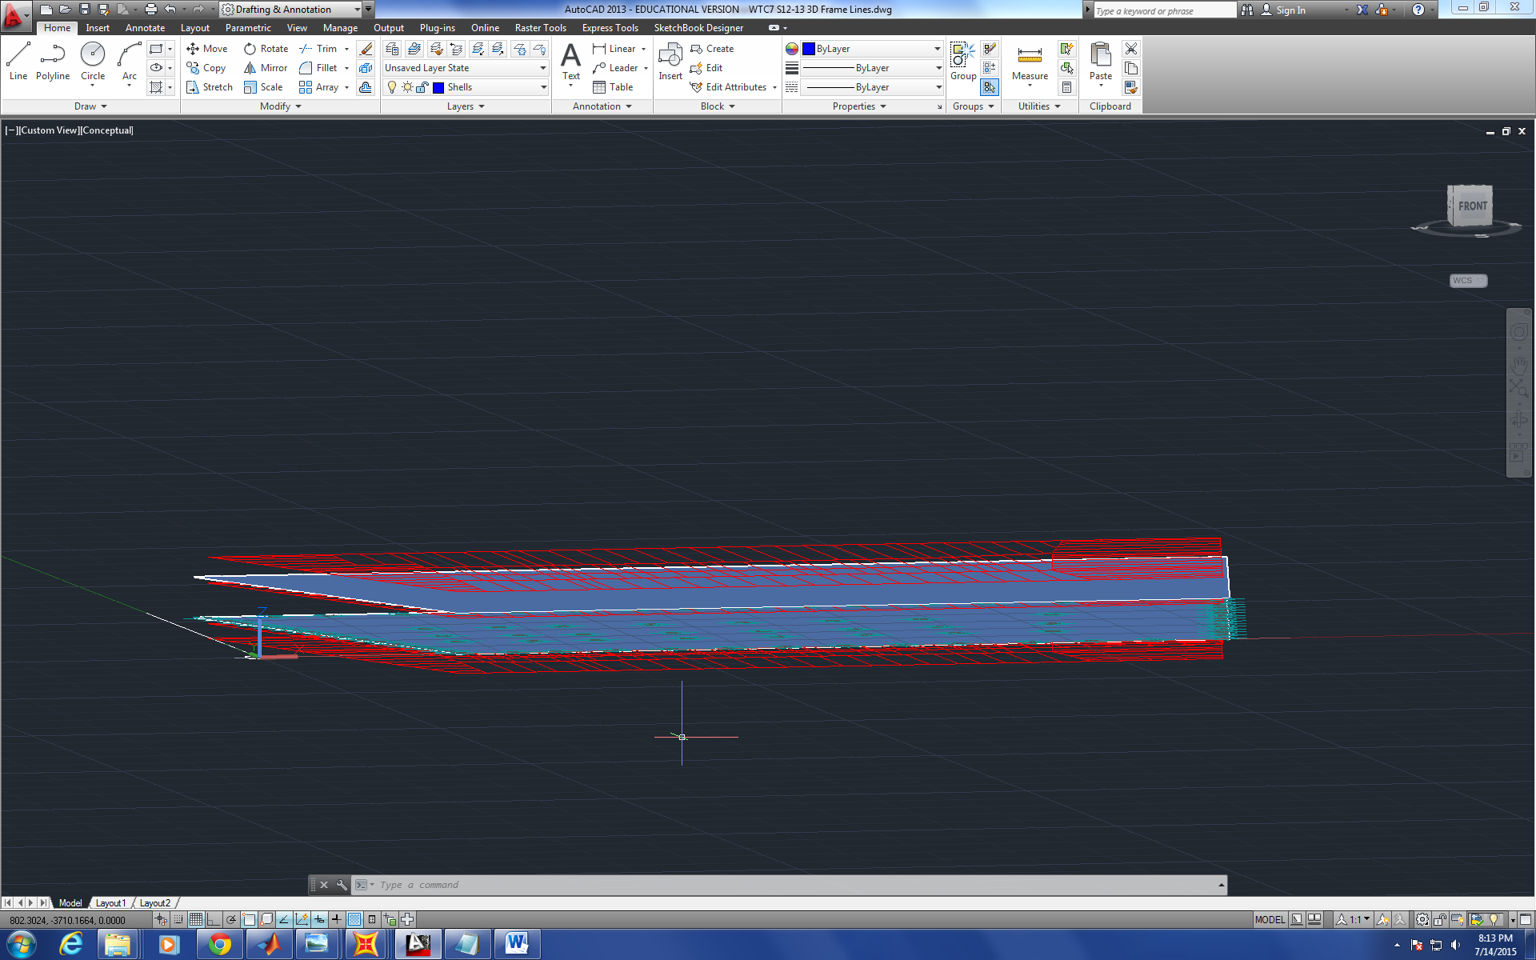
Figure 1
Figure 2 shows a lot study test done on SAP2000 V15 to see how to mesh unregular shaped “shell” elements connected with “beam” elements
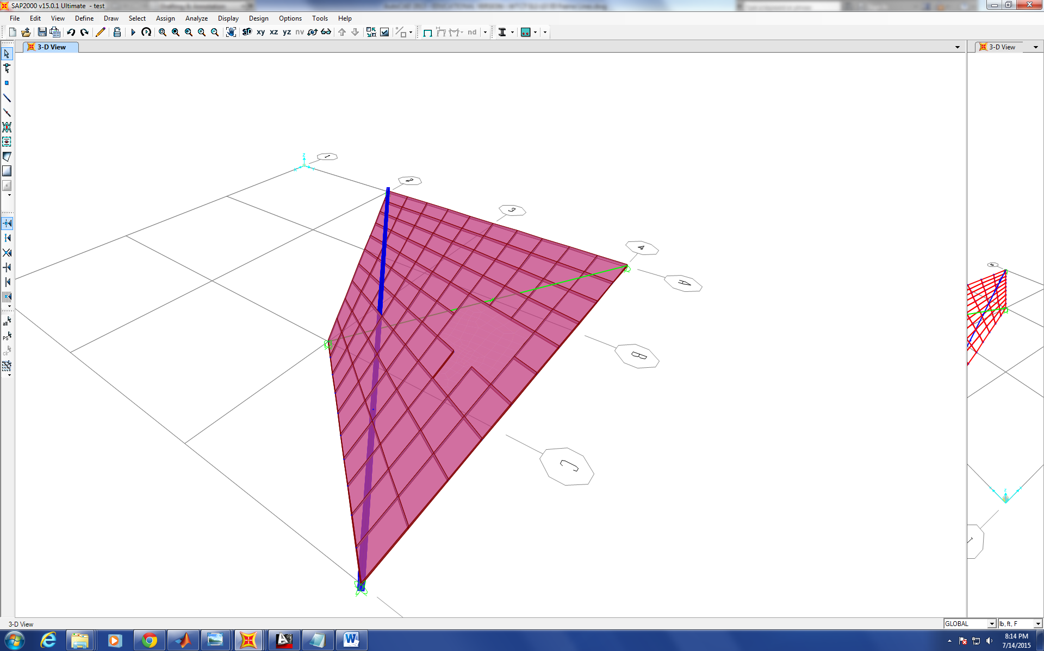
Figure 2

Analysis of the Cause of Collapse of World Trade Center 7
Progression of the Project Daily Report

Date: 07/15/2015 Working Hours: 8
Submitted by Zhili Quan

Today, research was done on how to model composite beams without setting apart the “shell” element representing concrete slab and the “frame” element representing W-beam. The “Frame Insertion Point” function was studied on SAP2000. The function is capable of offsetting the location of an individual member without moving the line that represents it. The results turned out to be just as good as the results calculated by setting apart the “shell” element and the “frame” element by the distance between the two elements’ centroids.
Figure 1 shows how to set up the “Fram Insertion Point” function.
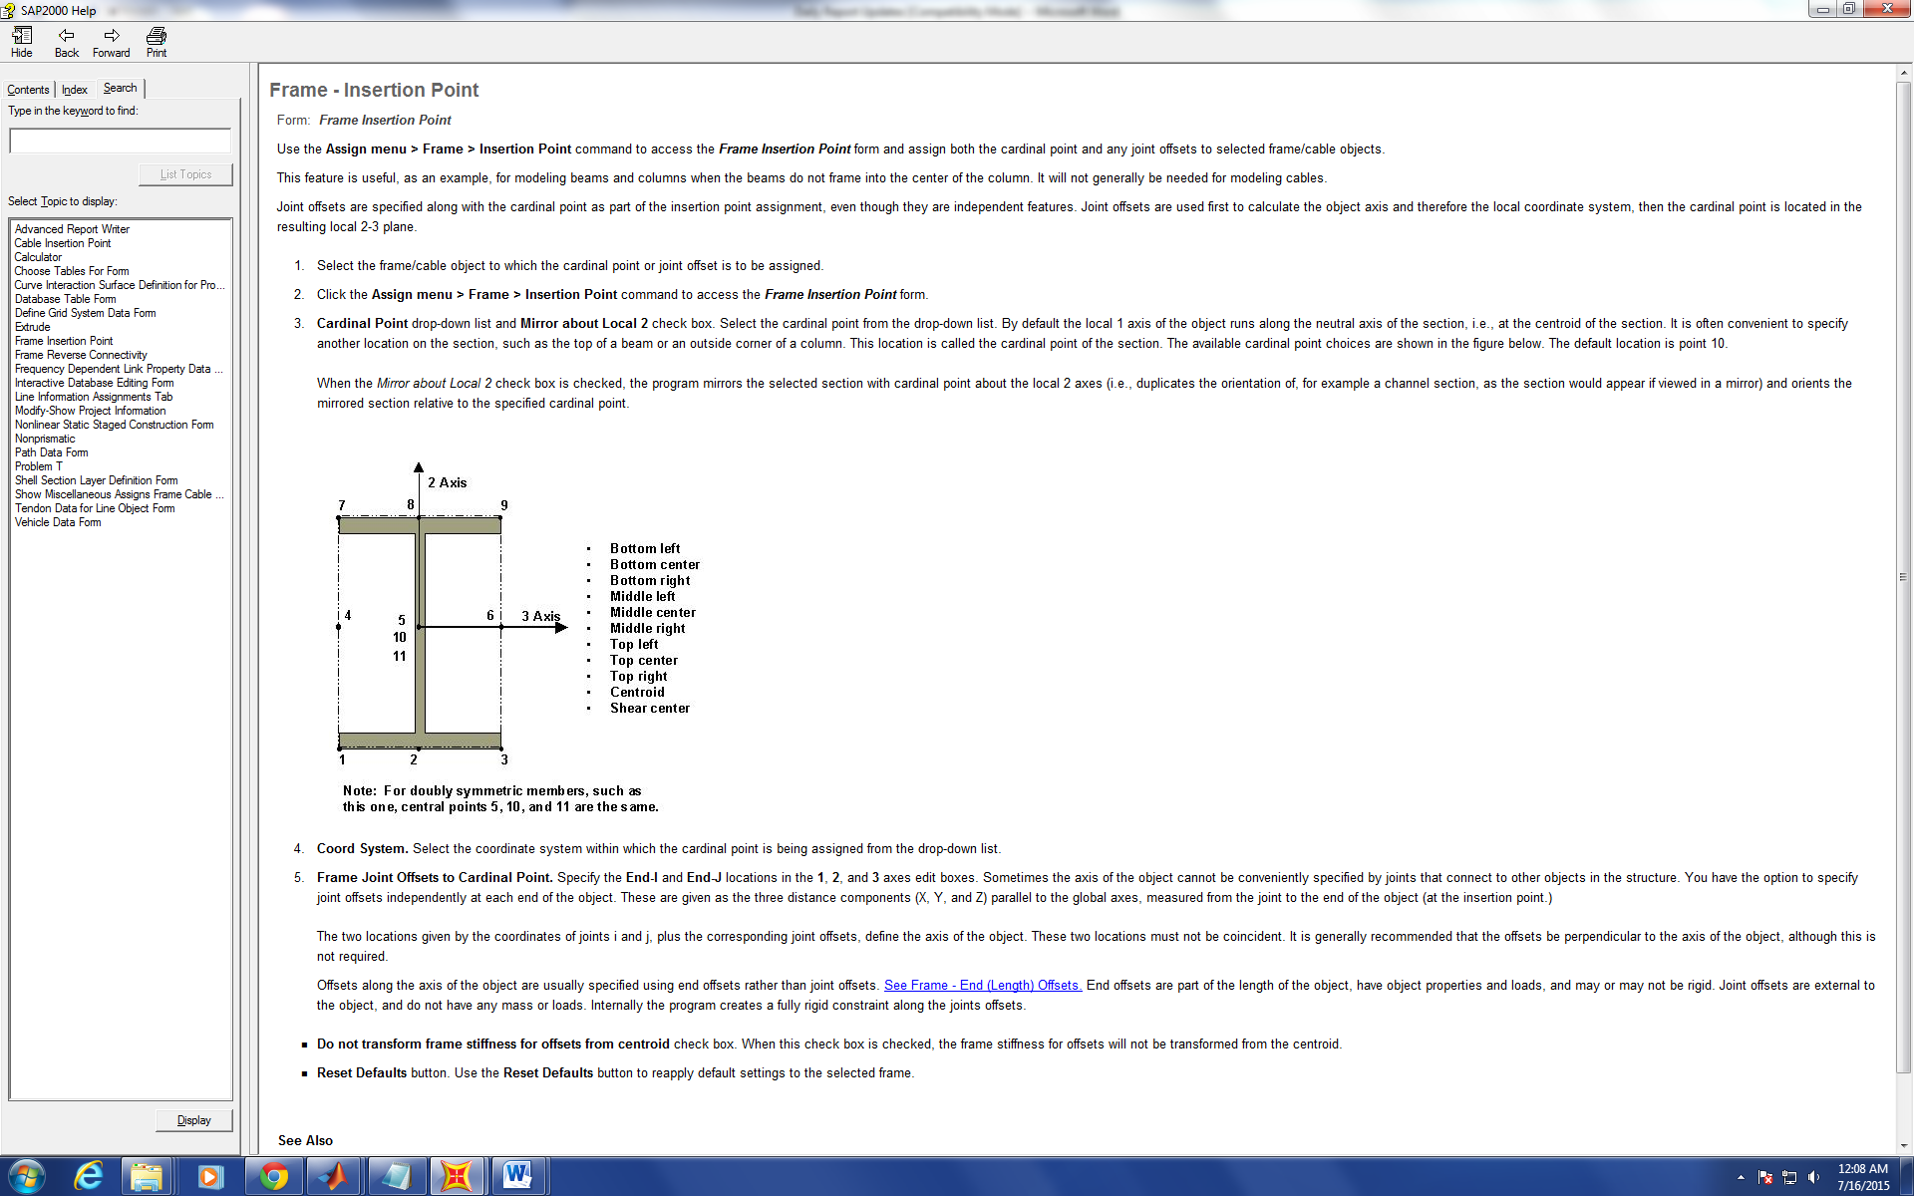
Figure 1
Figure 2 shows how the concrete slab and W-beam are located. The model on the top shows the top surface of the W-beam is touching the bottom surface of the concrete slab and the model on the bottom shows the concrete slab and W-beam are set apart by the distance of the two centroids and connected by rigid links.
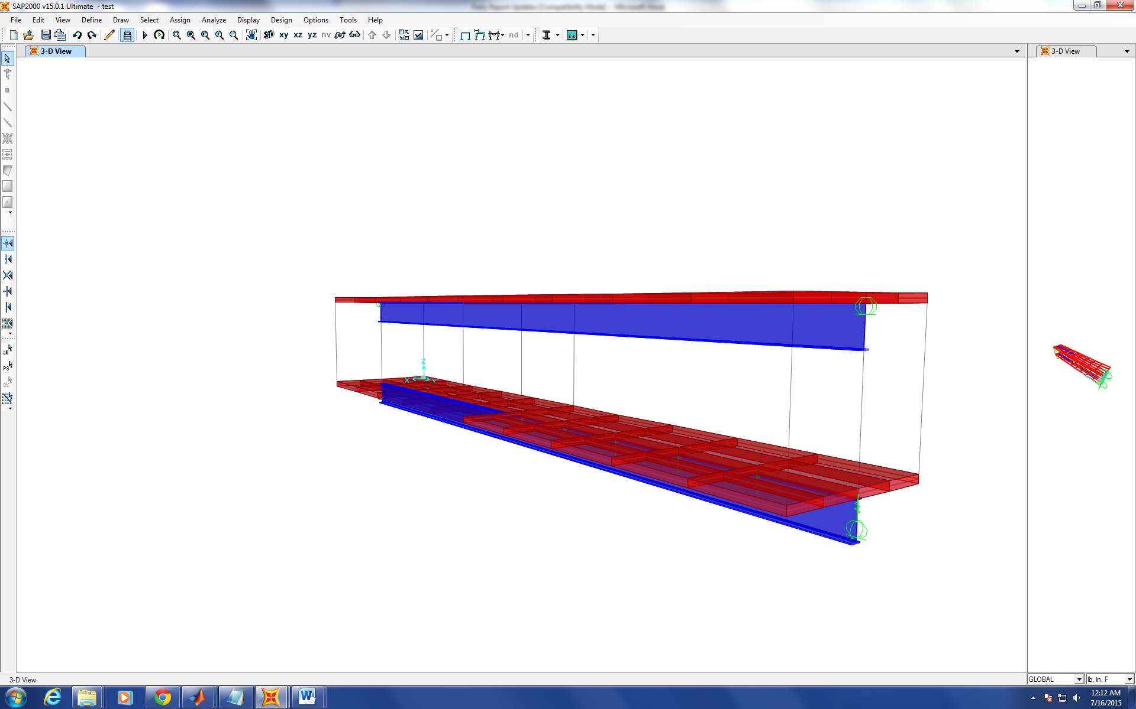
Figure 2

Analysis of the Cause of Collapse of World Trade Center 7
Progression of the Project Daily Report

Date: 07/16/2015 Working Hours: 8
Submitted by Zhili Quan

Today, modelling on the 12th&13th floor being put together was conducted on SAP2000 V15. A lot of issues were encountered as expected, and especially connecting all the “frame” elements and two “shell” elements together to make them act compositely.
Finally, after a lot of literature reviewing on SAP2000 and brain-storming, the issues have been solved.
Figure 1 shows the meshed two “shell” elements representing the concrete slab floors stacked on top of each other connected by “frame” element representing columns laid out vertically. In the figure, only the two “shell” elements are meshed. All the “frame” elements are modelled as whole pieces.
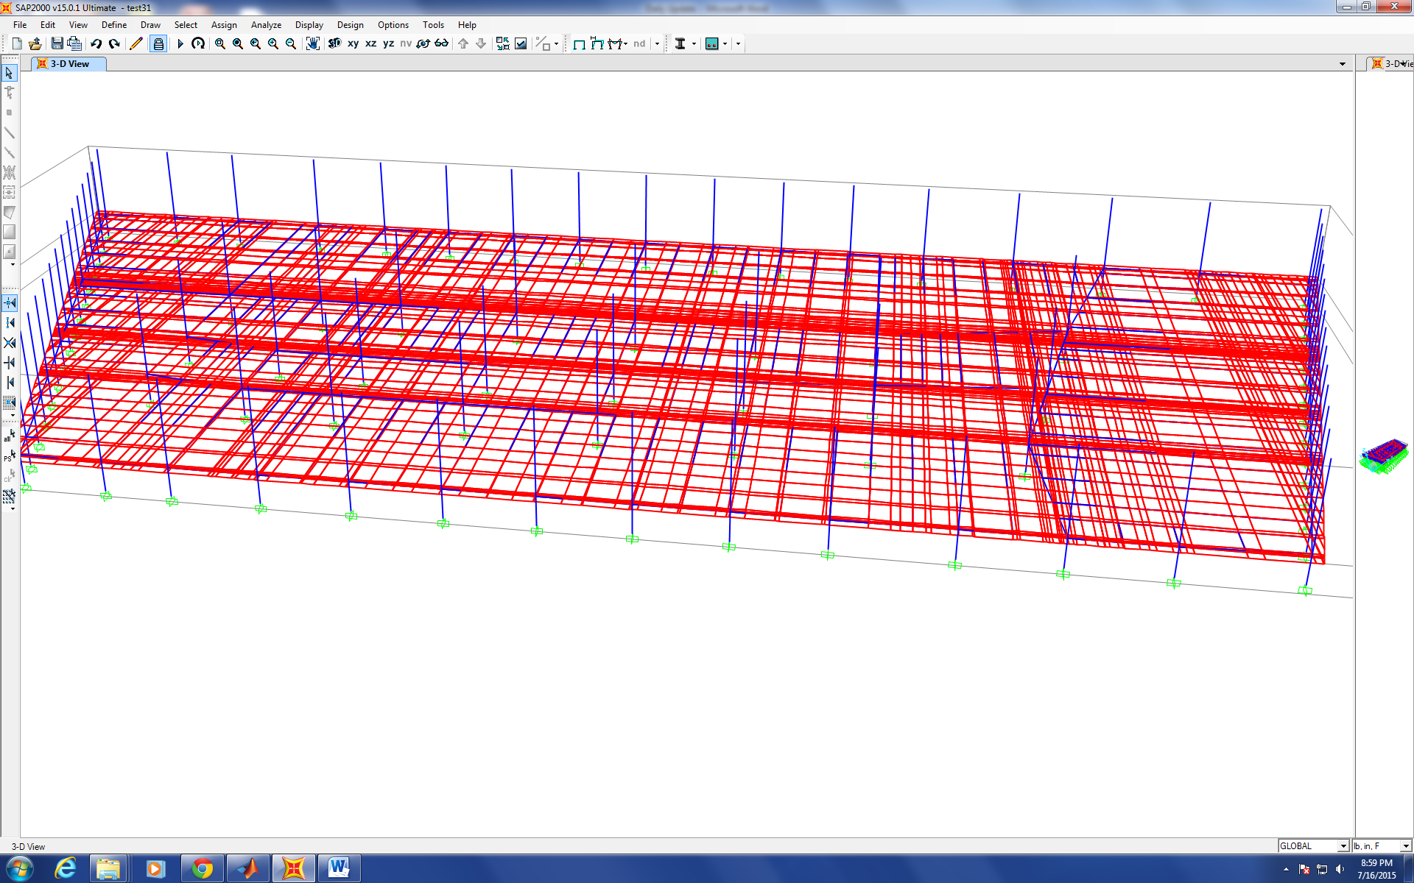

Figure 1
Figure 2 shows the deflection of the model under self-weight. The deflection is greatly exaggerated and the results make sense on the first sight numerically and intuitively. It can be observed that the floors are acting together with the beams on the figure. The results have to be checked with structural analysis in the next step.
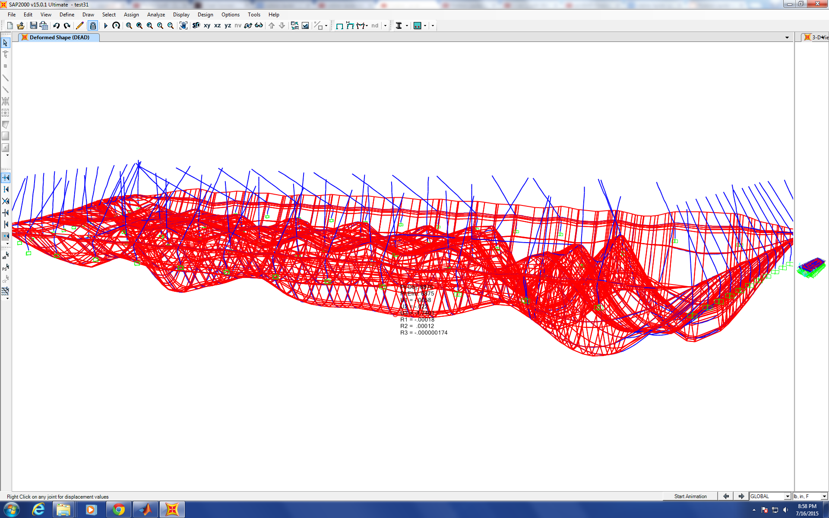
Figure 2

Analysis of the Cause of Collapse of World Trade Center 7
Progression of the Project Daily Report

Date: 07/16/2015 Working Hours: 8
Submitted by Zhili Quan

Today, modelling on the 12th&13th floor being put together was conducted on SAP2000 V15. A lot of issues were encountered as expected, and especially connecting all the “frame” elements and two “shell” elements together to make them act compositely.
Finally, after a lot of literature reviewing on SAP2000 and brain-storming, the issues have been solved.
Figure 1 shows the meshed two “shell” elements representing the concrete slab floors stacked on top of each other connected by “frame” element representing columns laid out vertically. In the figure, only the two “shell” elements are meshed. All the “frame” elements are modelled as whole pieces.

Figure 1
Figure 2 shows the deflection of the model under self-weight. The deflection is greatly exaggerated and the results make sense on the first sight numerically and intuitively. It can be observed that the floors are acting together with the beams on the figure. The results have to be checked with structural analysis in the next step.
Figure 2

Analysis of the Cause of Collapse of World Trade Center 7
Progression of the Project Daily Report

Date: 07/17/2015 Working Hours: 8
Submitted by Zhili Quan

Today, some test modelling on SAP2000 to see the difference it’d make if the distance between the centroid of the concrete slab floor and the centroid of the W-beam varies was done on SAP2000 V15. The results turned out to be considerate when the distance varied. Therefore, there is some discussion to be made about the how to set up the offset of the beams with respect to the concrete slab floor. Also, multiple meshing and connecting methods between the concrete slab floor and the beams were done on SAP2000 V15. The results turned out to be very close and made sense both intuitively and numerically. Finally, the layouts of the columns between 11th&12th floor and between 12th&13th floor were checked, and they are the same for both cases.
Figure 1 shows the different cases of composite beam consisting of the same concrete slab and the same W-beam but with varied distances between the centroids of the two. The deflections differ at the a considerable amount, up to 100% when distance was moved by 5-10 inches, and the original centroid is 14.535”.
Table 1 shows the max. deflection under each case.
Table 1
W24X55: | 7.005”width | 0.505”flange thickness | 0.395” web thickness | 23.57” depth
Concrete Slab: | 5.5” thickness | 114.25” width | 633” length
Centroids distance | 25” | 20” | 15” | 14.535” (Original) | 10”
Max. Deflection | 0.4589” | 0.6411” | 0.9486” | 0.9866” | 1.472”

Figure 1 and 2 show the side views of the composite beams with different centroid distances.

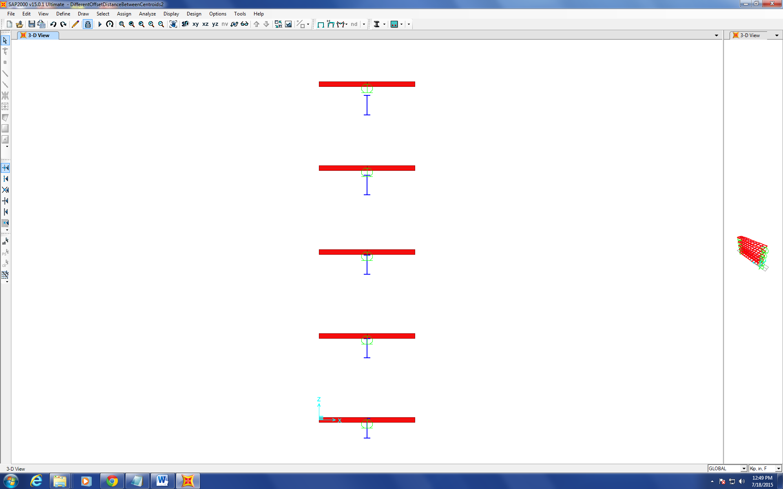
Figure 1
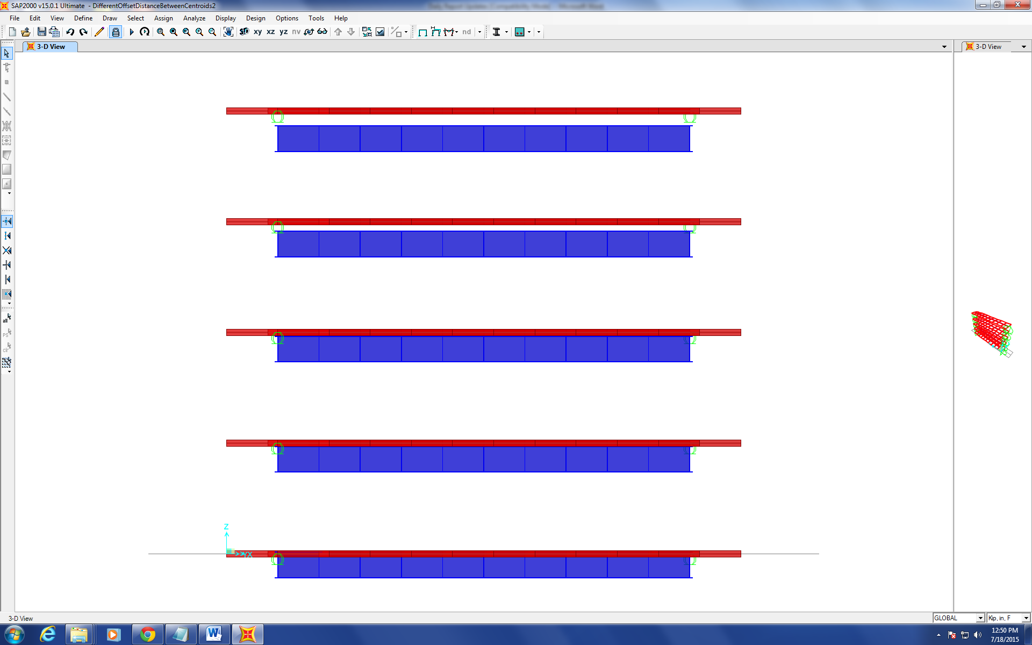
Figure 2

Progression of the Project Daily Report

Date: 07/20/2015 Working Hours: 8
Submitted by Zhili Quan

Today, effort was made on how to put 12&13th floors of WTC7 together easier. The building sat across over 300ft by 150ft. There were a lot of members that consisted the each floor and a lot of them were repetitive but not in any noticeable pattern. Therefore, put each member by hand on SAP2000 is very uneconomical. It would be both time consuming and error-prone. The “export” function in SAP2000 was used to export the two floors into excel file.
Figure 1 shows the generated excel file to represent the two floors being put together on SAP2000.
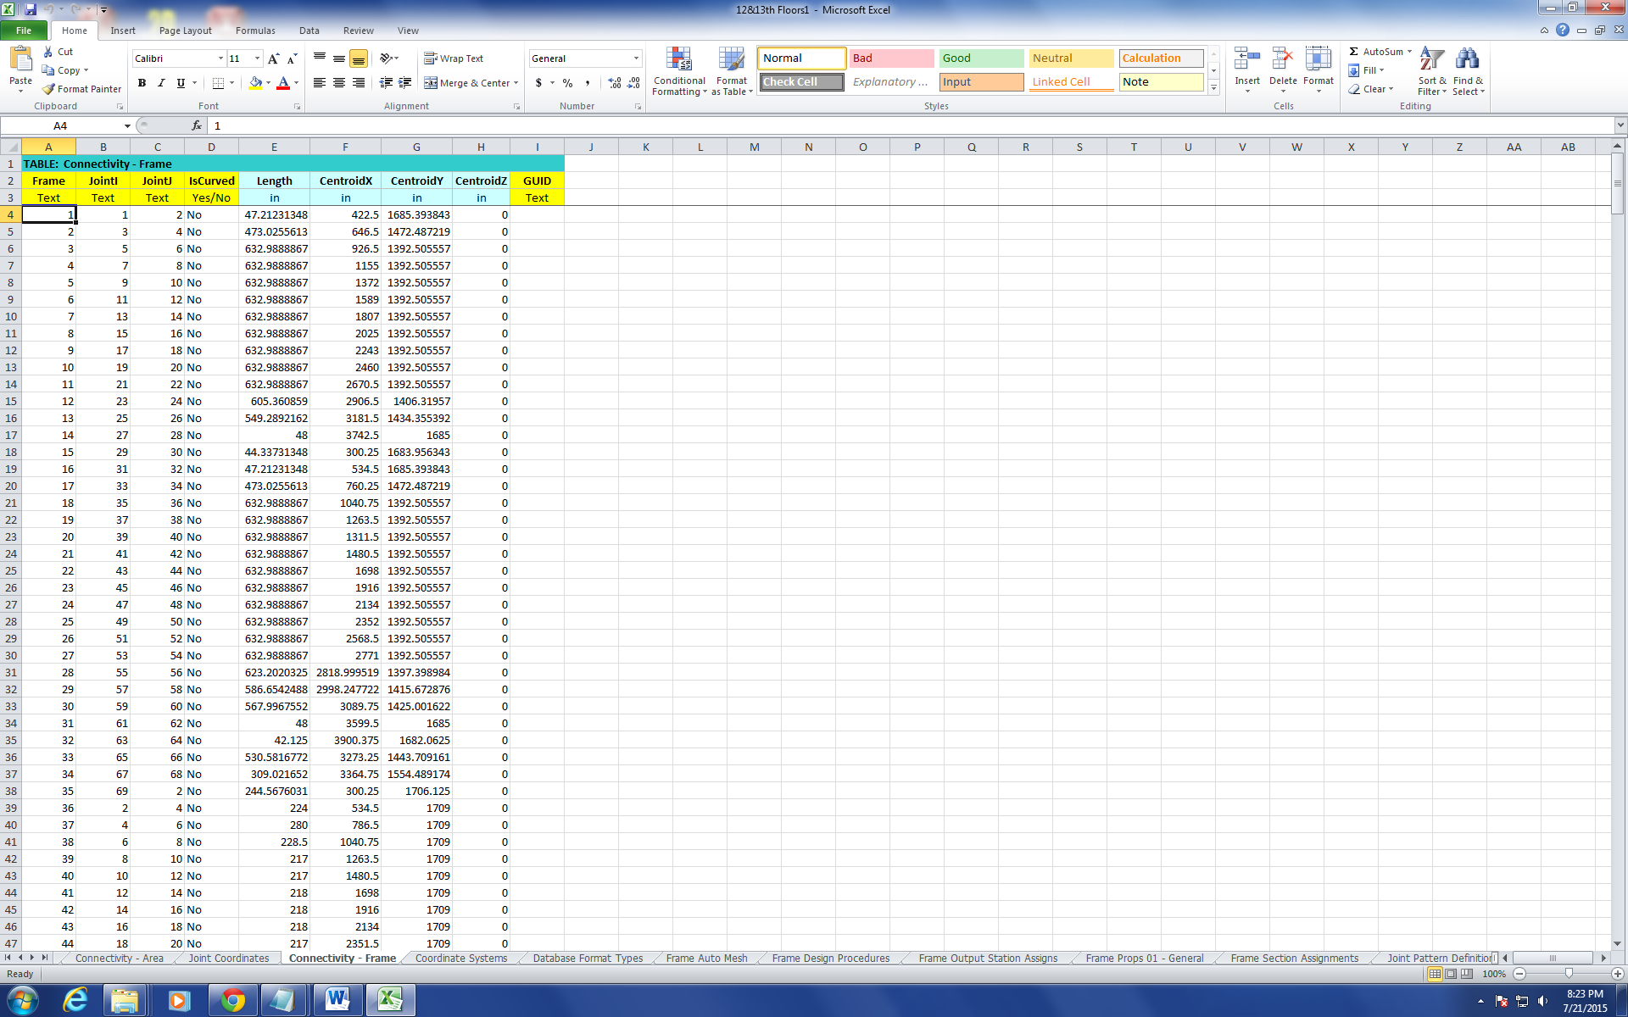
Figure 1

Progression of the Project Daily Report

Date: 07/21/2015 Working Hours: 8
Submitted by Zhili Quan

Today, a considerable amount of time was spent on how to write a program to put the members at the right place. However, it would take a lot of time to finish the tentative code and make time might be spent on testing and fixing the code. Therefore, for 12&13th floors combination, members are to be put on by hand on SAP2000. The 12th floor was finished with all the members being at the right place.
Figure 1 shows the finished plan view of the 12th floor with labelled members.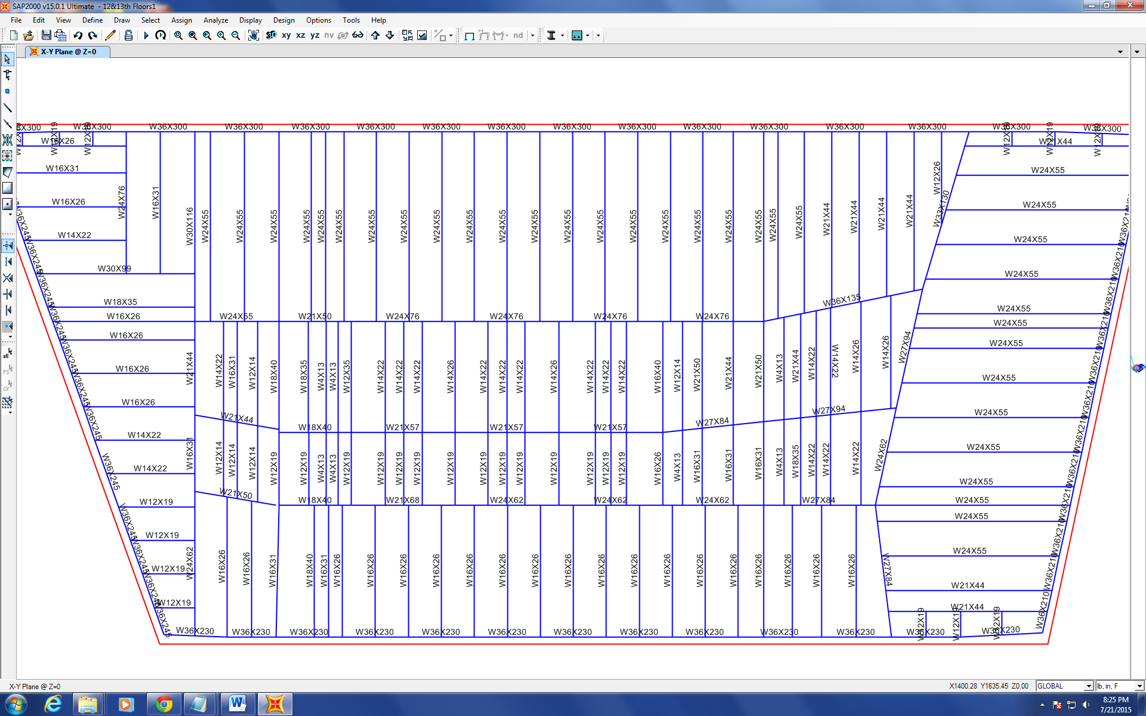
Figure 1

Progression of the Project Daily Report

Date: 07/22/2015 Working Hours: 8
Submitted by Zhili Quan

Today, it was realized after contacting the head quarter of the company that provides SAP2000 that they don’t respond to students only professors. Dr. Hulsey has learned the situation and will contact them soon with fellow research assistant Zhili Quan.
Modelling of 12th&13th floors being put together with half length of the columns both above and underneath the floors has finally been finished. Figure 1shows the finished model onSAP2000 V15.
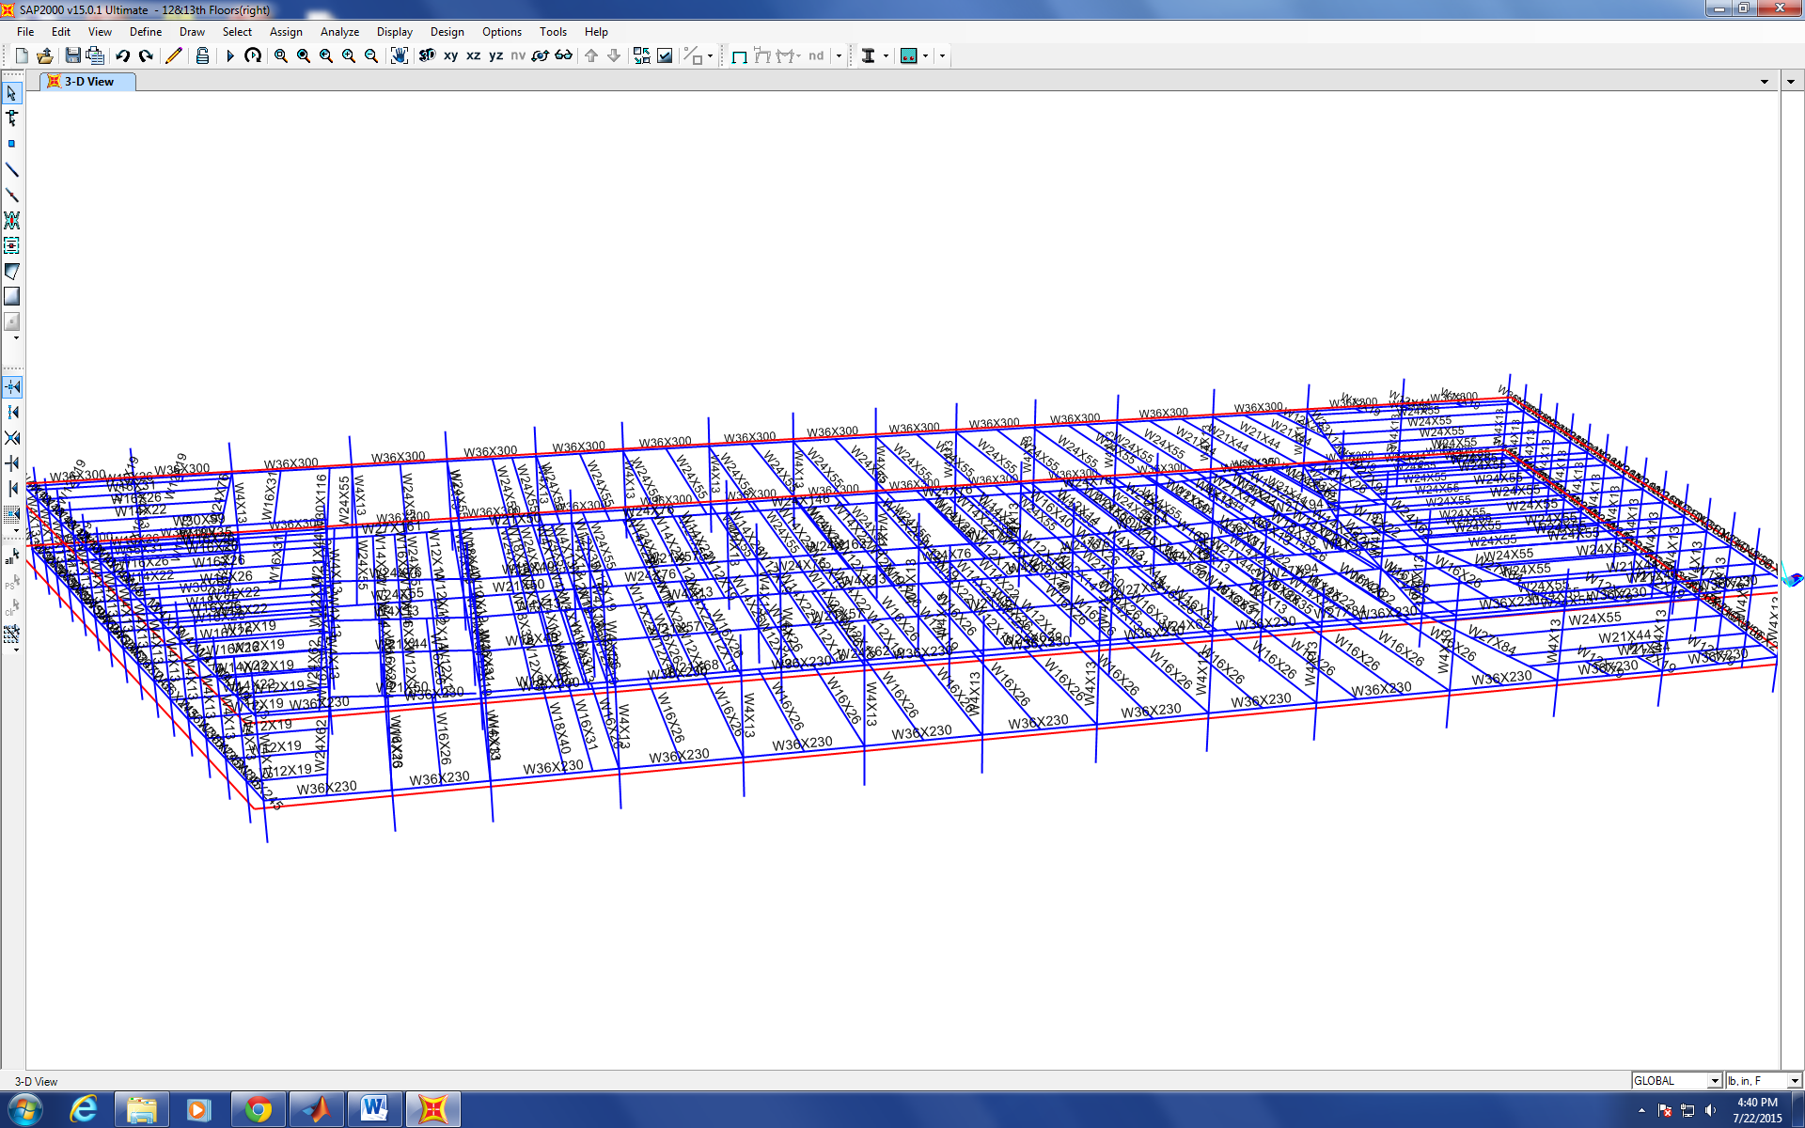
Figure 1
Figure 2 shows the response of the model under self-weight loading. The deflection is greatly exaggerated. The deflection makes sense both intuitively and numerically.
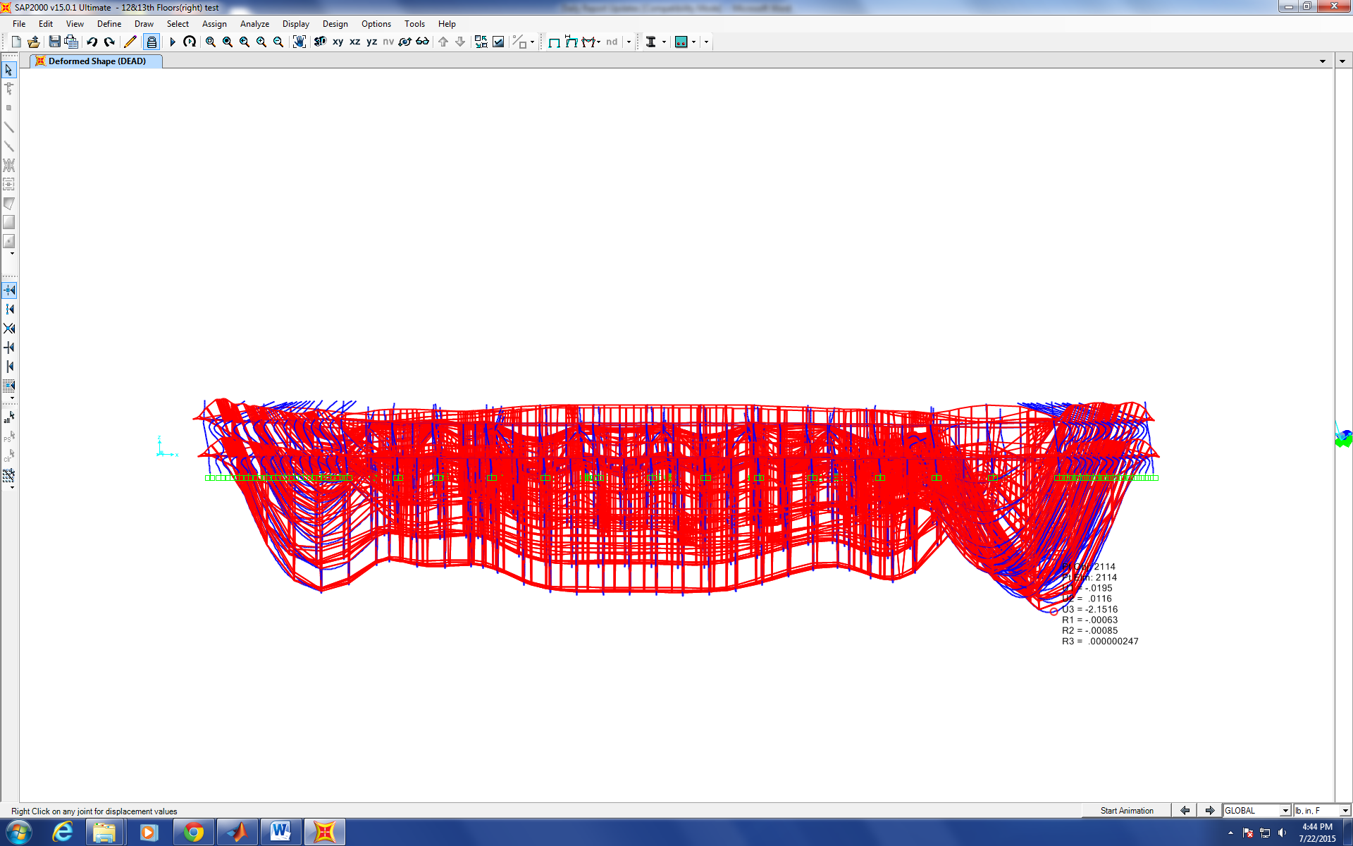
Figure 2

Progression of the Project Daily Report

Date: 07/23/2015 Working Hours: 8
Submitted by Zhili Quan

Today, it was found that there is some more work to do on the 12th&13th floors model. All the beams and girders have already been assigned. However, the columns have to be assigned as well.
Table 1 shows all the column members of the 12th and 13th floors of WTC7.
Table 1
12th&13th Column Members | A(in^2) | d(in) | bf(in) | tf(in) | tw(in) | Ixx(in^4) | Iyy(in^4)
W14X176 | 51.8 | 15.22 | 15.65 | 1.31 | 0.83 | 2140 | 838
W14X283 | 83.3 | 16.74 | 16.11 | 2.07 | 1.29 | 3840 | 1440
W14X311 | 91.4 | 17.12 | 16.23 | 2.26 | 1.41 | 4330 | 1610
W14X342 | 101 | 17.54 | 16.36 | 2.47 | 1.54 | 4900 | 1810
W14X370 | 109 | 17.92 | 16.475 | 2.66 | 1.655 | 5440 | 1990
W14X426 | 125 | 18.67 | 16.695 | 3.035 | 1.875 | 6600 | 2360
W14X455 | 134 | 19.02 | 16.835 | 3.21 | 2.015 | 7190 | 2560
W14X500 | 147 | 19.6 | 17.01 | 3.5 | 2.19 | 8210 | 2880
W14X550 | 162 | 20.24 | 17.2 | 3.82 | 2.38 | 9430 | 3250
W14X605 | 178 | 20.92 | 17.415 | 4.16 | 2.595 | 10800 | 3680
W14X665 | 196 | 21.64 | 17.65 | 4.52 | 2.83 | 12400 | 4170
W14X730 | 215 | 22.42 | 17.89 | 4.91 | 3.07 | 14300 | 4720

According to the column table which is part of the originally as-built, the columns were spliced between each two floors and 3'6"above the odd numbered floors and this pattern started from the 5th floor on. A new idea was discussed among two student assistants and will be discussed with Dr. Hulsey about how to assign columns.

Progression of the Project Daily Report

Date: 07/24/2015 Working Hours: 8
Submitted by Zhili Quan

Today, Dr. Hulsey and fellow student research assistant Zhili Quan contacted the head quarter of the provider of structural analysis software SAP2000 V15. According to the conversation with the technician over the phone, there is no limit on the number of nodes and frame lines and the non-linearity associated with “frame” and “shell” analysis can be well address via SAP2000. However, it was learned that SAP2000 can only run on WINDOWS operation systems.
Modelling of 12th&13th floors has been finished today with a little change of the column configuration. The columns are chosen that each column is taken between two splices. Therefore, the column is continuous and only has one member assigned with it.
The following diagram shows the finished column configuration on SAP2000 V15.
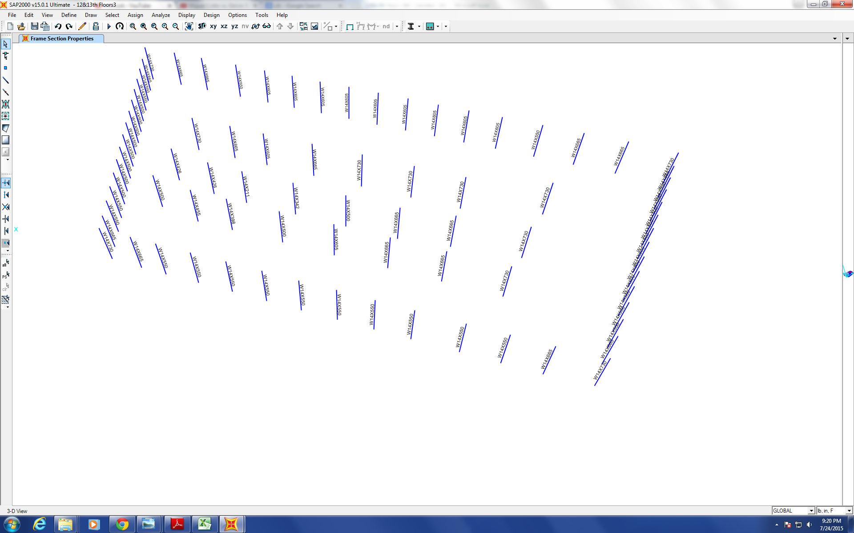
Figure 1
It is about time to run the analysis of the model of 12th&13th floors under certain given loading.
Progression of the Project Daily Report

Date: 07/27/2015 Working Hours: 8
Submitted by Zhili Quan

Today, several mistakes of the SAP2000 model representing the 12th&13th floors being put together were found and corrected. As expected, assigning each member by clicking each frame line on SAP2000 V15 is very error prone and time consuming. In addition, as Dr. Hulsey suggested, two floors should be analyzed in each case not the whole building being put together in a single case.
However, after all the mistakes were correct (most of the mistakes were due to negligence, such as wrongly located/placed members and wrong offset distances), two meshing techniques were used to compare results. The results of deflection for two models with same everything except meshing methods is shown in Figure 1 and Figure 2.
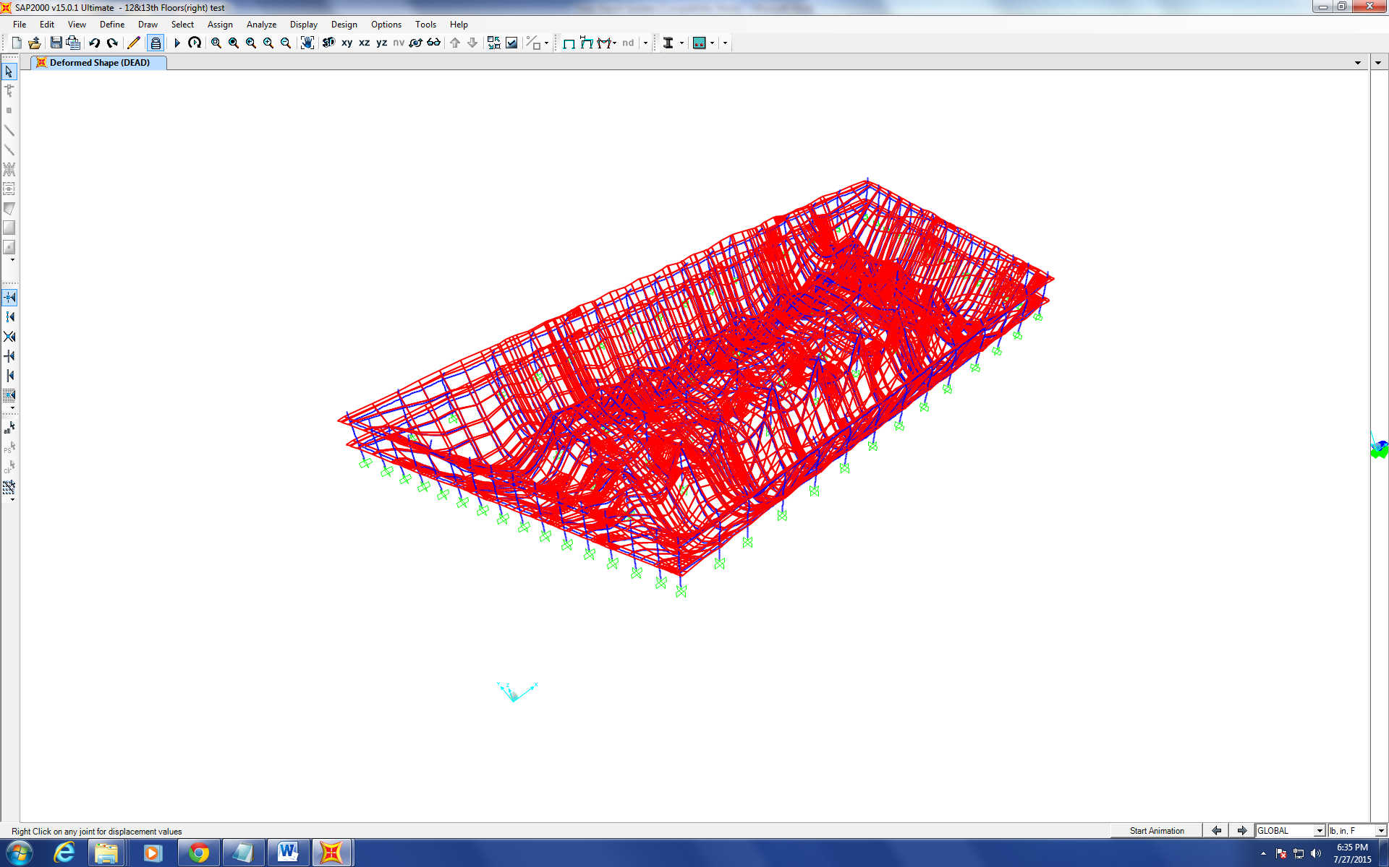
Figure 1
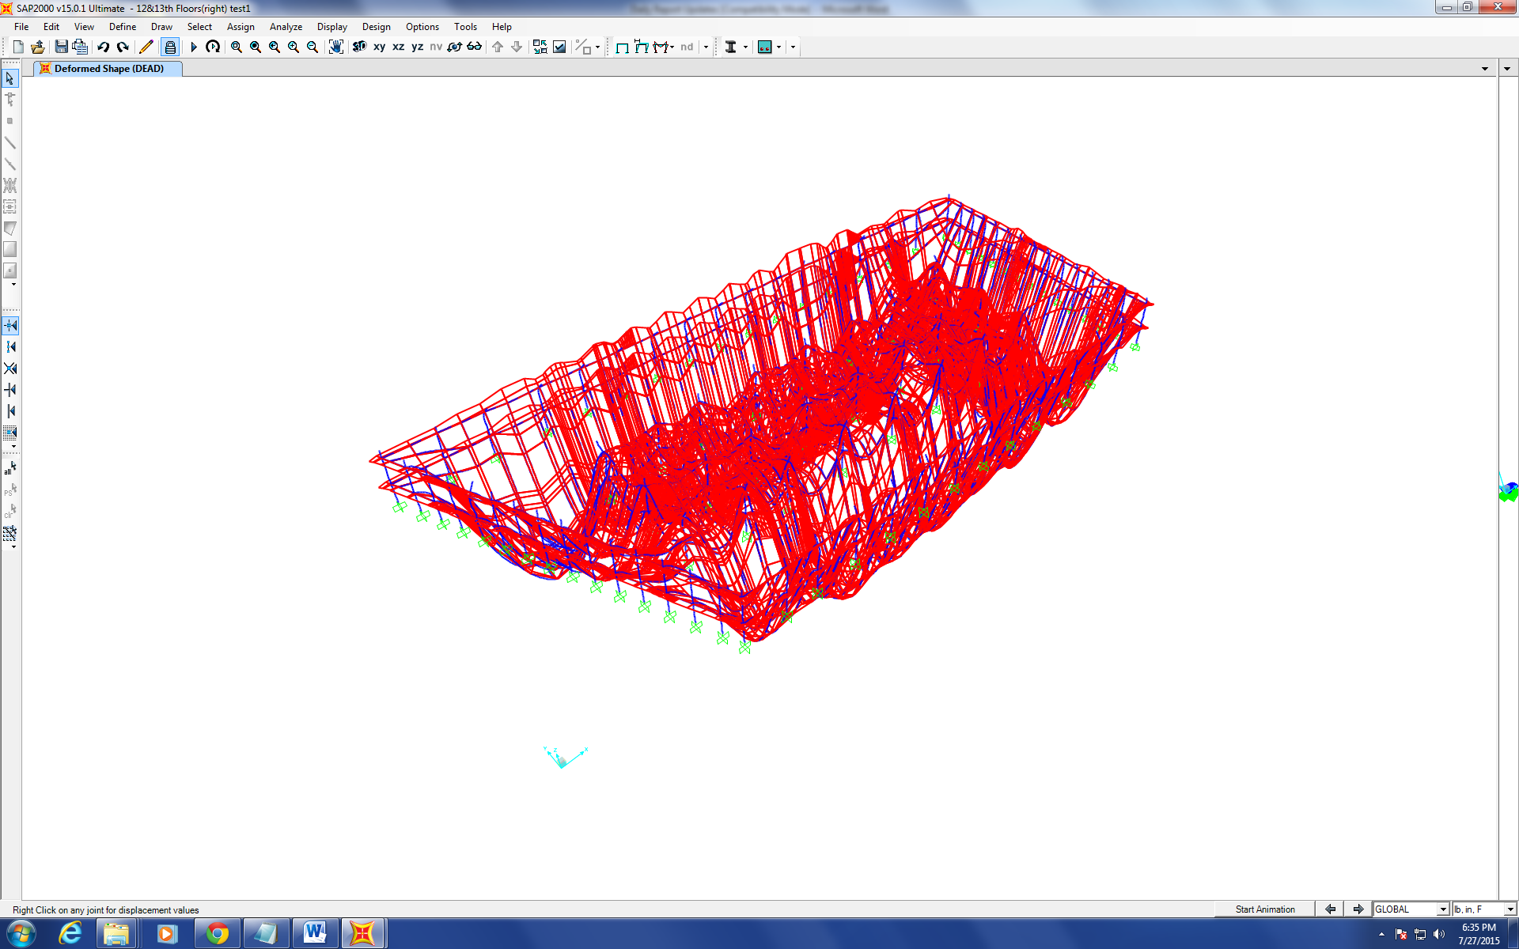
Figure 2
Figure 1 represents the model that has two concrete slabs meshed with no beam element meshed and Figure 2 represents the model that has two concrete slabs meshed with all the beam elements meshed as well.
It is visibly obvious that the deflection is larger in Figure 2 than in Figure 1.
More research needs to be done to find out what is the cause of the discrepancy.

Progression of the Project Daily Report

Date: 07/28/2015 Working Hours: 8
Submitted by Zhili Quan

Today, SAP2000 V15 was extensively studied. Numerous test modellings were done to see the difference under different meshing techniques. The 12&13th floors being put togehter model on SAP2000 was tested with different meshing techniques and reaction forces being checked. The results were still the same. Whether or not to mesh "frame" elements played a significant factor in the results. Even roughing meshing "frame" elements can generate results that were very close to even very fine meshing. No meshing of any “frame” element generated smaller deflection which was a surprise.
After discussion with fellow research assistant Feng Xiao, it was concluded that meshing "frame" elements is necessary and the smaller results due to no meshing "frame" elements was most likely due to fixed boundary condition on the edge of "shell" elements. Checked the website of ARSC (Arctic Research Supercomputer Center) and will be applying access to it in the next couple of days.

Progression of the Project Daily Report

Date: 07/29/2015 Working Hours: 8
Submitted by Zhili Quan

Today, an application to the access of ARSC (Arctic Region Supercomputer Center) was filed and submitted. ARSC has supercomputers that combine processors and rams to achieve a very high computing speed. In addition, ARSC provides numerical analysis software such as MATLAB and Finite Element Analysis Software like COMSOL and ABAQUS.
Studies have been done on the new document provided by Dr. Hulsey. The document provides the modification on the 13th floor. However, no information has been found on the electrical substation upon which WTC7 was built yet, and it may be significant to have the information.

Progression of the Project Daily Report

Date: 07/30/2015 Working Hours: 8
Submitted by Zhili Quan

Today, more study was done on the new document given by Dr. Hulsey. According to research assistant Zhili Quan, no information was found in the new document about the electrical substation. However, during the meeting with Dr. Hulsey, there is detailed information about the electrical substation in the new document. Therefore, more study has to be done on it.
Two problems were encountered when using SAP2000 to model different floors of WTC7. Dr. Hulsey suggested to model two floors each time for one SAP2000 model and put all the models together in the end. The reason to do that is because it is very hard to be error-free if instead of putting two floors together at a time, trying to put all 47 stories together. However, it was found SAP2000 cannot combine two files together. The problem was solved because there is an “import” function on SAP2000 and can add completed models on top of the current one. Another problem was on SAP2000, “COPY” and “PASTE” functions only copy the frame lines but not the frame section setups such as member assignment and offset distances. The problem was also solved by using “replicate” feature on SAP2000.
Figure 1 shows how to replicate members with the exact same setup (including member assignment and offset distances etc.) A 6-floor model was created based on the originally finished two-floor model.
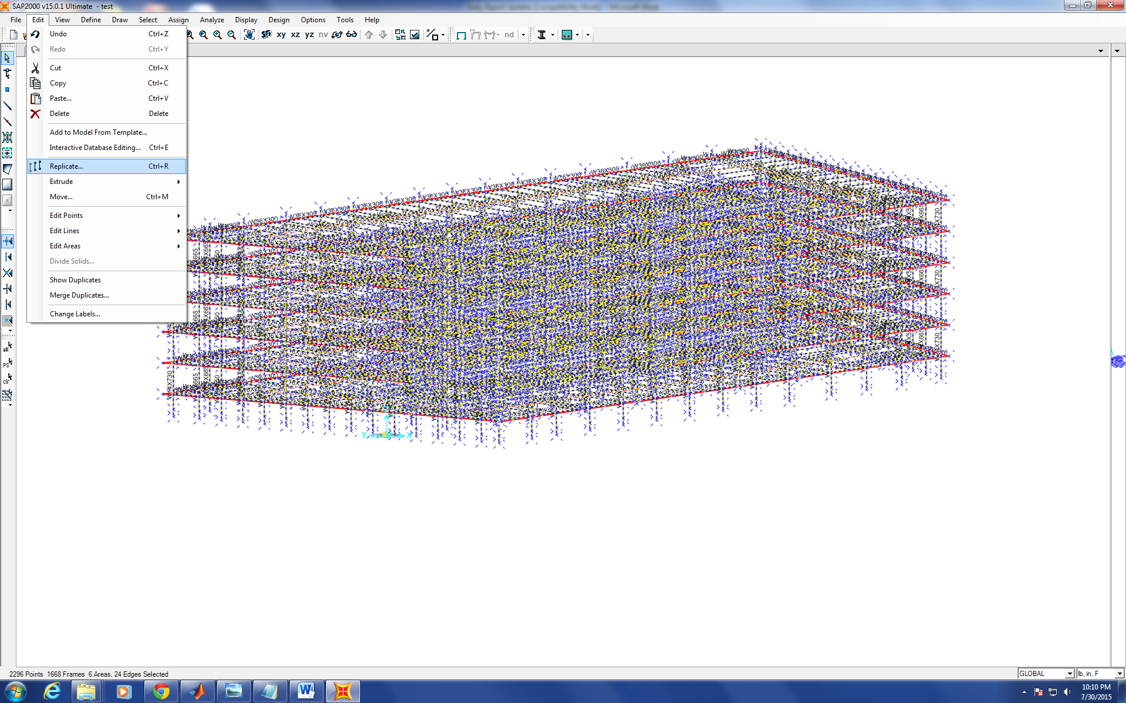
Figure 1
Progression of the Project Daily Report

Date: 07/31/2015 Working Hours: 8
Submitted by Zhili Quan

Today, more study was done again on the new document given by Dr. Hulsey. There are detailed drawings about the caisson foundation of the building. However, the information about the layout the pre-existing electrical substation has been found and more effort is needed. (There is massive amount of information about WTC7 and there is no surprise it has taken so much time.)
The ABAQUS model done by fellow research assistant Feng Xiao was ready. However, it was realized the connections between the concrete slabs and steel beams were not correctly set up and it takes some more effort to find out how to do it correctly.
During the meeting with Dr. Hulsey, it was concluded that there is need to find the response of the building under loading at the centroid of the slab in all directions. On top of that, uniformly distributed load can also be applied to see the model’s response in a more wholesome manner.
There’s more documents provided by Dr. Hulsey, including the design load of the building.

Progression of the Project Daily Report

Date: 08/03/2015 Working Hours: 8
Submitted by Zhili Quan

Today, a lot of testing was done on SAP2000. Different meshing techniques were introduced and analyzed. The results vary depending on the meshing techniques.
Figure 1 shows the finest meshing so far and all the meshing elements are rectangles or very close to rectangles.
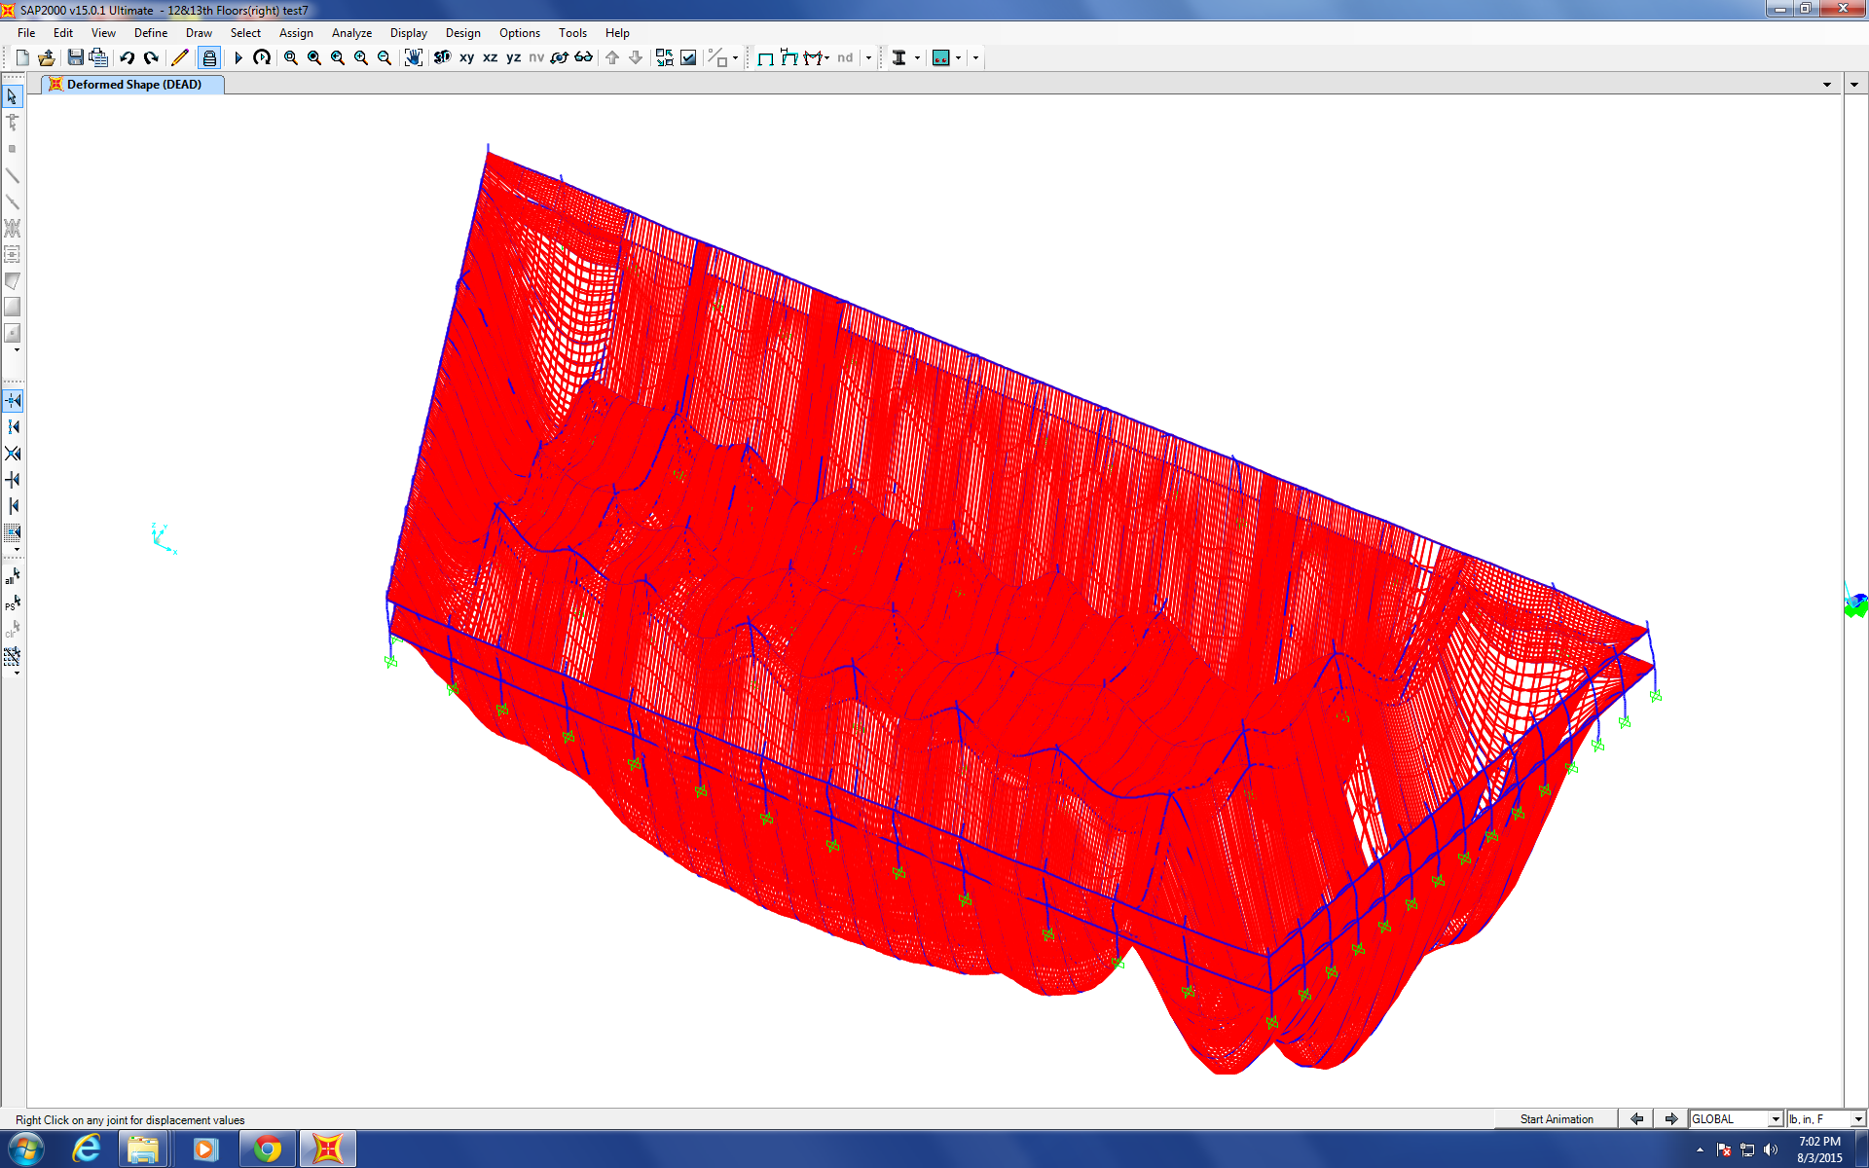
Figure 1
The results need to be analyzed according to different meshing methods, meshing extent (rough to medium to fine), meshing elements’ shapes and the subsequent analyzing time periods.
More detailed diagrams, tables, plots and comparison among different models with different coefficients will be done tomorrow.

Progression of the Project Daily Report

Date: 08/04/2015 Working Hours: 8
Submitted by Zhili Quan

Today, a lot of testing was done on SAP2000 and numerous models were used to simulate the 12th&13th floors acting together. Different meshing methods and combinations for “frame” elements and “shell” elements were used. The results vary but there are noticeable trends among results.
As the meshing becomes more fined, SAP2000 becomes very unstable and leads to failure frequently. Mostly due to not enough storage, overflow and unable to analyze due to the massive elements and all these problems led to failure and reanalyzing.
There are10 models in this report and the deflection is show in each model’s results. The deflection results can be categorized into two groups and each group follows certain pattern depending on how fine the model is meshed.
The model consists of the 12th&13th floors and the beams, girders and the columns that supported the two floors. Therefore, the 1st group is when only the floors are meshed but not the beams and girders. The 2nd group is when both the floors and the beams and girders are meshed. Meshing columns doesn’t make any difference in terms of results which makes sense and was expected.
The 1st group shows as the meshing becomes finer (smaller meshing elements); the deflection tends to become smaller. However, the deflection is the smallest when the floors are not meshed but only divided between beams and girders. The 2nd group shows that when both the floors and beams and girders are meshed, the meshing doesn’t play a big role in the magnitude the deflection. However, again when the floors are not meshed but only divided, the deflection becomes the smallest.
In both groups, the meshing nodes between the floors and the beams and girders are connected rigidly.
Figure 1 to Figure 10 show different meshing of the model with analyzed deflection.

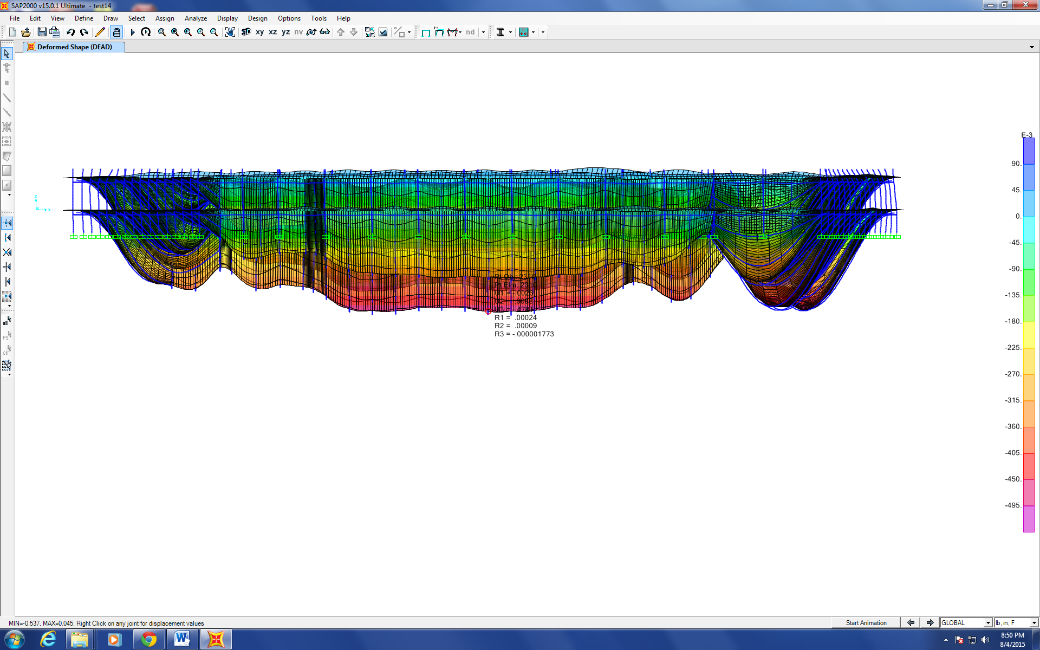
Figure 1. 10X10 elements between frame divisions without frame meshing
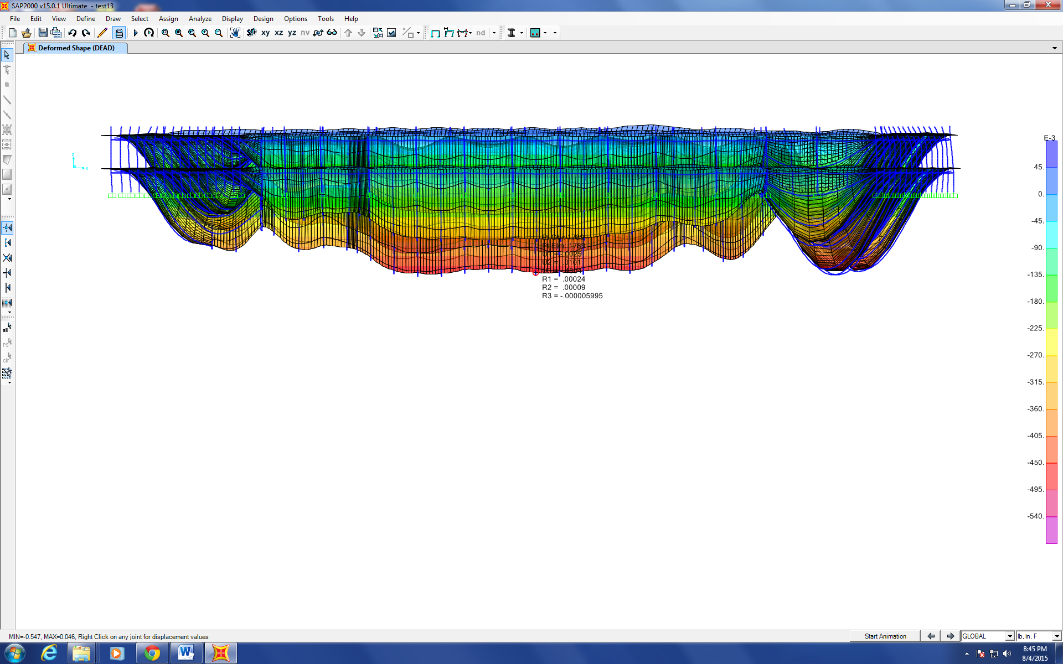
Figure 2. 8X8 elements between frame divisions without frame meshing
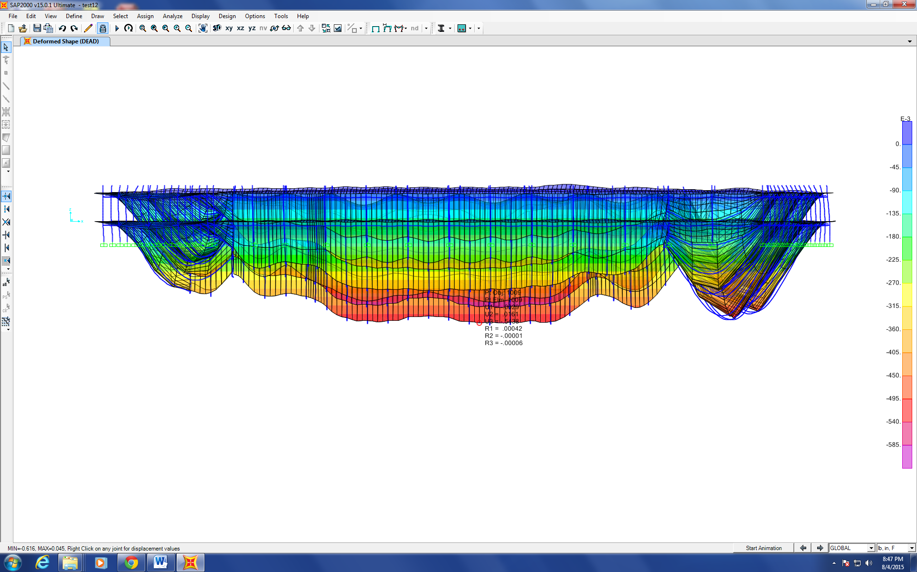
Figure 3. 4X4 elements between frame divisions without frame meshing
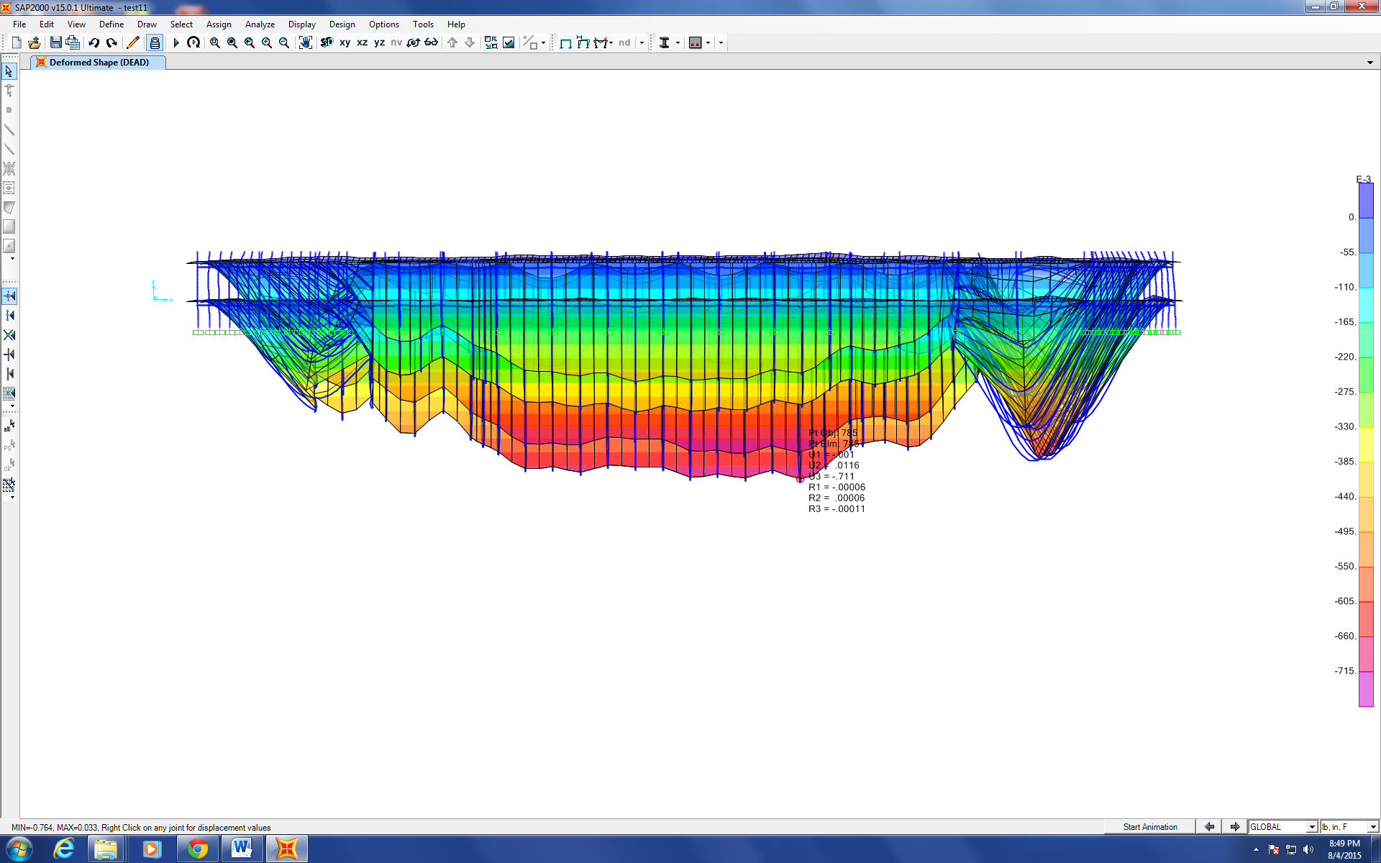
Figure 4. 2X2 elements between frame divisions without frame meshing
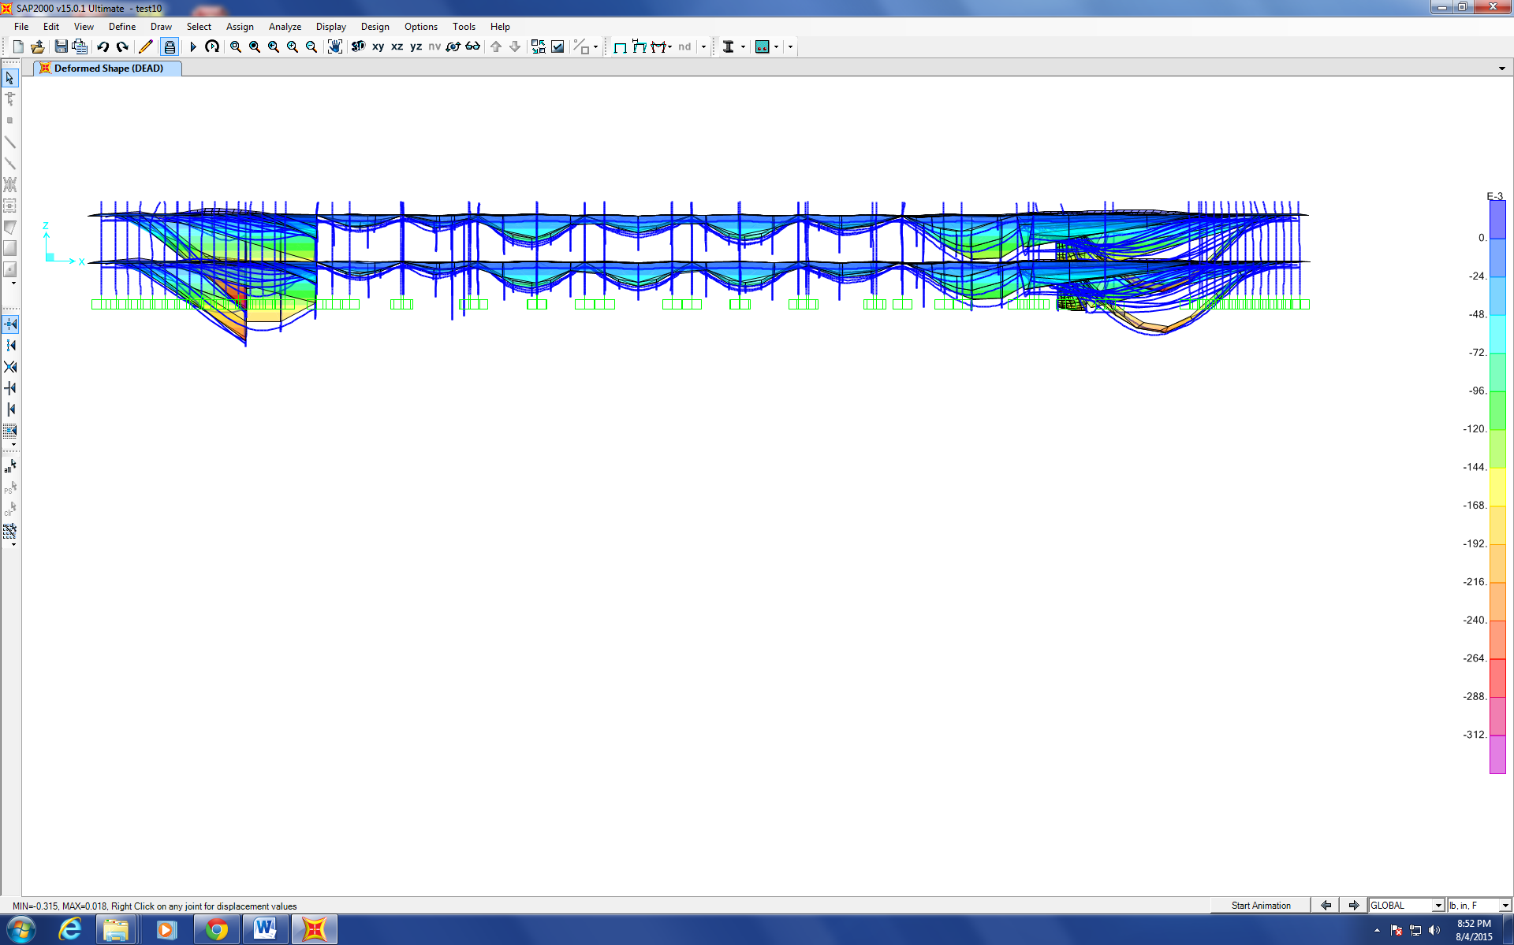
Figure 5. no floor meshing between frame divisions and no frame meshing
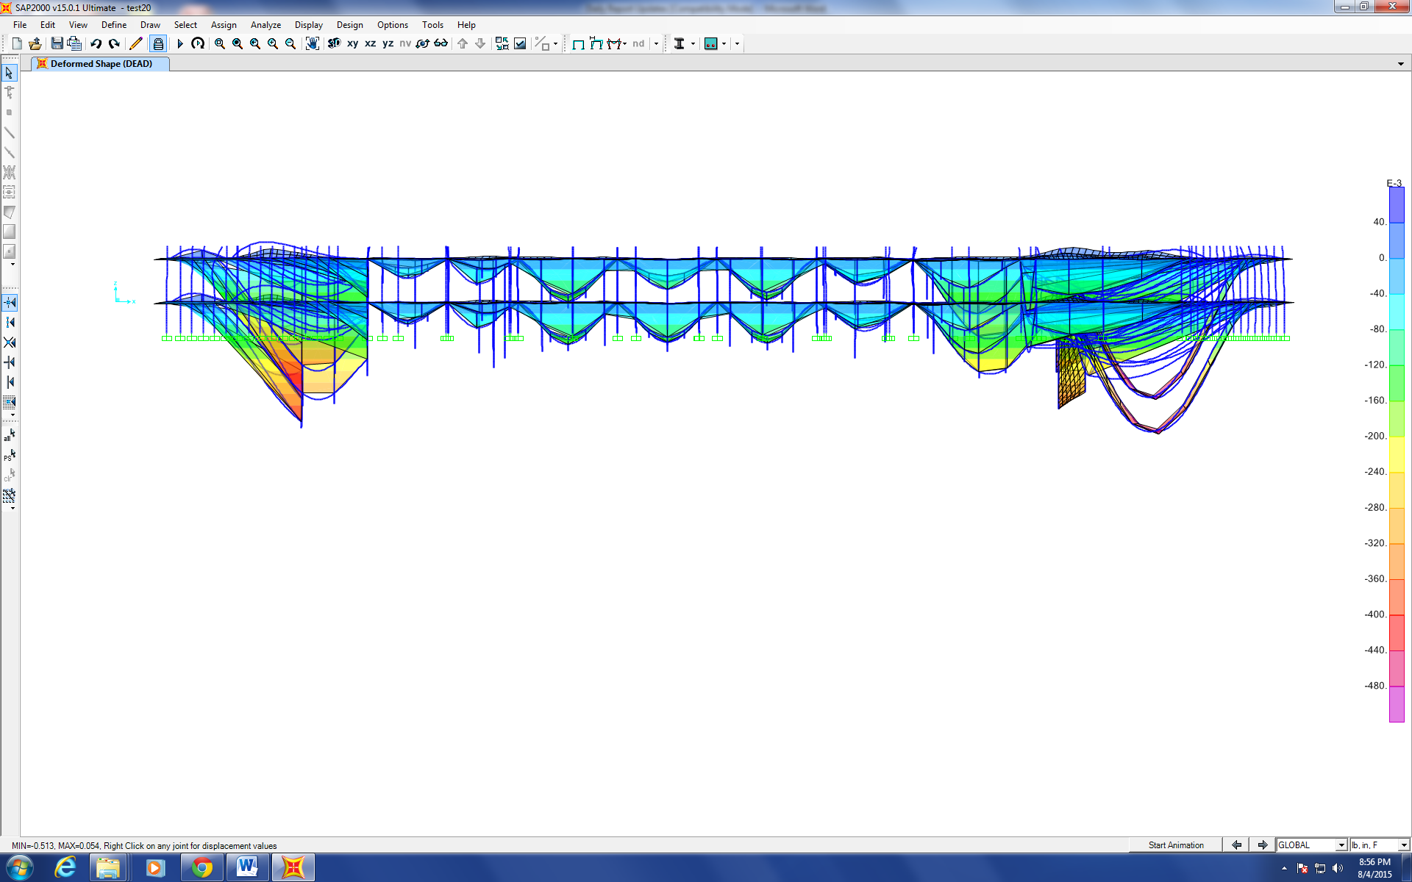
Figure 6. no floor meshing between frame divisions and with frame meshing
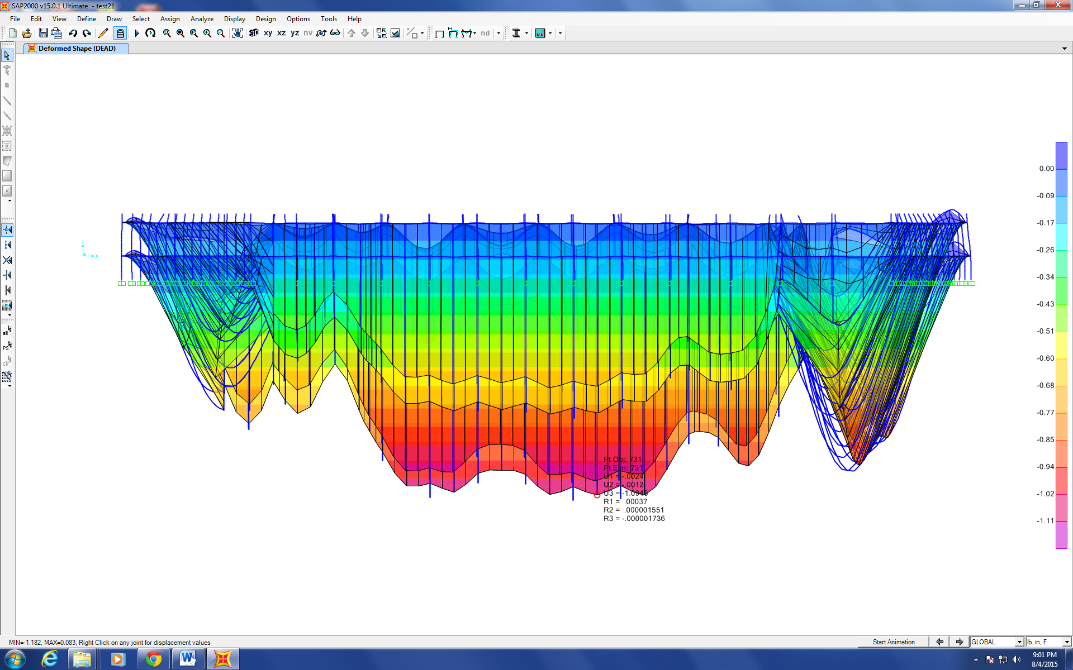
Figure 7. 2X2 elements between frame divisions with frame meshing
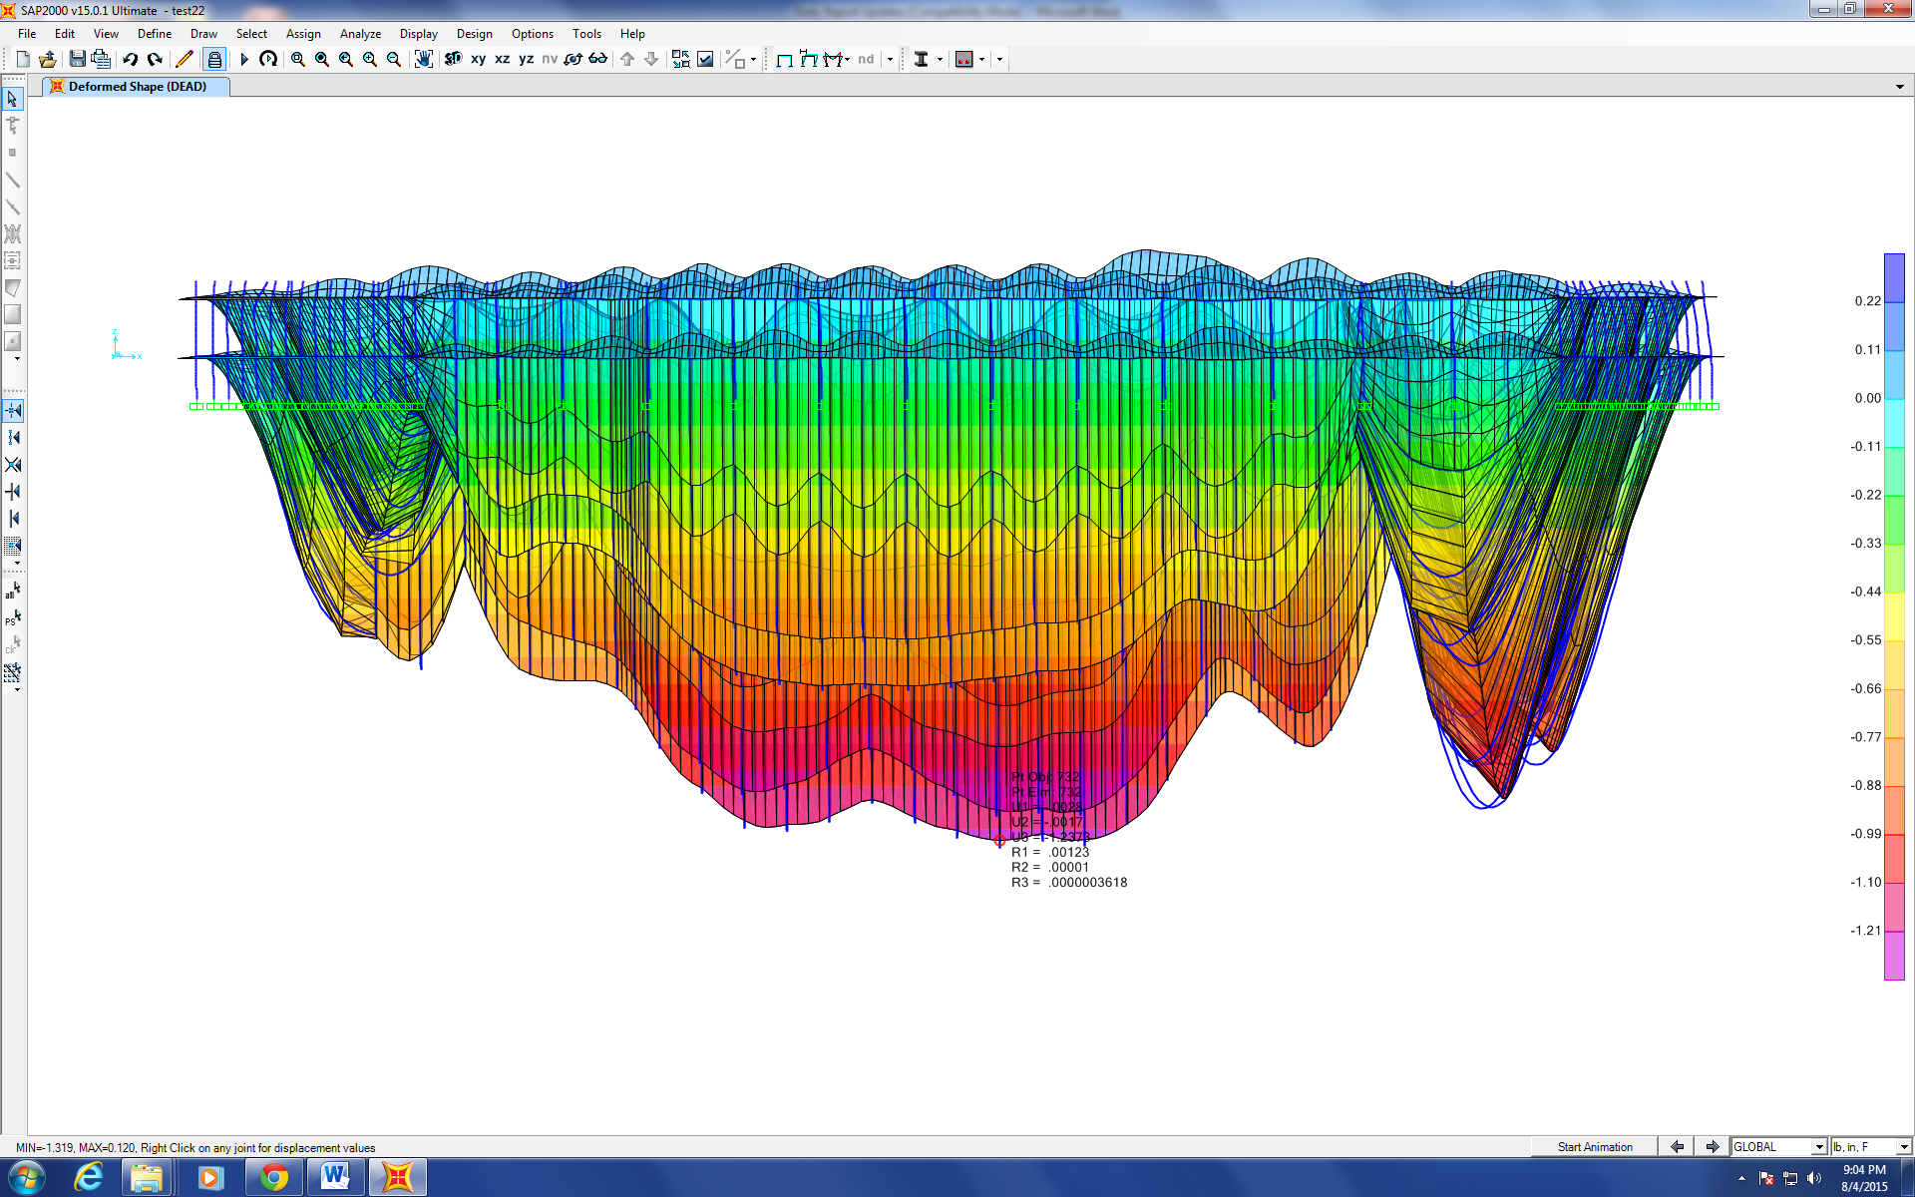
Figure 8. 4X4 elements between frame divisions with frame meshing
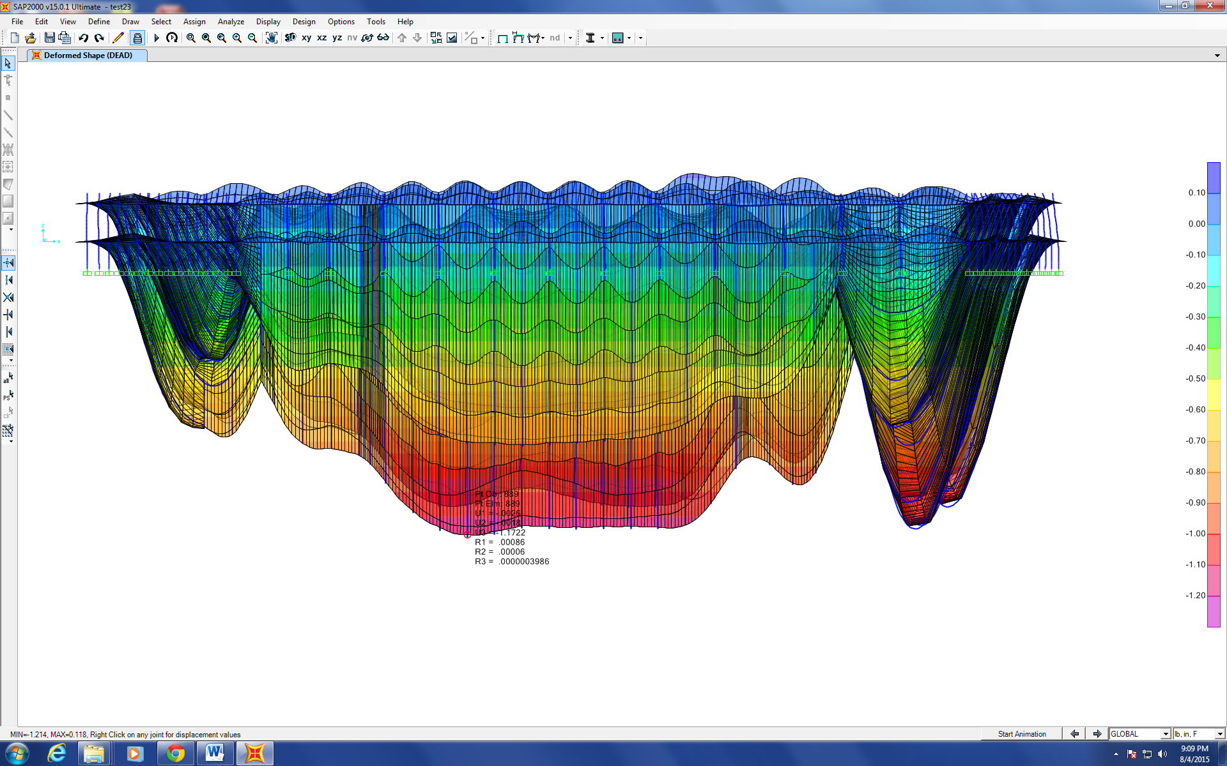
Figure 9. 8X8 elements between frame divisions with frame meshing
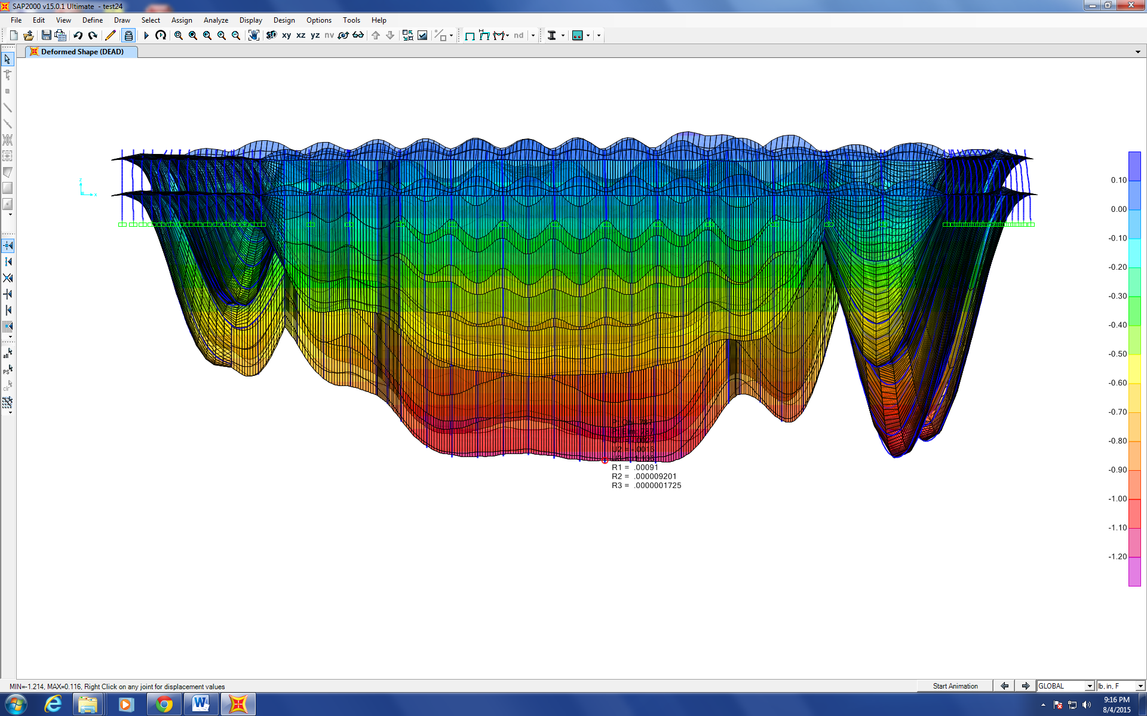
Figure 10. 10X10 elements between frame divisions with frame meshing
Progression of the Project Daily Report

Date: 08/05/2015 Working Hours: 8
Submitted by Zhili Quan

Today, a lot of modeling on SAP2000 was done due to the difference that existed in yesterday’s models between models with meshed and unmeshed “frame” elements. Finally, after a lot of trial and error, the cause was finally found. It is due to the fact the SAP2000 automatically resets offset distance to zero after meshing any “frame” element. Therefore, after resetting the offset distances for each “frame” element, the two testing models shown in Figure 1 with the one on the right without meshing the frames and the other one with meshing frames have the same analyzed deflection.
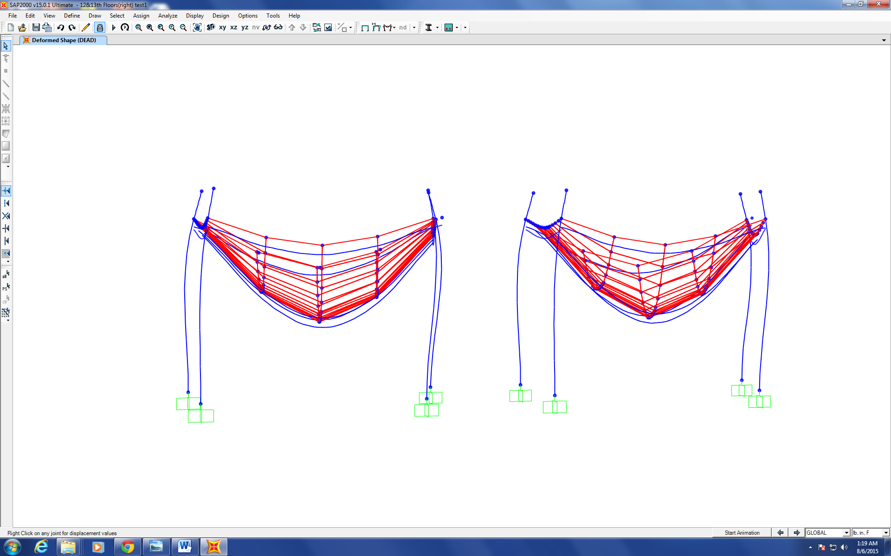
Figure 1

Progression of the Project Daily Report

Date: 08/06/2015 Working Hours: 8
Submitted by Zhili Quan

Today, more modeling on SAP2000 was done, just for the verification of yesterday’s discover that SAP2000 automatically rewrites “frame” elements properties when they are meshed by hand by using “frame meshing” under “edit lines” feature. Figure 1 shows the final model of floor 12&13 without meshing “frame” elements. The result deflection is consistent and less than half of that if “frame” elements were meshed with offset distances all be zero. That makes perfect sense due to the fact that offset distances between the centroid of the slab and the beams give the model a high rigidity. The transformed second moment of area is larger which numerically causes the deflection to be smaller under the same loading. The area between each framing division is sub-divided into 10 by 10 sub-elements.
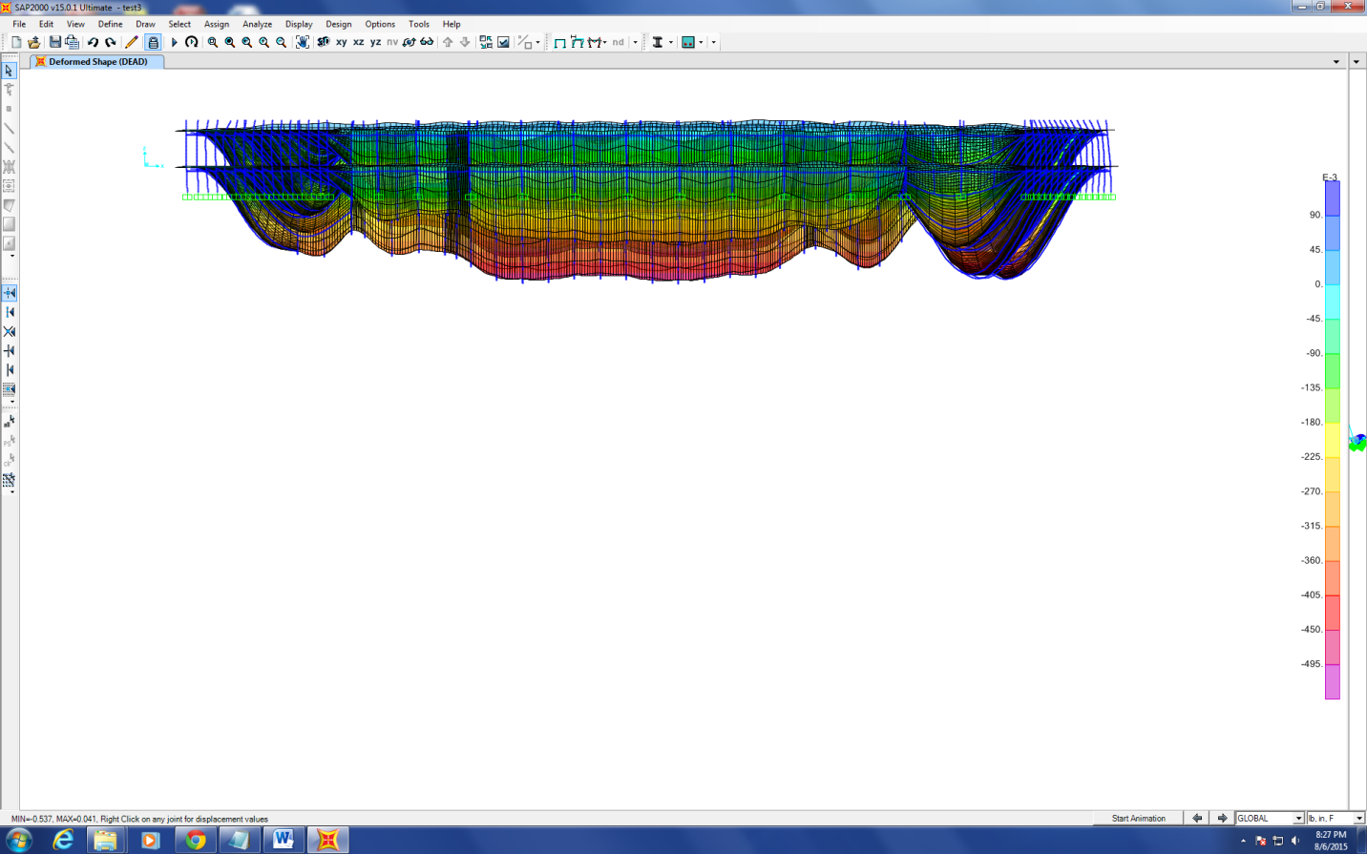
Figure 1
Dr. Hulsey gave fellow research assistants Zhili Quan and Feng Xiao some more information about WTC7 via emails and the emails are to be reviewed.

Progression of the Project Daily Report

Date: 08/07/2015 Working Hours: 8
Submitted by Zhili Quan

Today, 6 models were done on SAP2000 to find out the response of the 12th&13th being put together under unit loading at the centroid of each floor in x, y directions and a unit torsion at the centroid of each floor in the positive z direction. The deflections at 16 locations of both floors under unit loading in x direction are given in table 1. The locations are demonstrated in Figure 1. The loading at the centroid of each floor in x and y directions is set at 10,000kips and the torsion at the centroid of each floor in the positive z direction is set at 10,000 ft*kips.
Table 1
Location# | U1(in) | U2(in) | U3(in) | theta1(radi) | theta2(radi) | theta3(radi)
1 | 0.46915 | 0.042 | 0.03892 | -0.0002323 | 0.0008707 | -0.0001028
2 | 0.50445 | 0.075 | 0.00029 | -0.0008119 | 0.00237 | -0.00001379
3 | 0.48312 | 0.091 | 0.03499 | -0.0004648 | 0.00101 | 0.000144
4 | 0.49375 | 0.012 | 0.00895 | -0.0001626 | -0.0000178 | 0.00007744
5 | 0.48595 | -0.063 | -0.0381 | 0.0003748 | 0.00111 | 0.0004908
6 | 0.53709 | -0.047 | -0.0003 | 0.0005065 | 0.00239 | 0
7 | 0.50913 | -0.022 | -0.034 | 0.0001248 | 0.00102 | -0.0005075
8 | 0.5531 | 0.009 | 0.0064 | 0.00004 | 0.00005 | 0.00003
9 | 0.15686 | 0.021 | 0.05244 | -0.000292 | 0.00127 | -0.00005424
10 | 0.13573 | 0.017 | 0.00041 | -0.0005972 | 0.00184 | -0.00001293
11 | 0.14904 | 0.017 | 0.03741 | -0.0004558 | 0.00135 | 0.00005324
12 | 0.14527 | 0.006 | 0.01543 | -0.000259 | -0.0001285 | 0.00007623
13 | 0.15227 | -0.006 | -0.0396 | 0.0003218 | 0.00143 | 0.0003939
14 | 0.14437 | -0.01 | -0.0004 | 0.0004032 | 0.00194 | 0
15 | 0.1651 | -0.015 | -0.044 | 0.0001574 | 0.00144 | -0.0004118
16 | 0.16072 | 0.003 | 0.00632 | 0.0000207 | -0.0001335 | -0.00008755

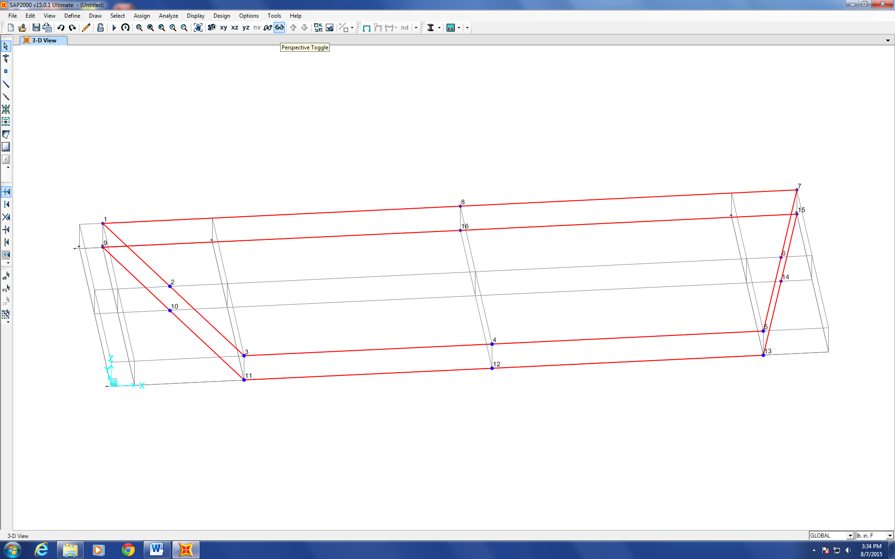
Figure 1
The results were compared with the results obtained by fellow research assistant Feng Xiao with ABAQUS and are satisfactorily close.

Progression of the Project Daily Report

Date: 08/10/2015 Working Hours: 8
Submitted by Zhili Quan

Today, another model was done to simulate the analysis done on ABAQUS by fellow research assistant Feng Xiao. Two forces were applied at 15ft away from the centroid of the upper concrete floor. The forces had the same magnitude as 10,000kips but opposite directions. The force applied 15ft north of the centroid was pointing in the positive x direction and the force applied 15ft south of the centroid was pointing in the negative x direction. Consequently, a couple was generated with the magnitude of 10,000*30 ft.*kips. The analyzed deflection by SAP2000 was shown in Figure 1.
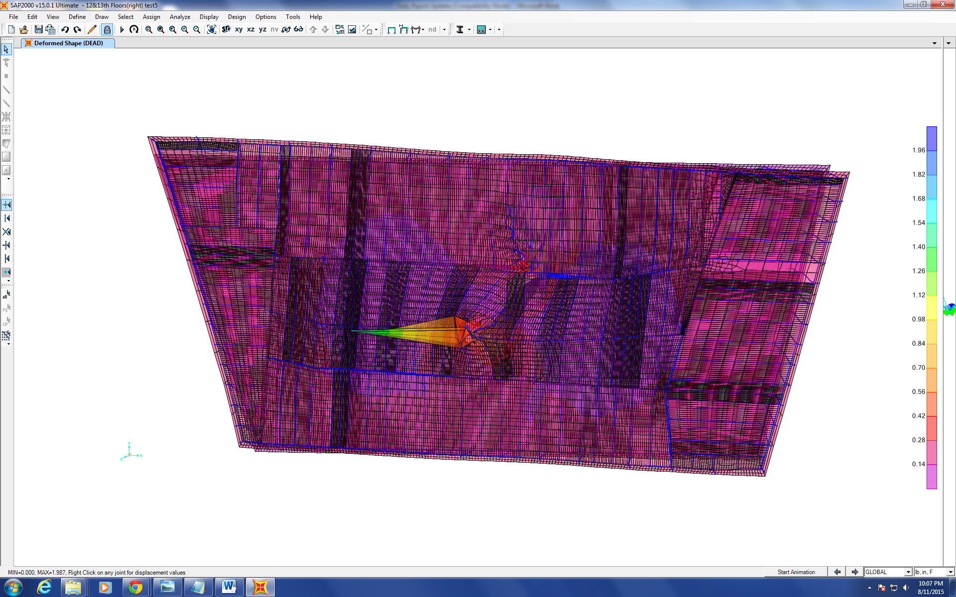
Figure 1
The deflection near the application points of the forces is much larger than the places that are far away from the application points due to saint venant principle that loading dissipates along distance.
Several emails sent by Dr. Hulsey were read and the articles that came with the emails were studied. One of the articles concluded it was very unlikely that WTC7 collapsed due to the fire burned out of control.
Progression of the Project Daily Report

Date: 08/11/2015 Working Hours: 8
Submitted by Zhili Quan

Today, the model of the 12th&13th floors being put together with fixed and released connections according to the original drawing was finished. Deflection was analyzed in that model. The result deflection was 15-20% larger than the one with all fixed connections. The deflection was not significantly increased for the model with a considerable amount of connections being pinned is believed to be due to the fact that the concrete slab is assumed to be rigidly connected in both models with all the “frame” elements, and it serves as the main stiffness of the model resisting vertical loading. The vertical loading for both cases is only self-weight and it is not very large.
Figure 1 shows the new model with mostly released connections and some remaining fixed connections.
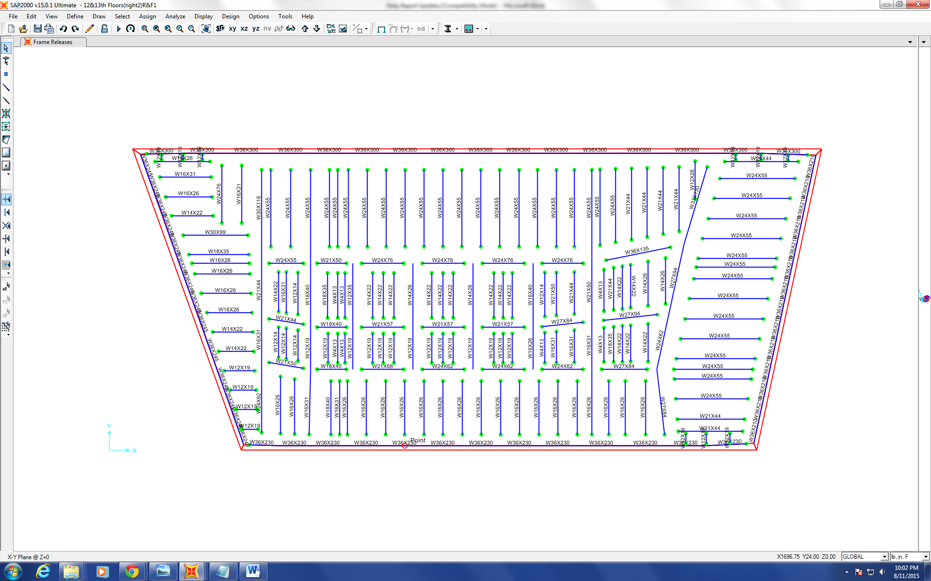
Figure 1
Figure 2 shows the analyzed deflection contour of the new model on SAP2000.
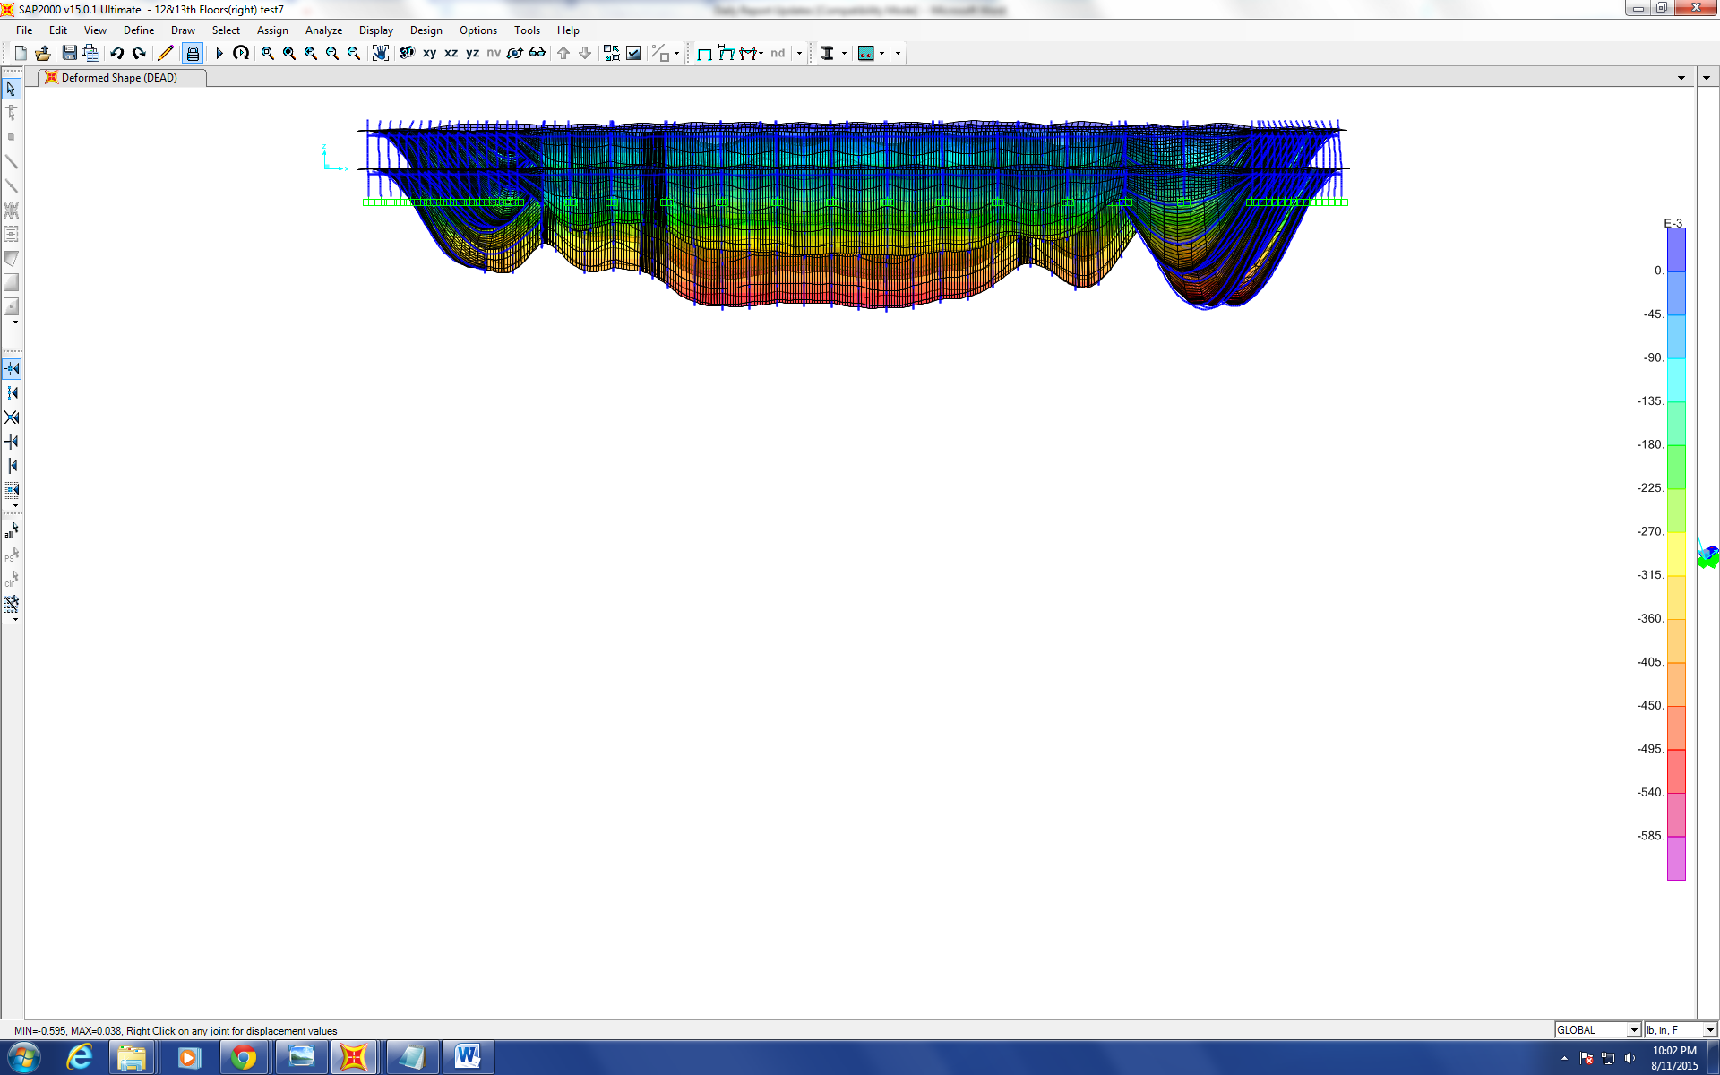
Figure 2
Figure 3 shows the analyzed deflection contour of the original model with all the connections fixed. The deflection is about 15-20% smaller.
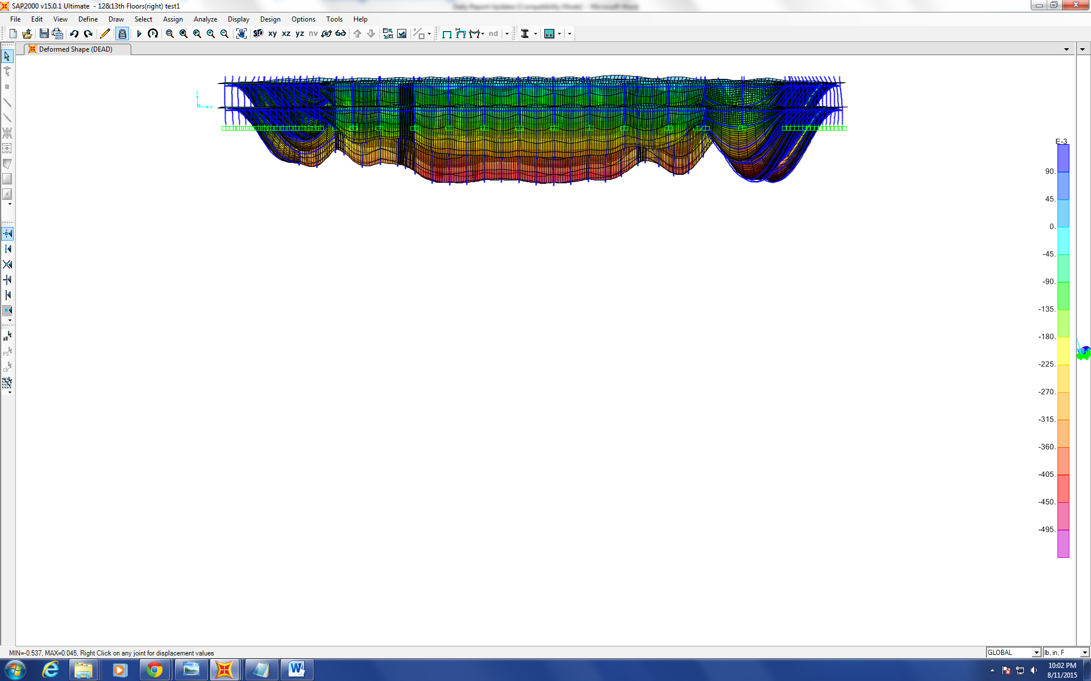
Figure 3

Progression of the Project Daily Report

Date: 08/12/2015 Working Hours: 8
Submitted by Zhili Quan

Today, the modified model (the 12th&13th floors being put together with both fixed and released connections according to the original drawing) was loaded in x, y directions with 10,000 kips and a couple consisting of two 10,000 kips that each is 15ft away from the centroid with one in the north and one in the south and acting in opposite directions. The response of the model is significantly different from the original one. The difference is reflected from deflection distribution rather than the maximum deflection and it is due to the innate configuration of the model has changed significantly.

Progression of the Project Daily Report

Date: 08/13/2015 Working Hours: 8
Submitted by Zhili Quan

Today, Corrected a mistake made yesterday. For the original model, which all the connections were assumed to be fixed, the self-weight loading was ignored. However, the modified model when the connections were mixed with both fixed and released (majority) according to the original drawing. The result deflection for both models under different directions are very close, but the modified model with both fixed and released connections has smaller deflection under the same loading as the original model.
It was to be expected the model to behavior like that because released connections can only resist shear force unlike fixed connections can resist both shear and moment.
Also, the deflection for both models doesn't vary much (about 10% or less depending on the loading situation) is due to the fact that the majority resisting elements are the columns and the concrete slabs, and they are not changed at all.
Figure 1 and 2 show the deflection of the original model and the modified model under 10,000 kips loading in x direction respectively.
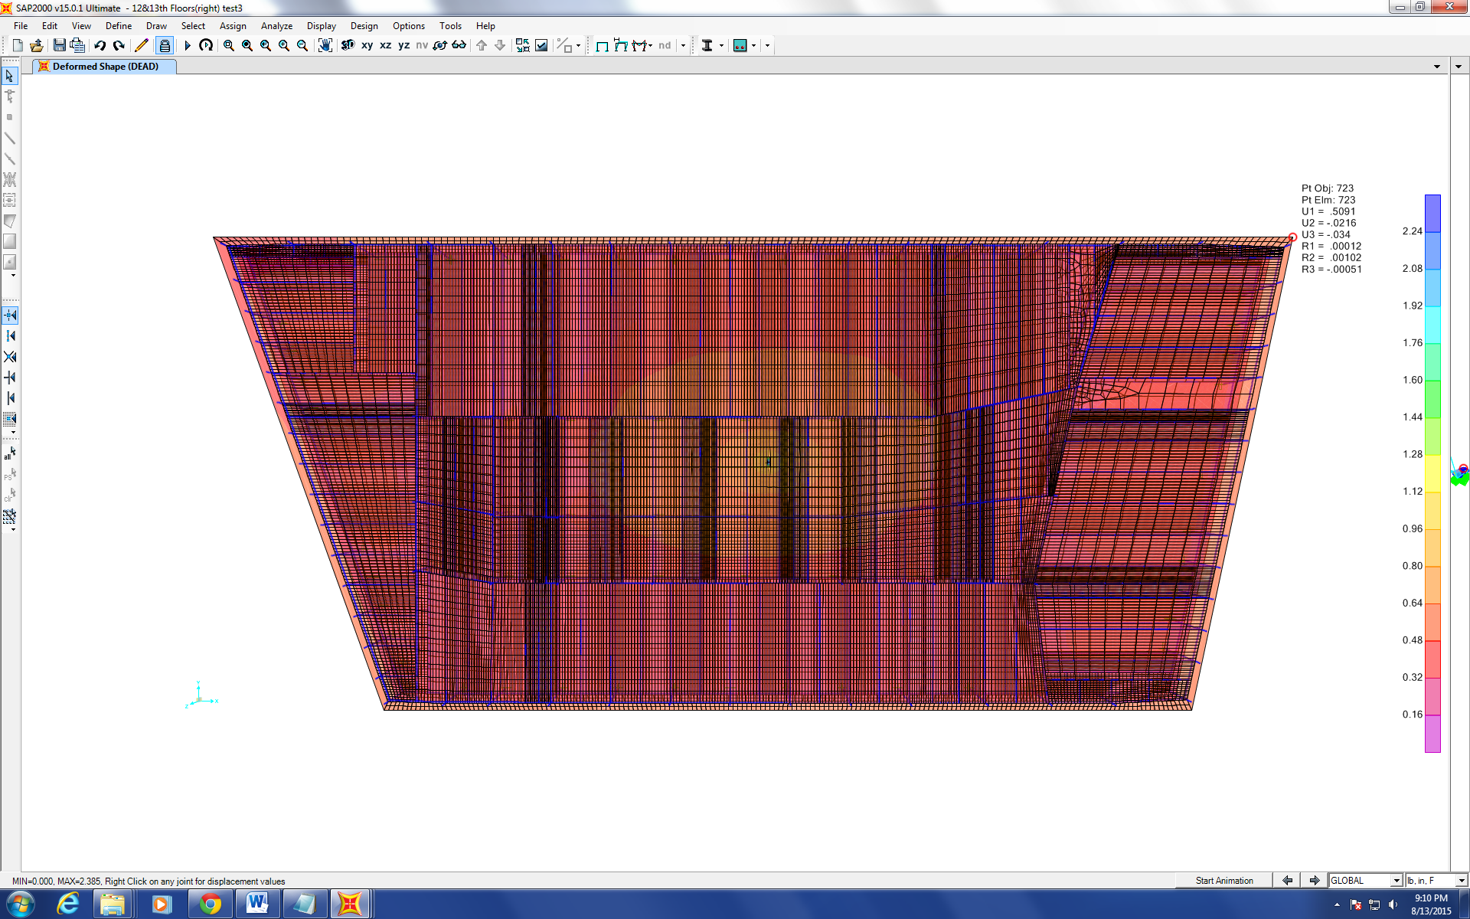Figure 1
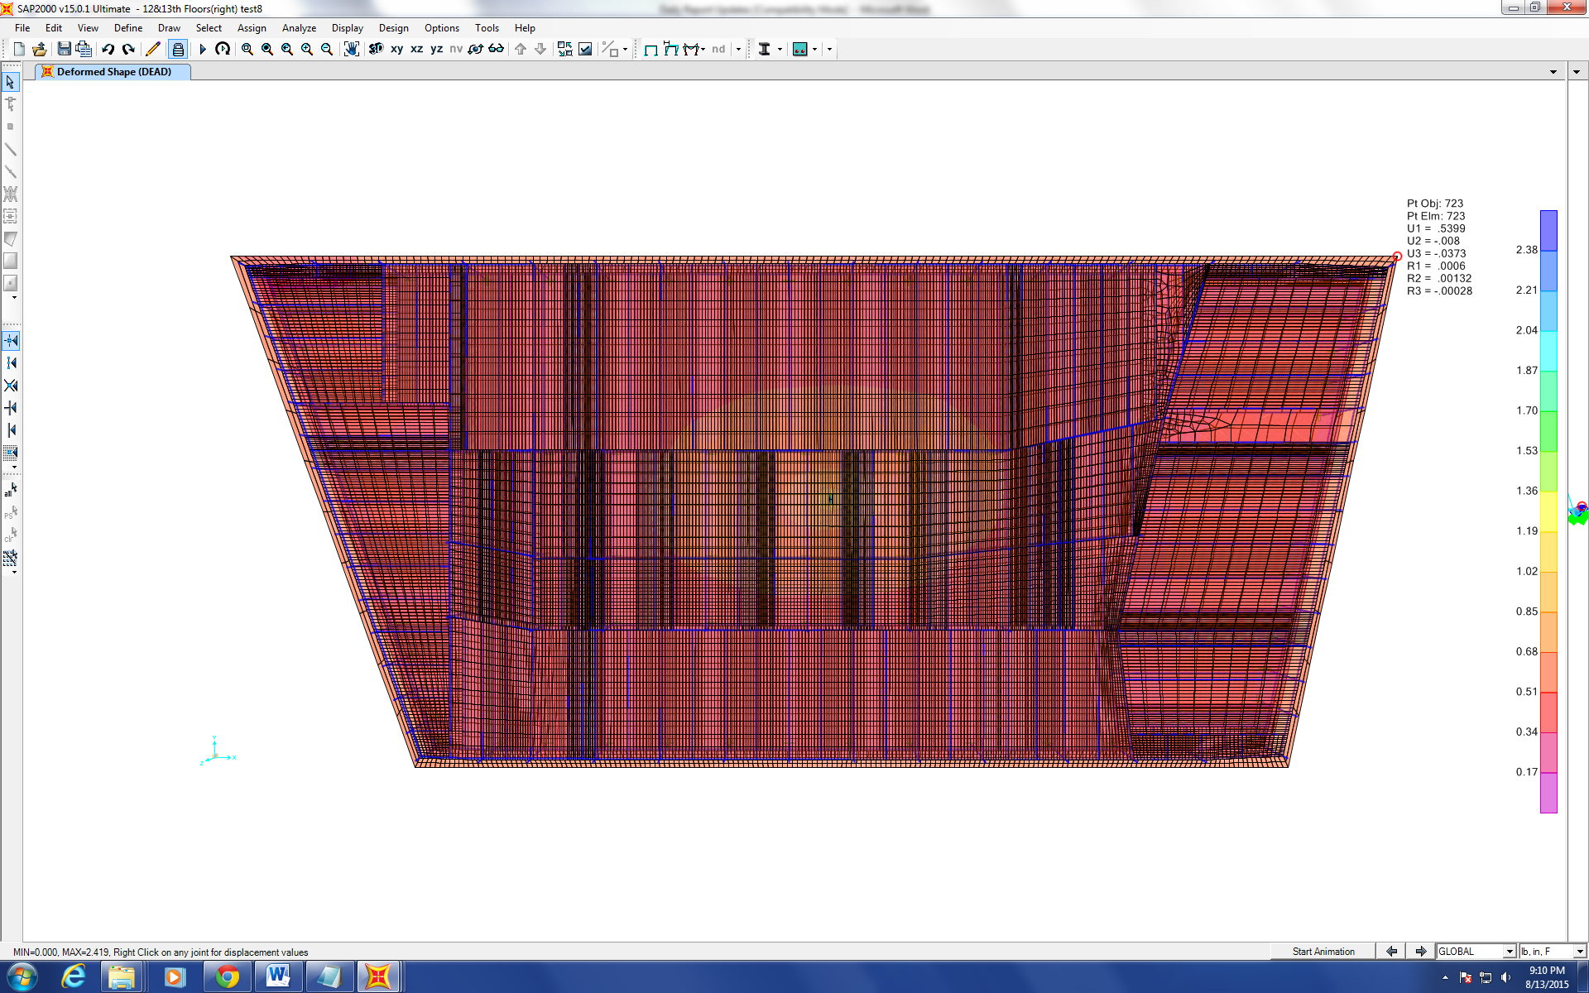 Figure 2
Figure 3 and 4 show the deflection of the original model and the modified model under 10,000kips in y direction respectively.
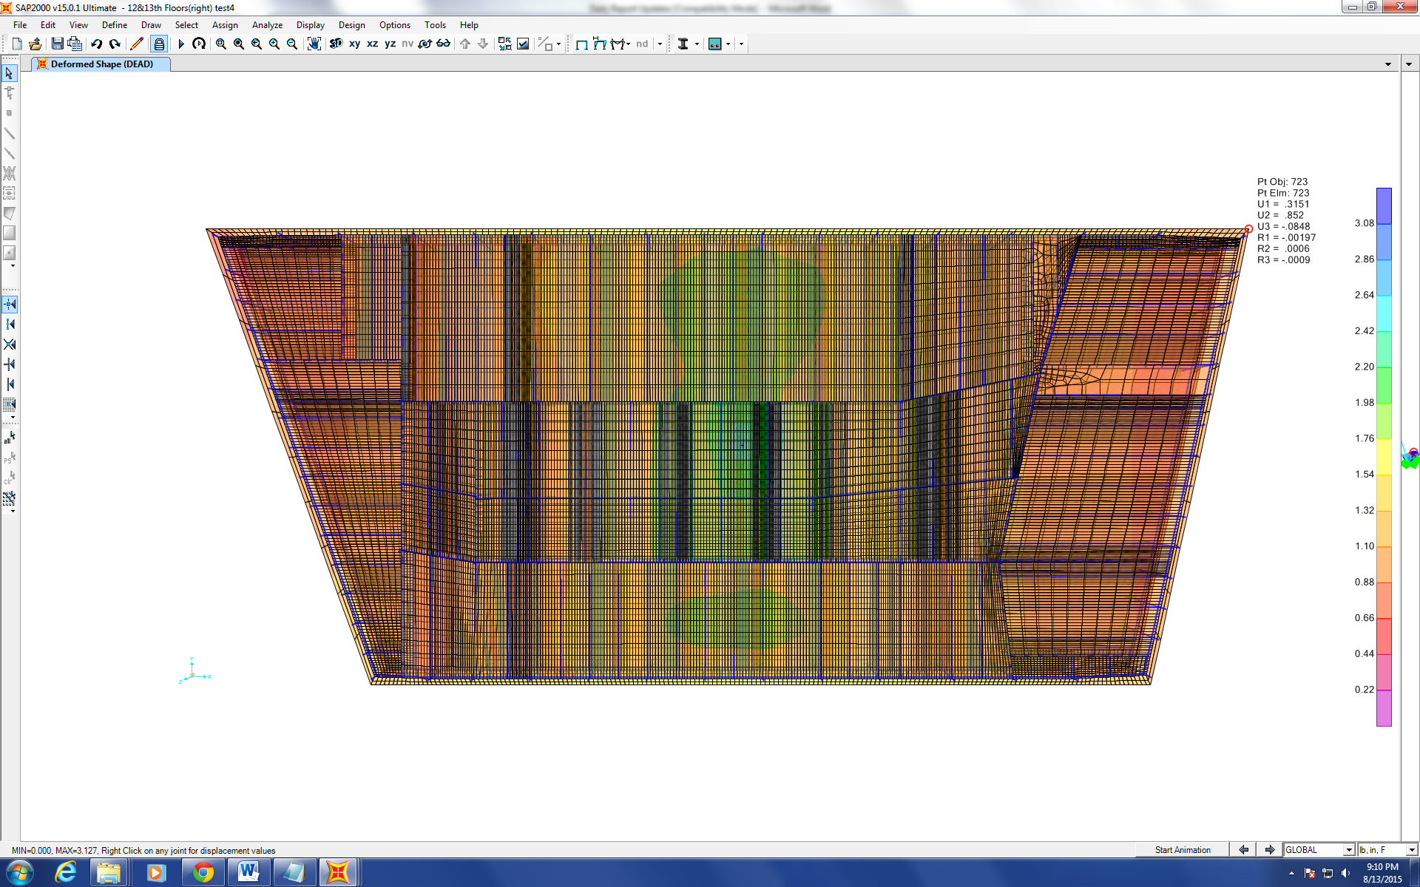 Figure 3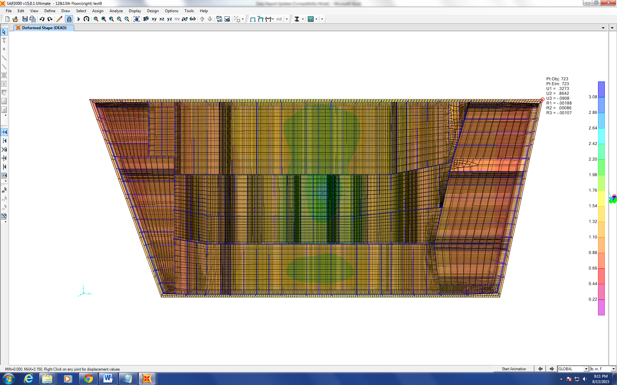 Figure 4
Figure 5 and 6 show the deflection of the original model and the modified model under 10,000kips in y direction respectively.
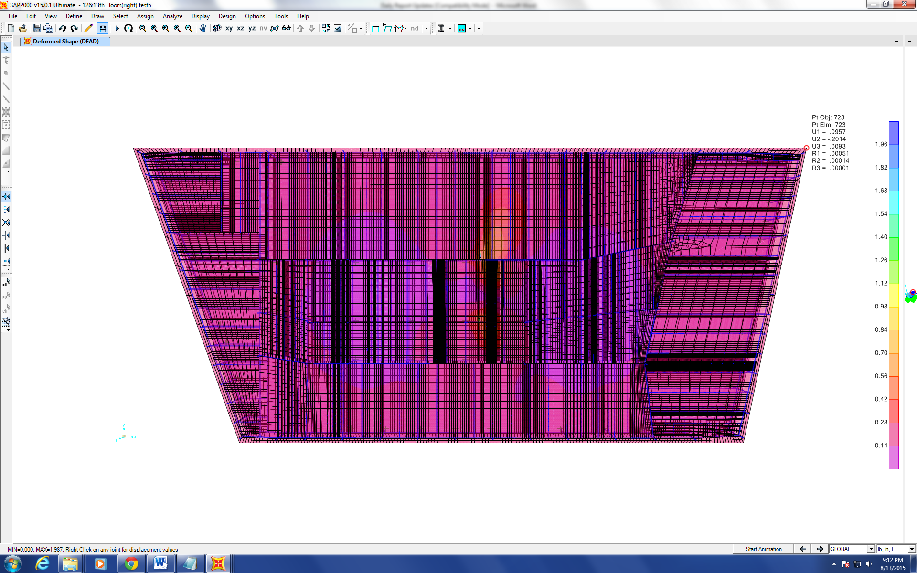 Figure 5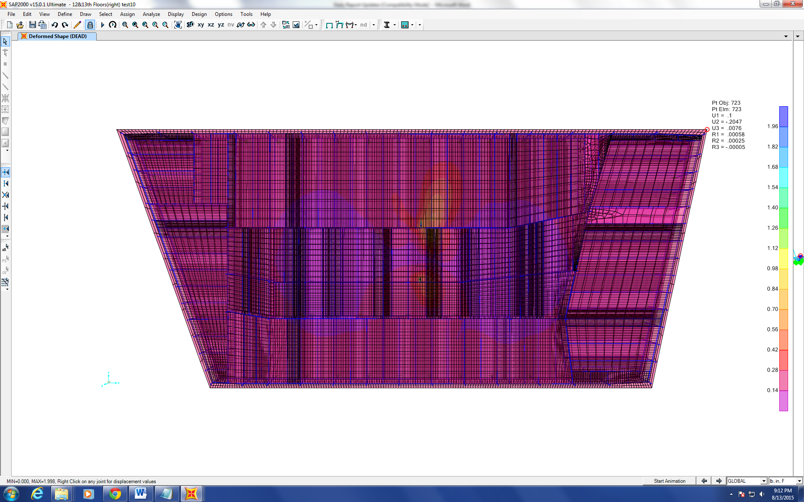 Figure 6
Also, Dr. Hulsey suggested it is time to put the rest of the floors together, and like the model that consists of 12th&13th floors, the rest of the floors should be put together in the way that two consecutive floors will be put in one single model. Fortunately, floor 8-20 and floor 25-45 are very similar. Therefore, only small changes are needed to make those floors. However, the first three floors were built upon the pre-existing electrical substation and the information about it is still mostly missing.

Progression of the Project Daily Report

Date: 08/14/2015 Working Hours: 8
Submitted by Zhili Quan

Today, 14th to 24th floor was identified and made comparison with the 12th and 13th floor being put together model. The effort is made to build the rest of the floors that two of them can be made into a single model on SAP2000 like the 12th and 13th floors.
During the meeting with Dr. Hulsey, he pointed out it is necessary to find out if detailed information regarding the roof of the building is available.
However, there is still missing information about the electrical substation.
The alteration on the 13th floor of the building has been studied and changes are needed to modify the original 12th and 13th floors model.

Progression of the Project Daily Report

Date: 08/17/2015 Working Hours: 8
Submitted by Zhili Quan
Today, more work was done on floors between the 13th to the 25th. Apparently, there is more work than expected and AutoCAD was decided to be used with SAP2000. It is because SAP2000 is only structural analysis software; the CAD package of SAP2000 is not nearly as advanced or "smart" as AutoCAD. Also, even the change between 12th&13th floors combination and the rest the floors (from the 8th floor on) is only minor, the change is somehow annoying and not quite repetitive enough to duplicate. Moreover, the "core" part of the building was different between each floor and the change varies between each floor.

Progression of the Project Daily Report

Date: 08/18/2015 Working Hours: 8
Submitted by Zhili Quan
Today, again more work was done on floors between the 13th to the 25th. Also, during the daily meeting with Dr. Hulsey, he suggested it is time to study how to model combinations of composite, non-composite and partially composite concrete slab and steel beam elements. The study has just been started and will serve as a foundation for the future modelling of the building.

Progression of the Project Daily Report

Date: 08/19/2015 Working Hours: 8
Submitted by Zhili Quan

Today, a lot of effort was made to find out how to model partially composite concrete slabs connected with steel beam. Partially composite models are meant to account for the effect that the shears stud connecting the concrete slabs and the steel beams are not rigid like the assumption made about purely composite where there is no slip between the slabs and the steel beams. In reality, there should be a certain stiffness existing between the slabs and the steel beams.
However, at the end of the day, a remaining problem was to be solved, and it was how to disconnect “shell” elements from “frame” elements or vice versa. In order to model partially composite concrete slabs connected with steel beams, they have to get separated first, then certain stiffness that represents the flexibility of the shear studs has to be put in place.
More effort is expected to be spent on the problem tomorrow.

Progression of the Project Daily Report

Date: 08/20/2015 Working Hours: 8
Submitted by Zhili Quan

Today, more effort was made to find out how to model partially composite concrete deck connected with steel beams. More literature review was done.
However, the progress got stuck when one obstacle was encounter, and that was when trying to disconnect “frame” elements from “shell” elements.
During the daily meeting with Dr. Hulsey, he suggested it may be necessary to make a phone call with the company that provides SAP2000 to see how it can be done.
Finally, after tons of tests were done, it was realized the “frame” elements and the “shell” elements have to be meshed the exactly same way in order to disconnect those two elements so they can act separately.
Figure 1 shows the reaction of a testing model, when the “frame” element was meshed according to the meshing of the “shell” elements. After using the “disconnect” feature on SAP2000. The reactions of the “frame” elements and the “shell” elements were separate.
Next step is to find out if putting 1 joint “link” elements at those shared but disconnected joints can put certain stiffness among those joints.
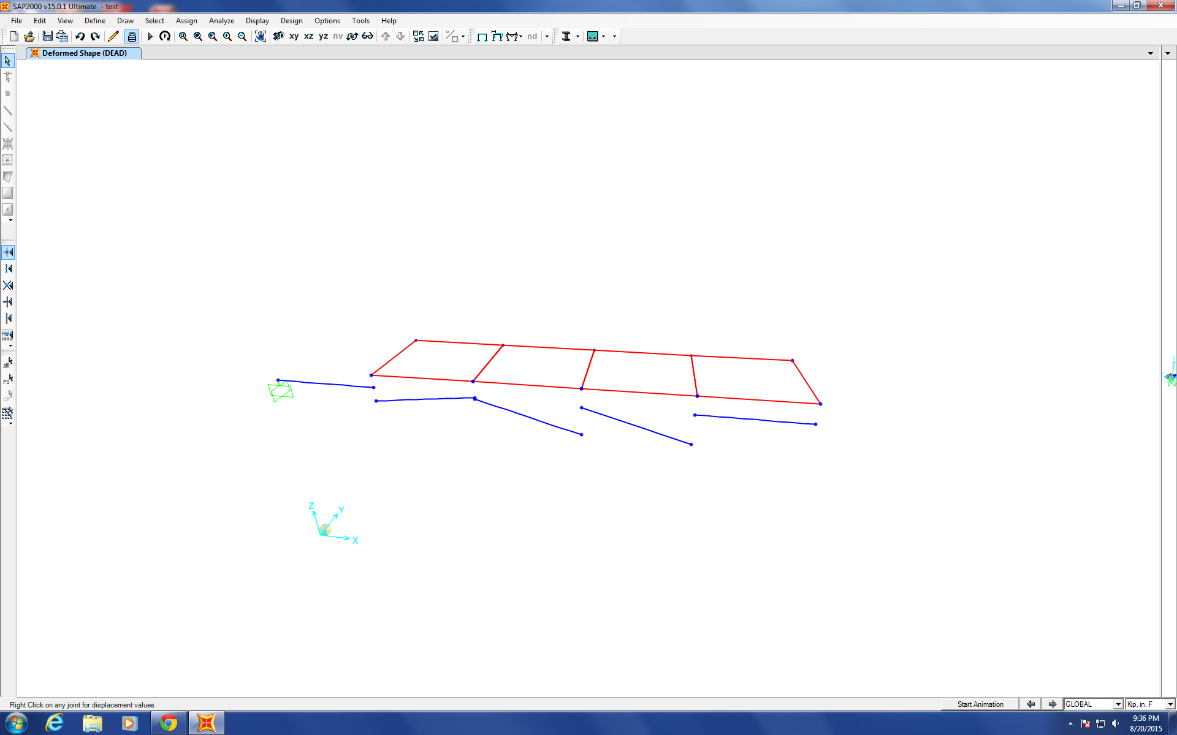
Figure 1

Progression of the Project Daily Report

Date: 08/21/2015 Working Hours: 8
Submitted by Zhili Quan

Today, “1 joint link” elements were studied. However, despite tons of effort being put into modeling the elements to simulate the stiffness between multiple elements that have one of their joints that share the same location, it cannot be done. Later, after a phone call consultation session with the company that provides SAP2000, it was found out that “1 joint link” elements can only be used to connect elements to the ground. Therefore, it cannot be used to simulate the stiffness between different elements that are connected.
“2 joint link” elements were also studied. After numerous test-modeling, it was found that a “2 joint link” element can be put into one shared location of two different joints of two different elements therefore giving the stiffness between these two elements.
Figure 1 shows a triangular “shell” element with one of its joints that shares the same location as one of the joints of a “frame” element. A “2 joint link” element has been inserted between these two elements.
However, when there are multiple elements that each has one of their joints sharing the same location as what is shown in Figure 2. The highlighted location has 6 different joints all clustered together. It takes very complicated connecting condition to model the partially composite elements. More study has to be conducted to resolve this issue.

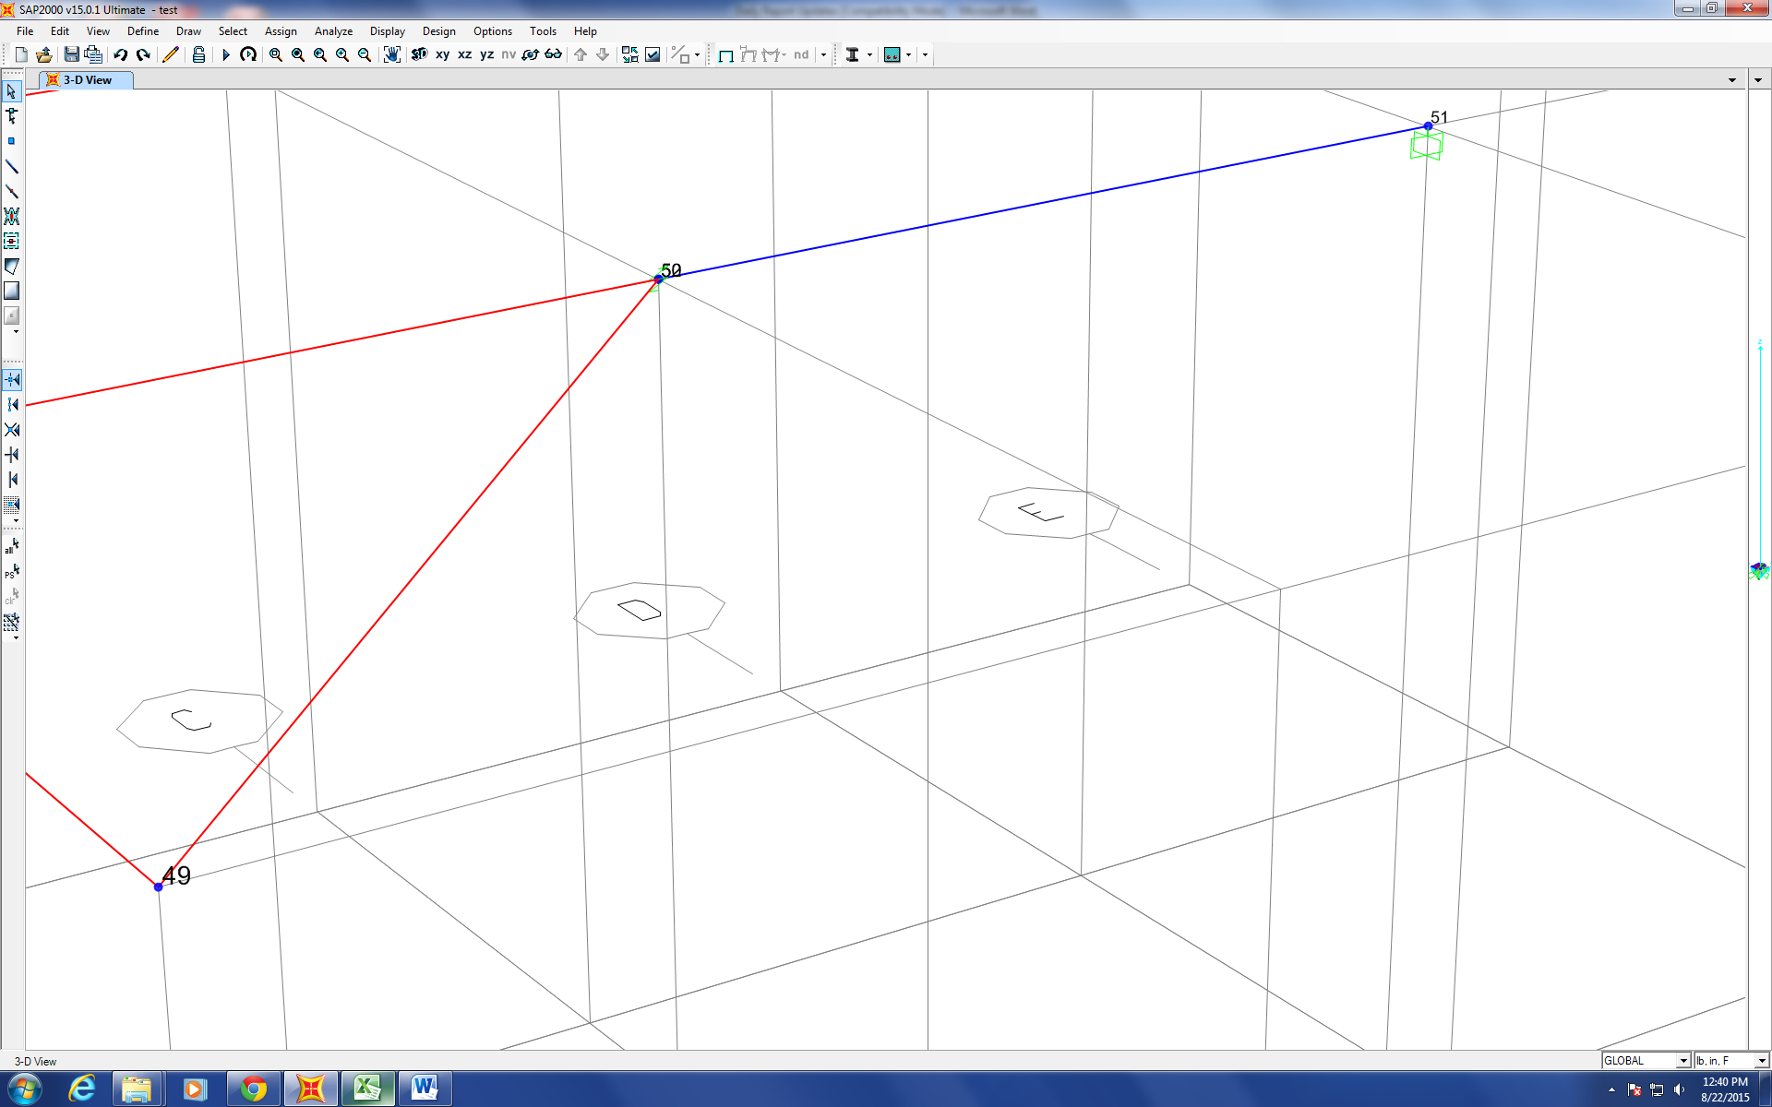
Figure 1
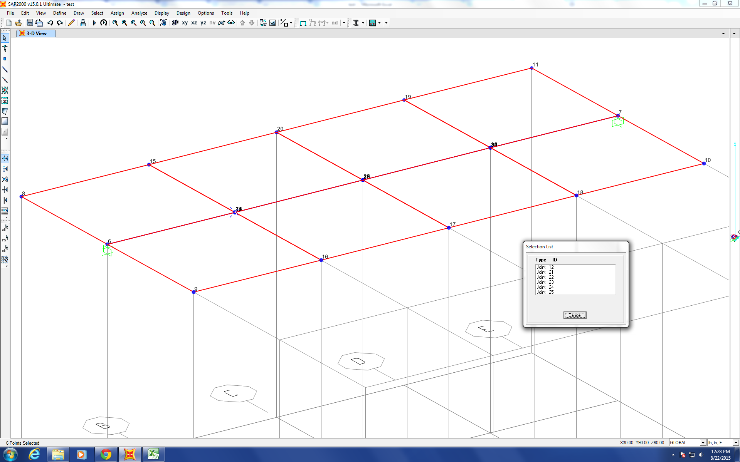
Figure 2
Progression of the Project Daily Report

Date: 09/01/2015 Working Hours: 8
Submitted by Zhili Quan

Today, lots of effort has been done on recovering the work that has been lost due to a broken hard-drive. Also, it always should the top priority that update the work files everyday on two different hard-drives so there is back up if one of them is broken or lost.
The 24th&25th floors combination has been done on SAP2000 and will be used as a “base” model for the rest of the floors. The 30th&31st floors combination has been partially finished as well.
Figure 1 shows the finished 24th&25th floors combination and Figure 2 shows the partially finished 30th&31th floors combination.
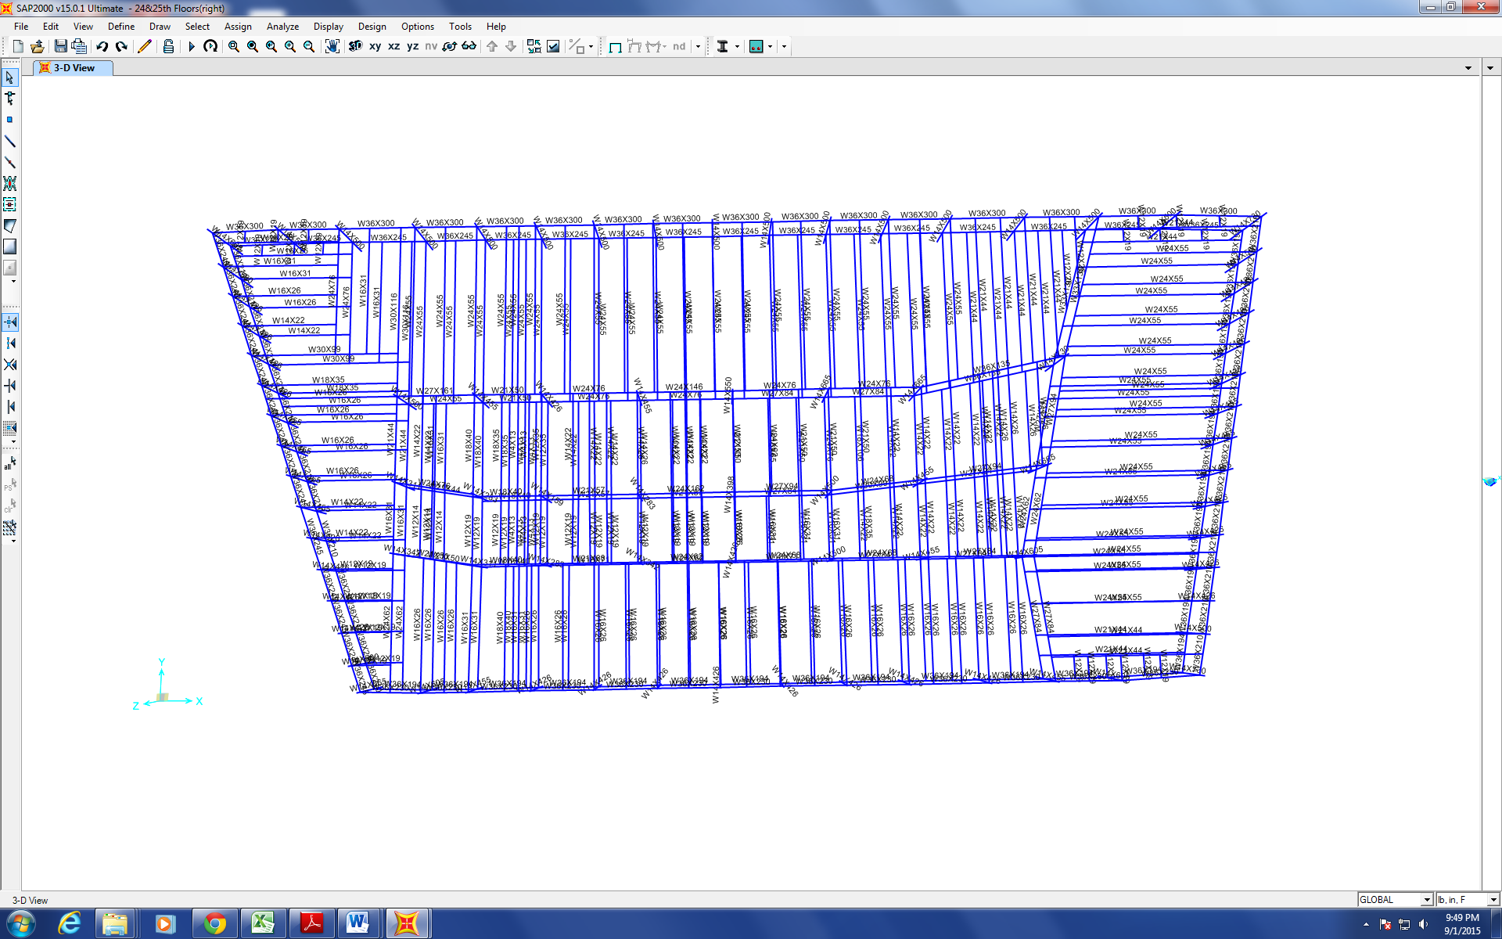
Figure 1
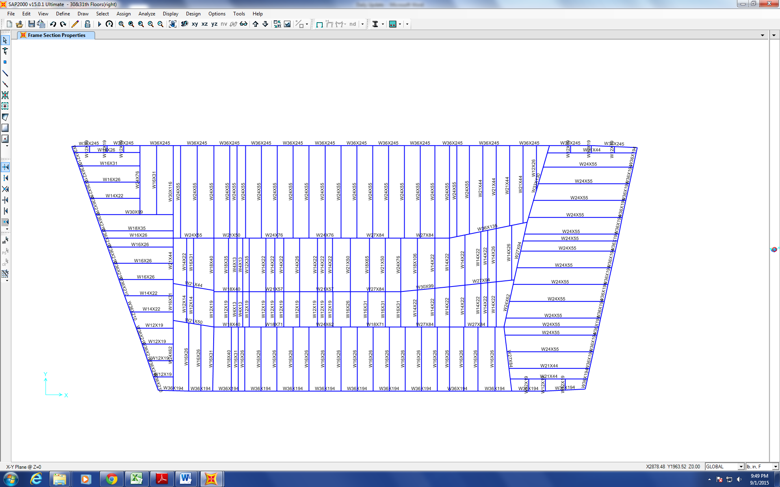
Figure 2
Figure 3 shows the columns that have been changed angles to match the original drawings.

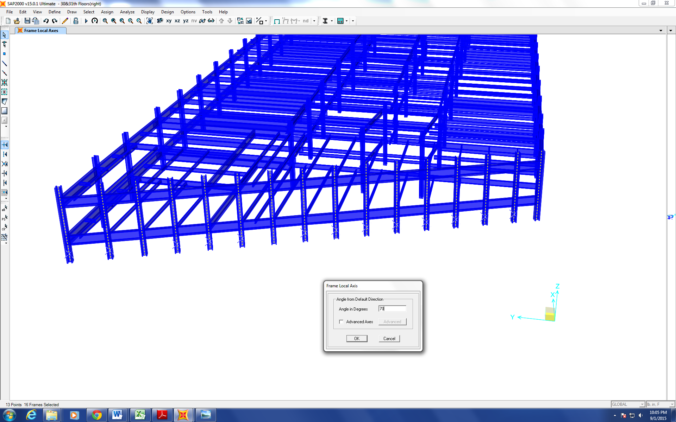
Figure 3
The broken hard-drive has been sent to the computer technicians of the Civil Engineering Department to get fixed. It is still unknown if the data can be retrieved.

Progression of the Project Daily Report

Date: 09/02/2015 Working Hours: 8
Submitted by Zhili Quan

Today, several mistakes were found on the new made models of floor 24&25 and floor 30&31, including the coordinate system set up (local or global and in this case it should be global coordinate system). The mistakes have been corrected.
Figure 1 shows the finished 30th&31st floors combination.
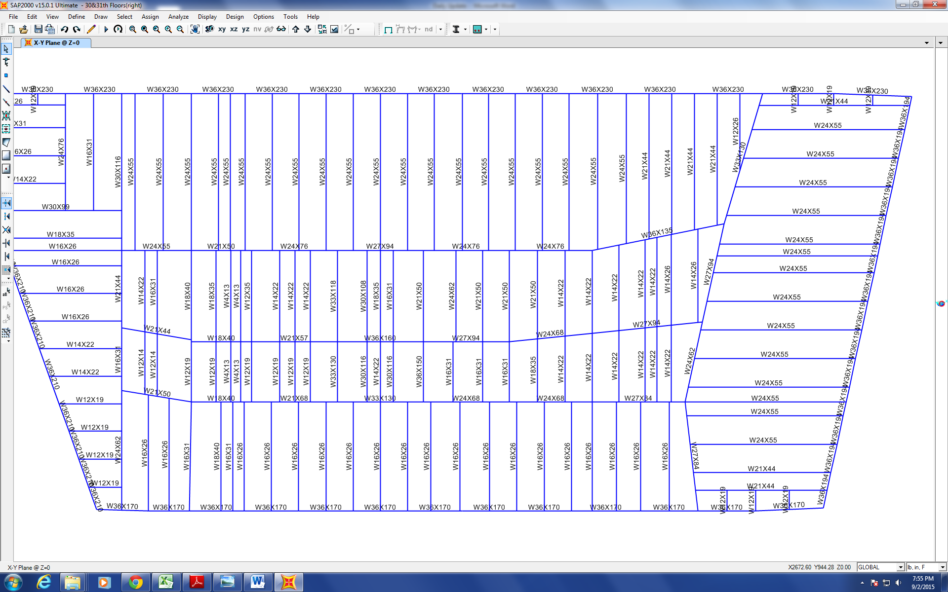
Figure 1

Progression of the Project Daily Report

Date: 09/03/2015 Working Hours: 8
Submitted by Zhili Quan

Today, 4 more floors were finished.
Figure 1 shows the finished 34th&35th floors combination and Figure 2 shows the finished 32nd&33rd floors combination.
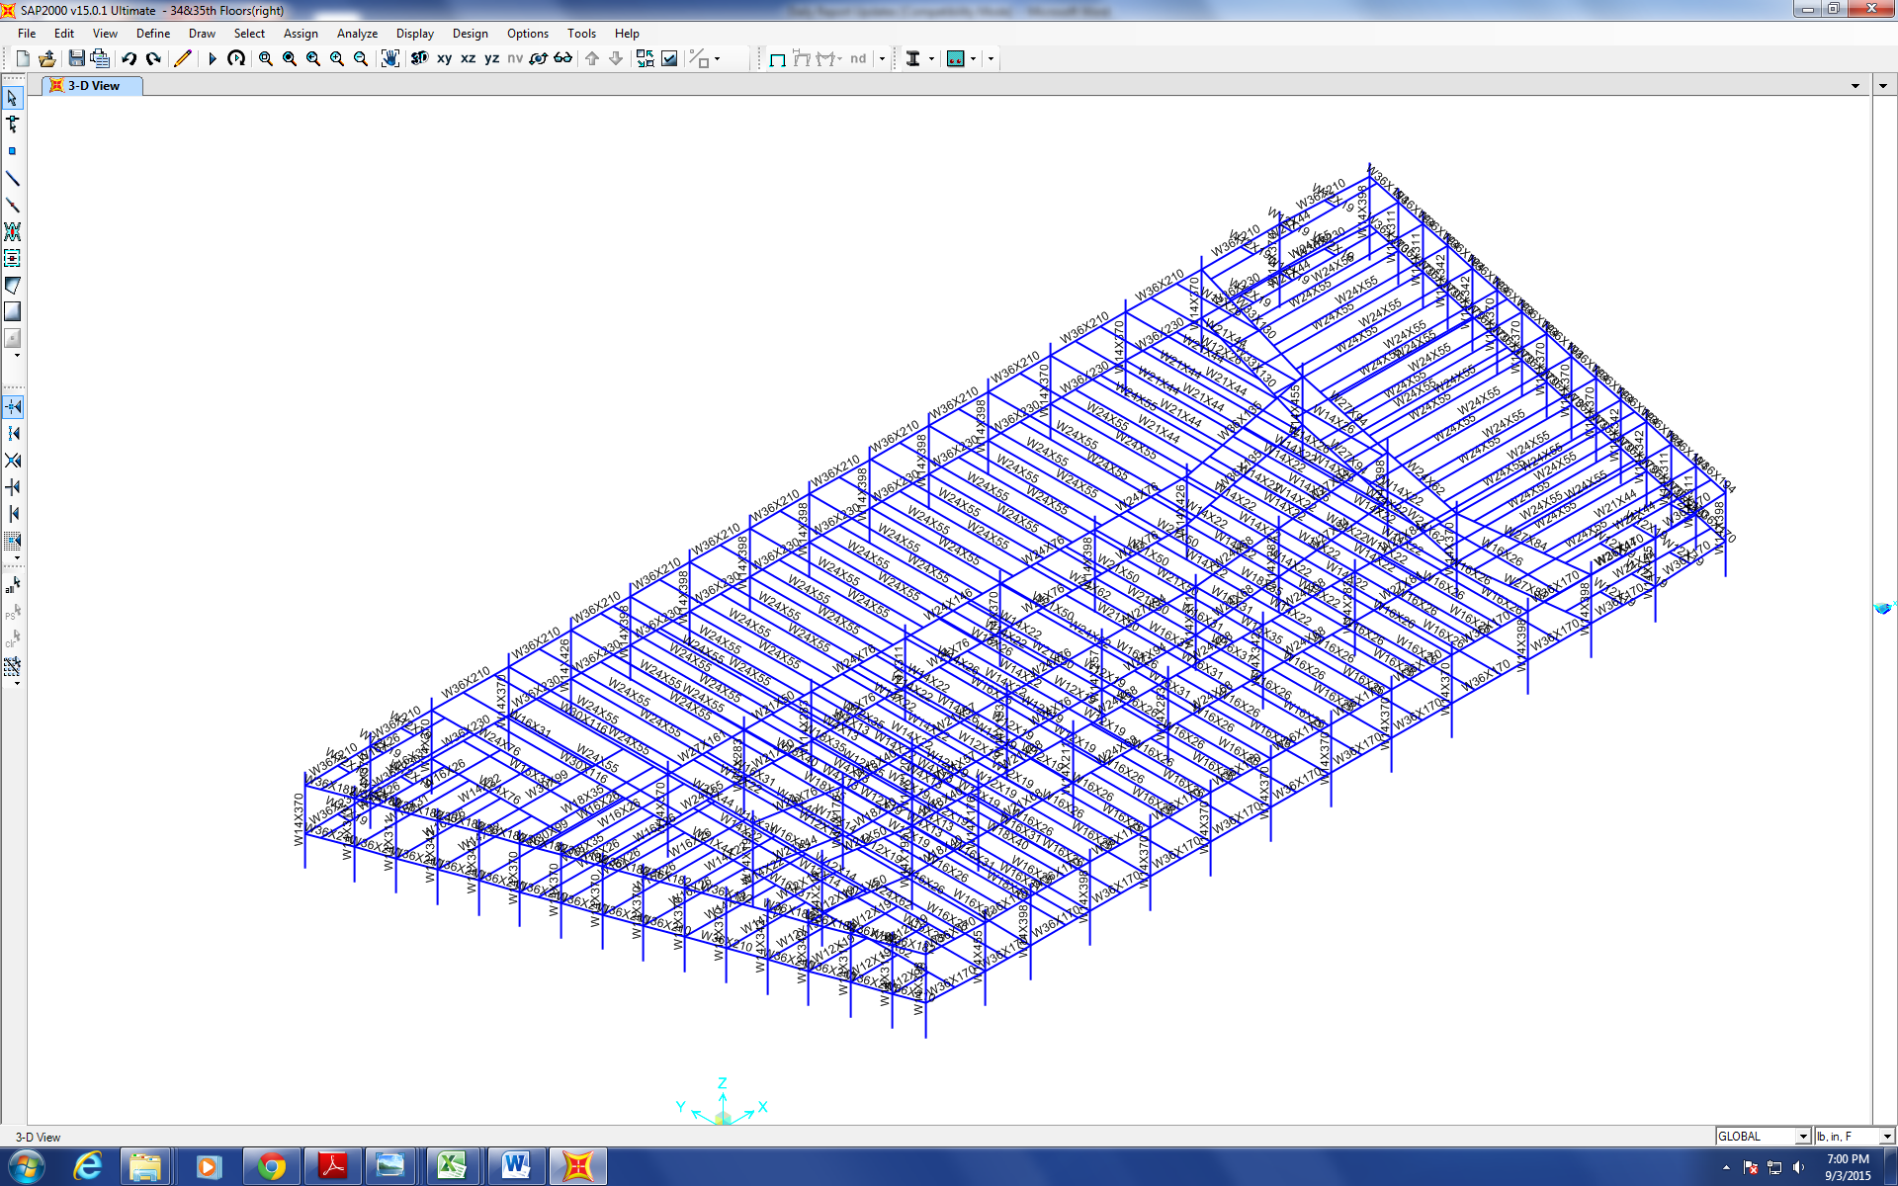
Figure 1
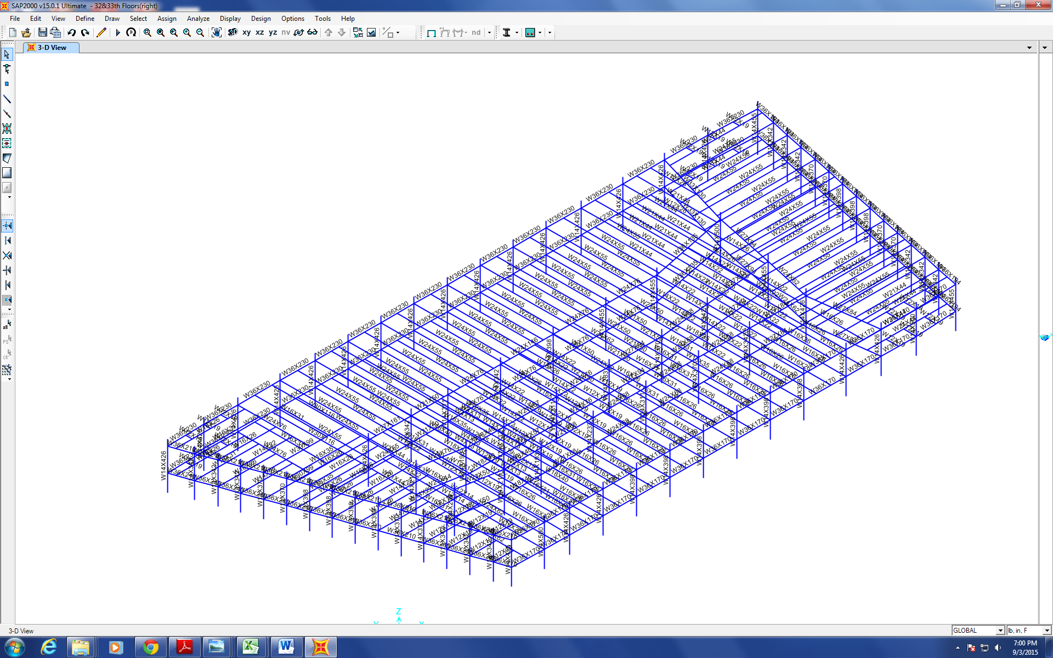
Figure 2

Progression of the Project Daily Report

Date: 09/04/2015 Working Hours: 8
Submitted by Zhili Quan

Today, floor 36&37 combination has been finished.
Figure 1 shows the finished model.
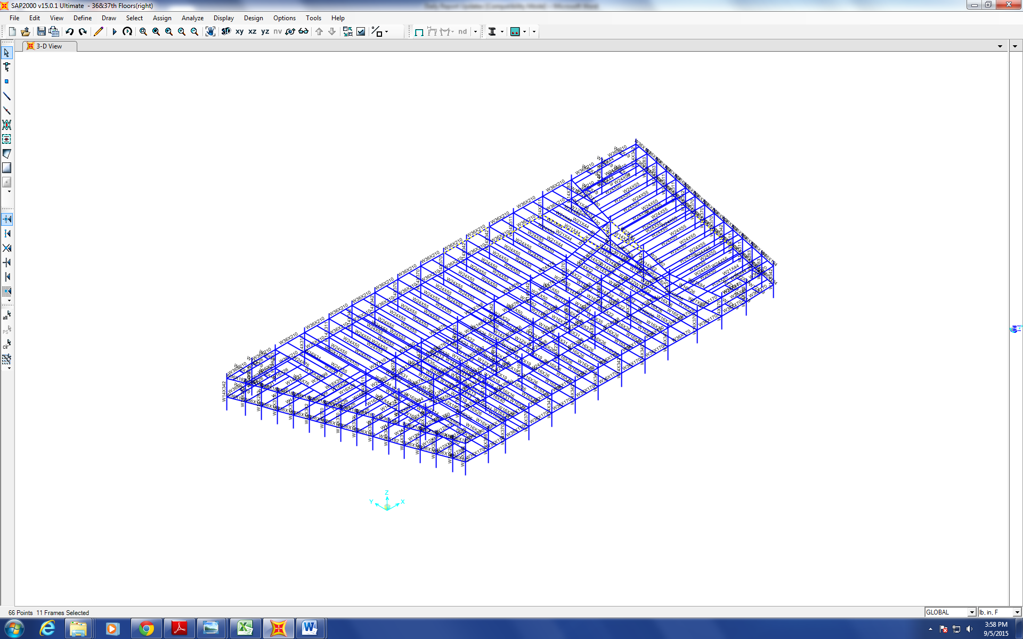
Figure 1
The modeling of floor 38&39 combination has started.
Figure 2 shows the unfinished model.
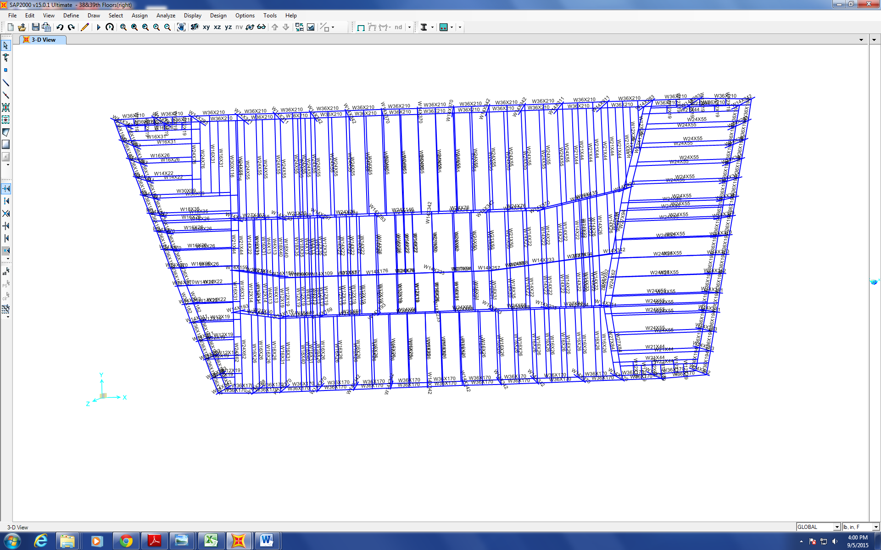
Figure 2

Progression of the Project Daily Report

Date: 09/07/2015 Working Hours: 8
Submitted by Zhili Quan

Up until today, floor 12th &13th combination and from floor 24th &25th combination to floor 44th & 25th combination have been finished.
There are 3 floor combinations that consist of 6 floors missing at the moment due to broken hard-drive. The UAF computer technicians have been working on recovering the data in the hard-drive.

